19.06.2018

40kHz current loop

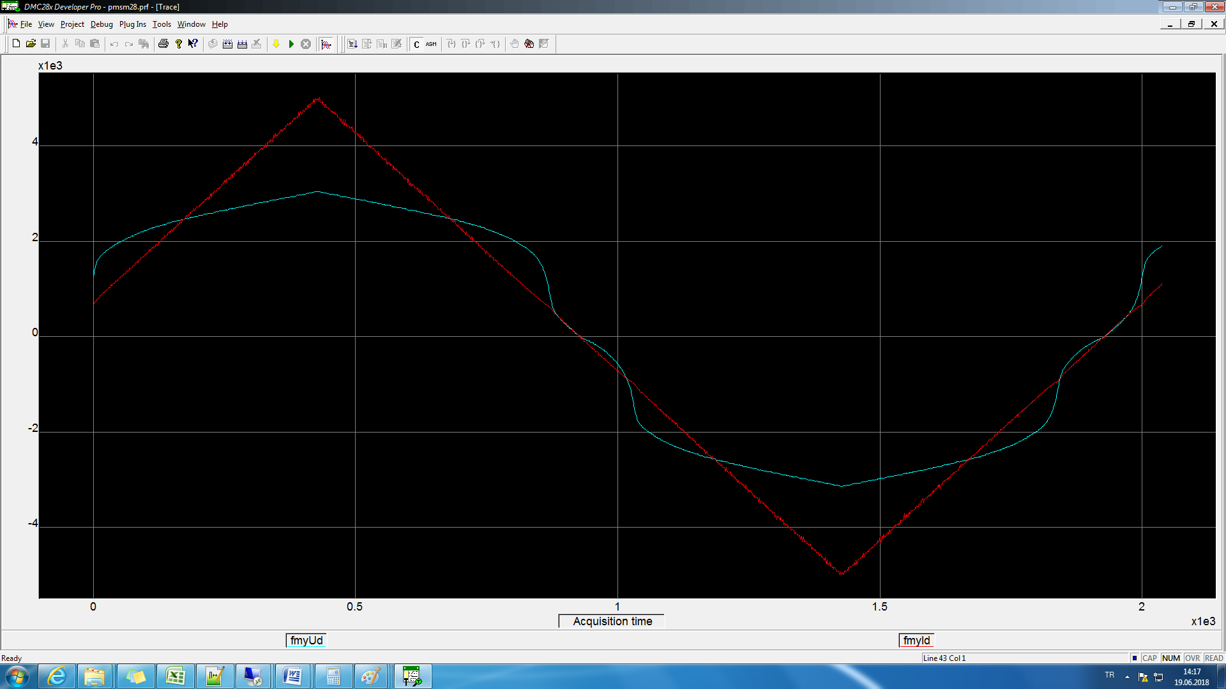

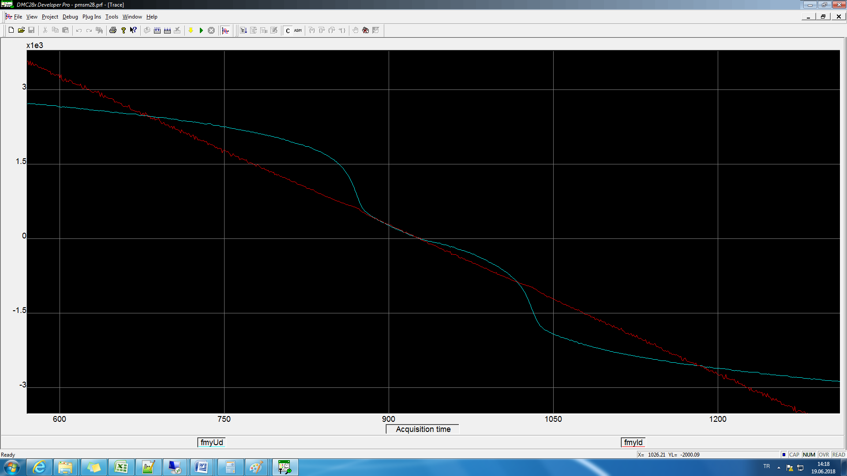

Slow loop log if (2 == cLogcntr)2ms’de bir

20kHz current loop

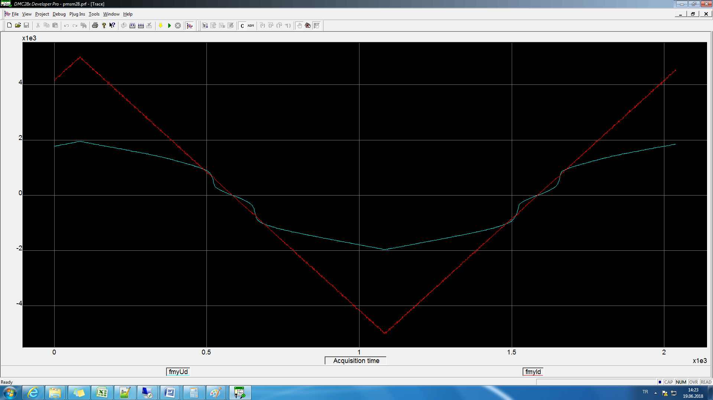

Slow loop log if (2 == cLogcntr) 2ms’de bir

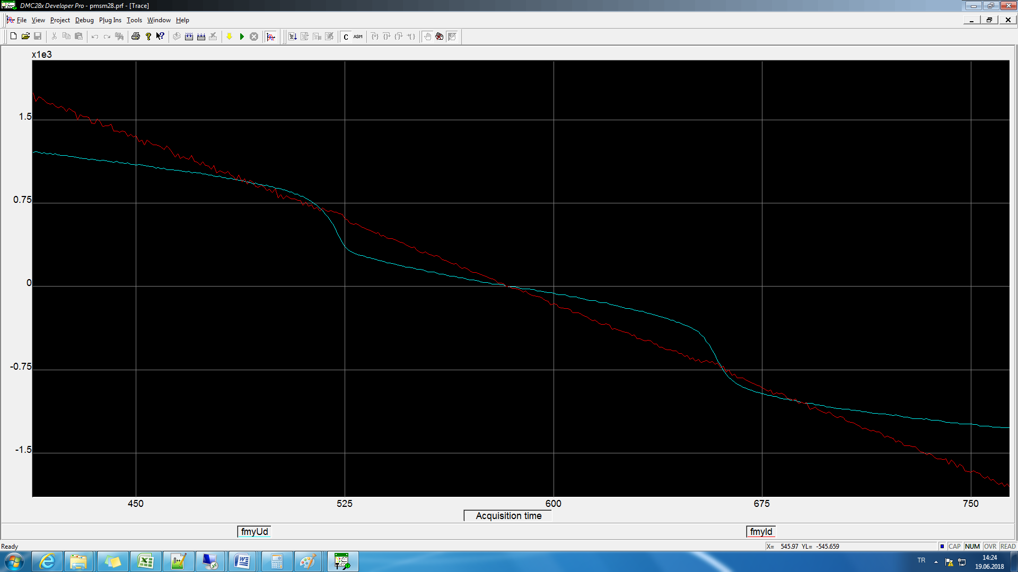

10kHz current loop

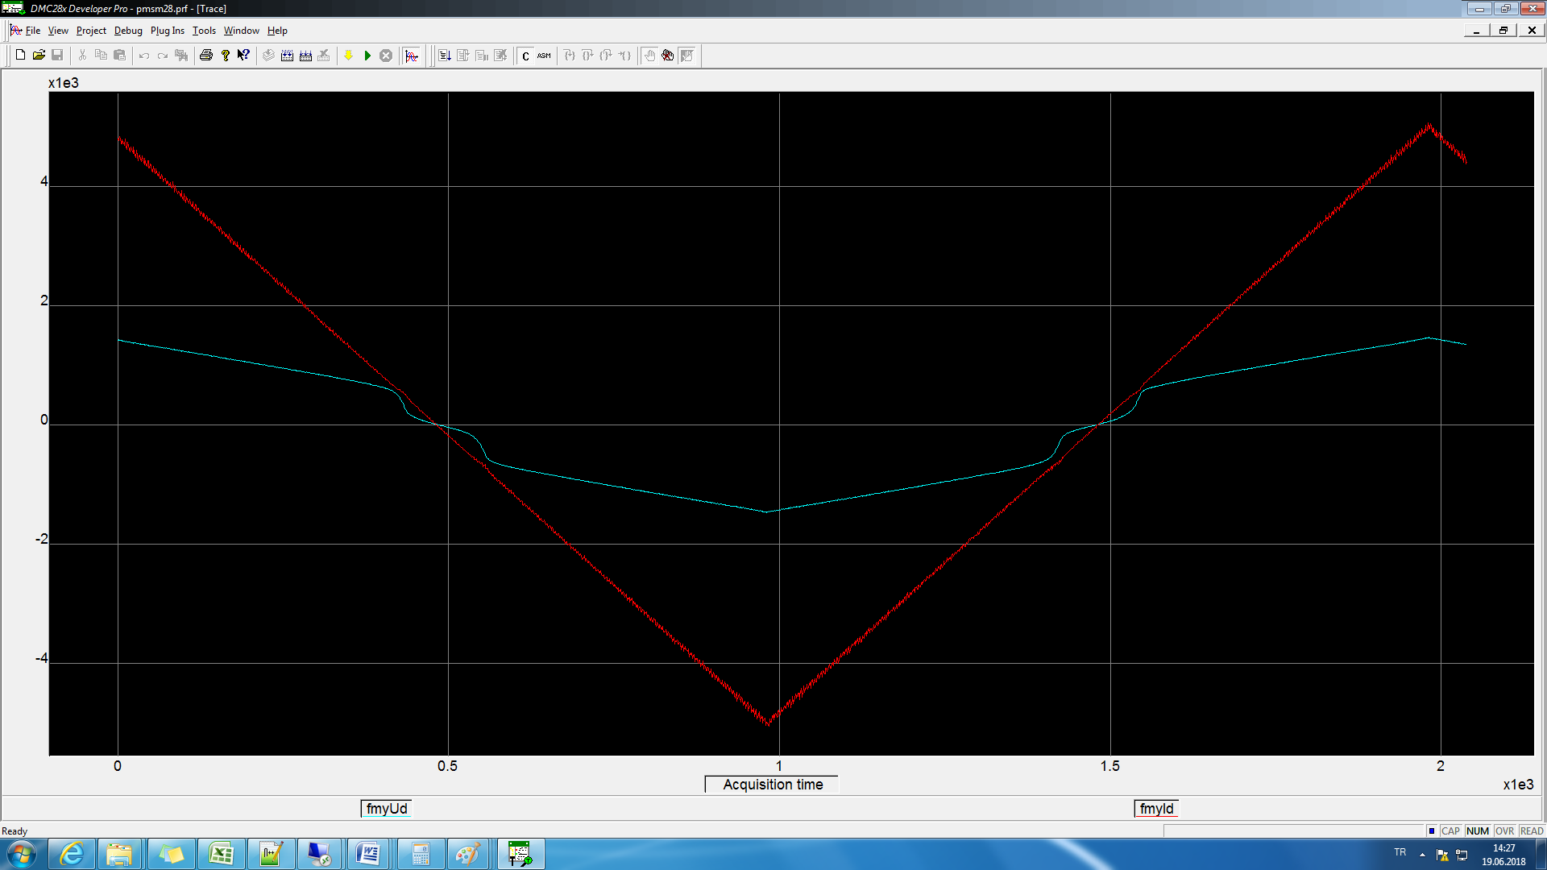

Slow loop log if (2 == cLogcntr) 2ms’de bir

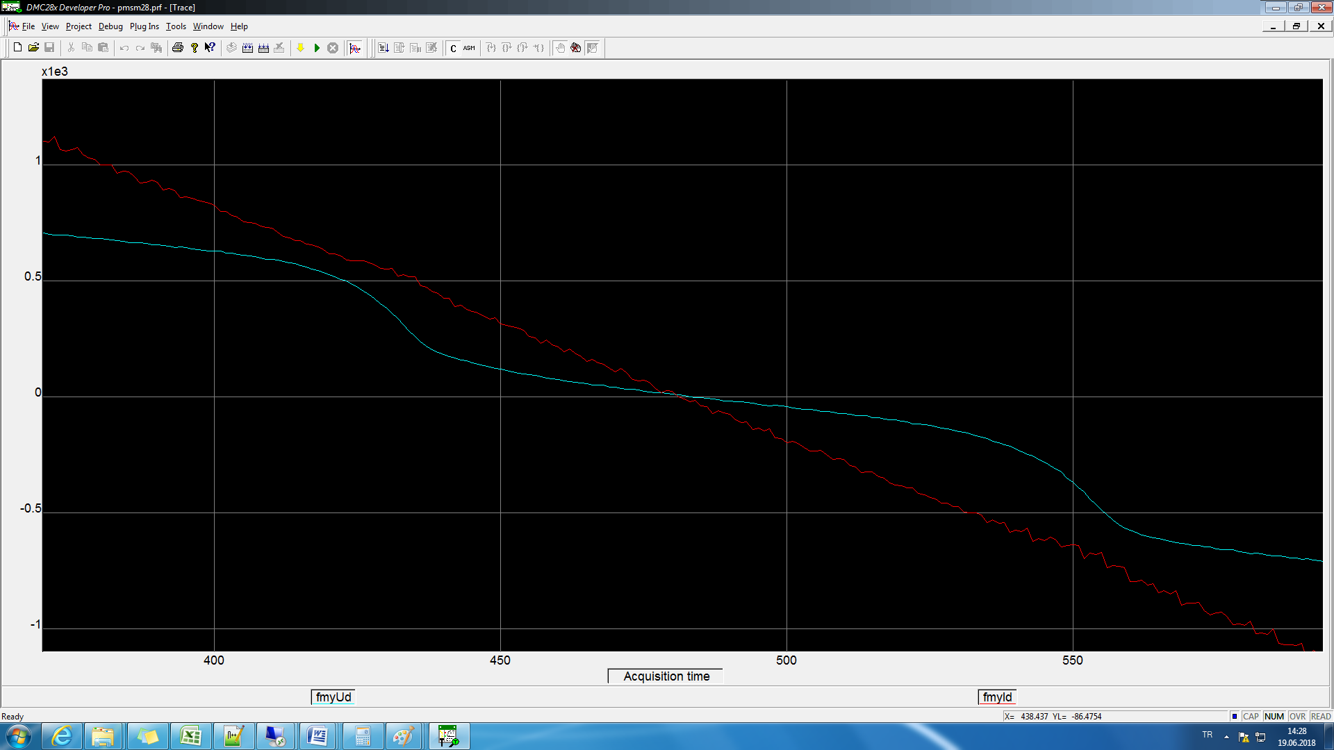

100kHz current loop

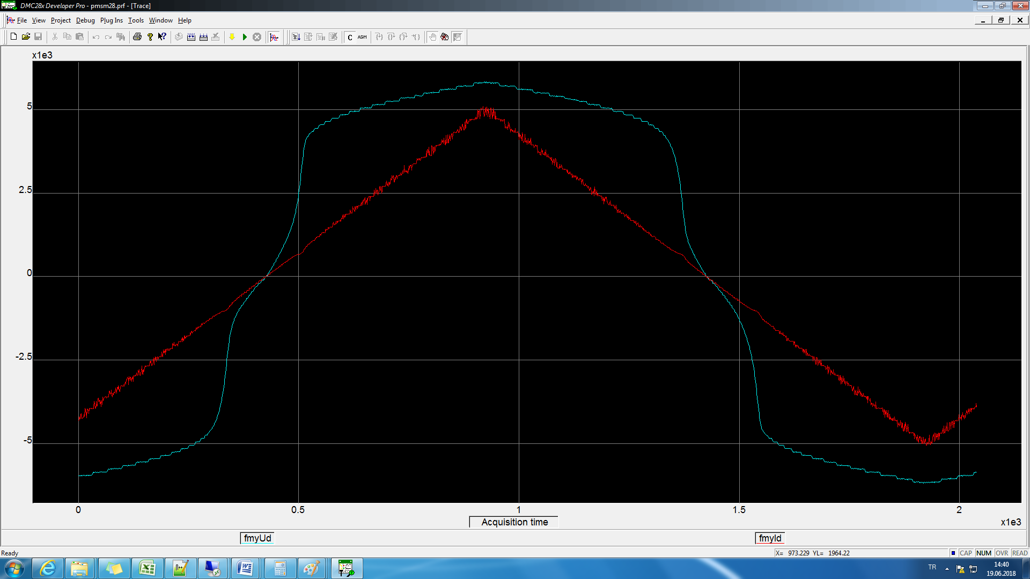

Slow loop log if (2 == cLogcntr) 2ms’de bir

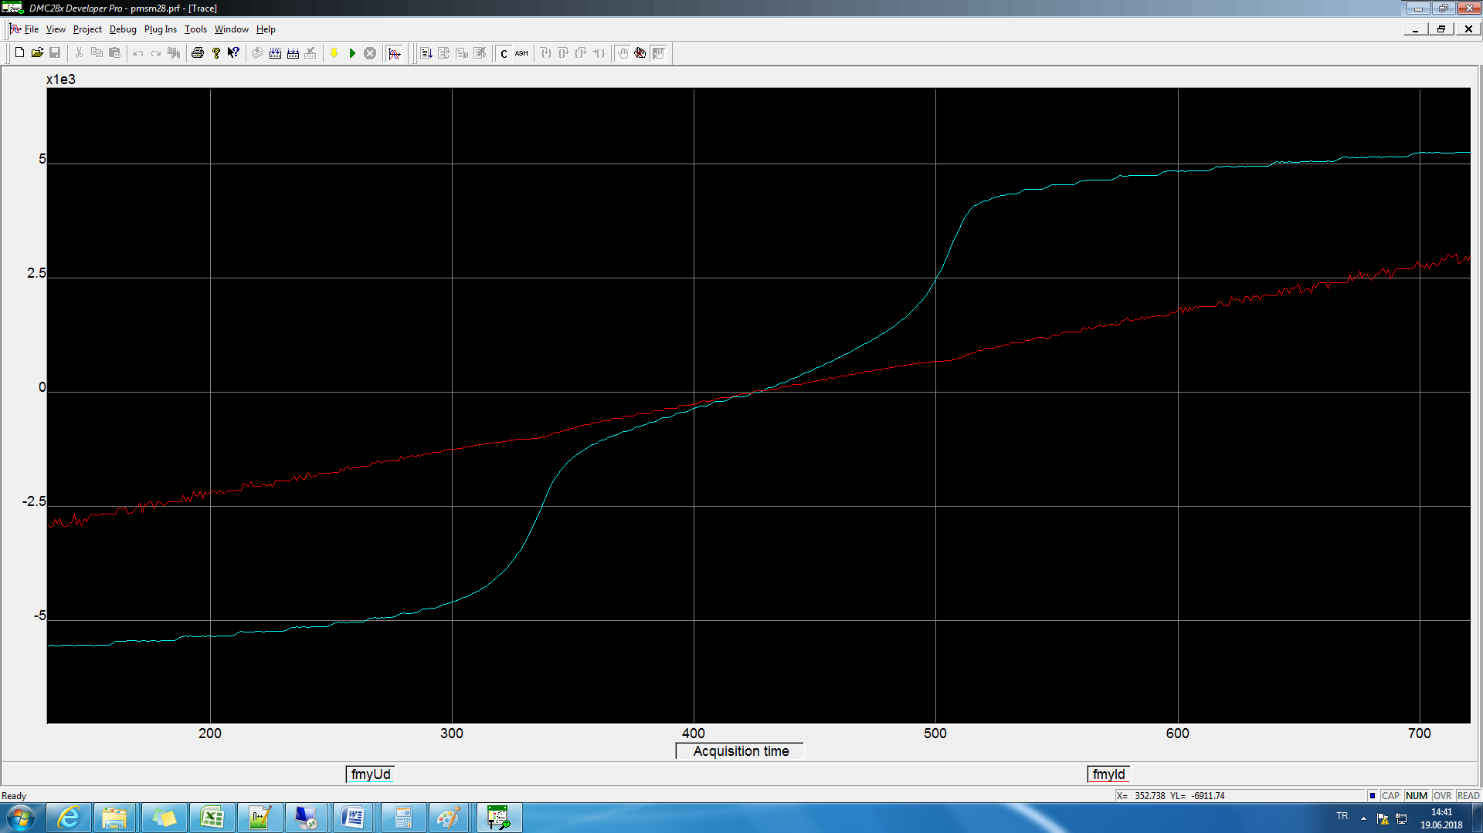

21.06.2018

b-a indexe gore yapıldıloglaraynı Slow loop log if (2 == cLogcntr) 2ms’de bir

20kHz

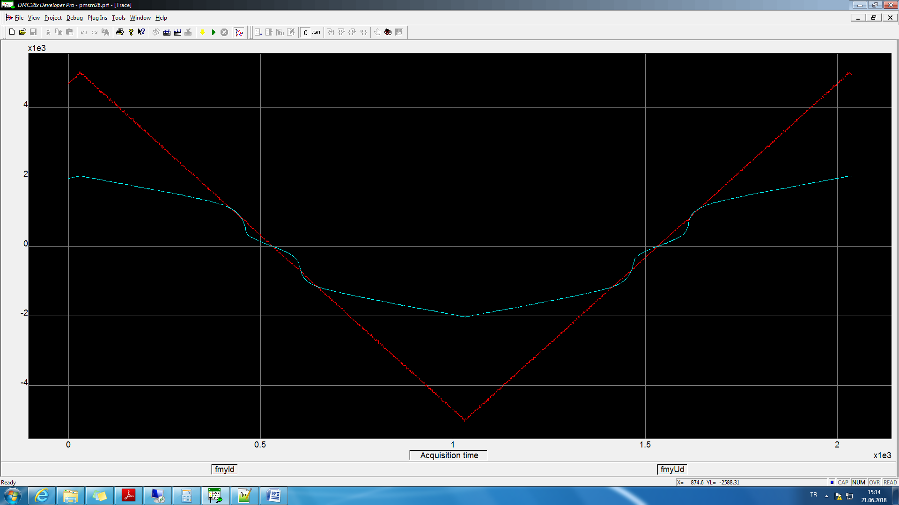

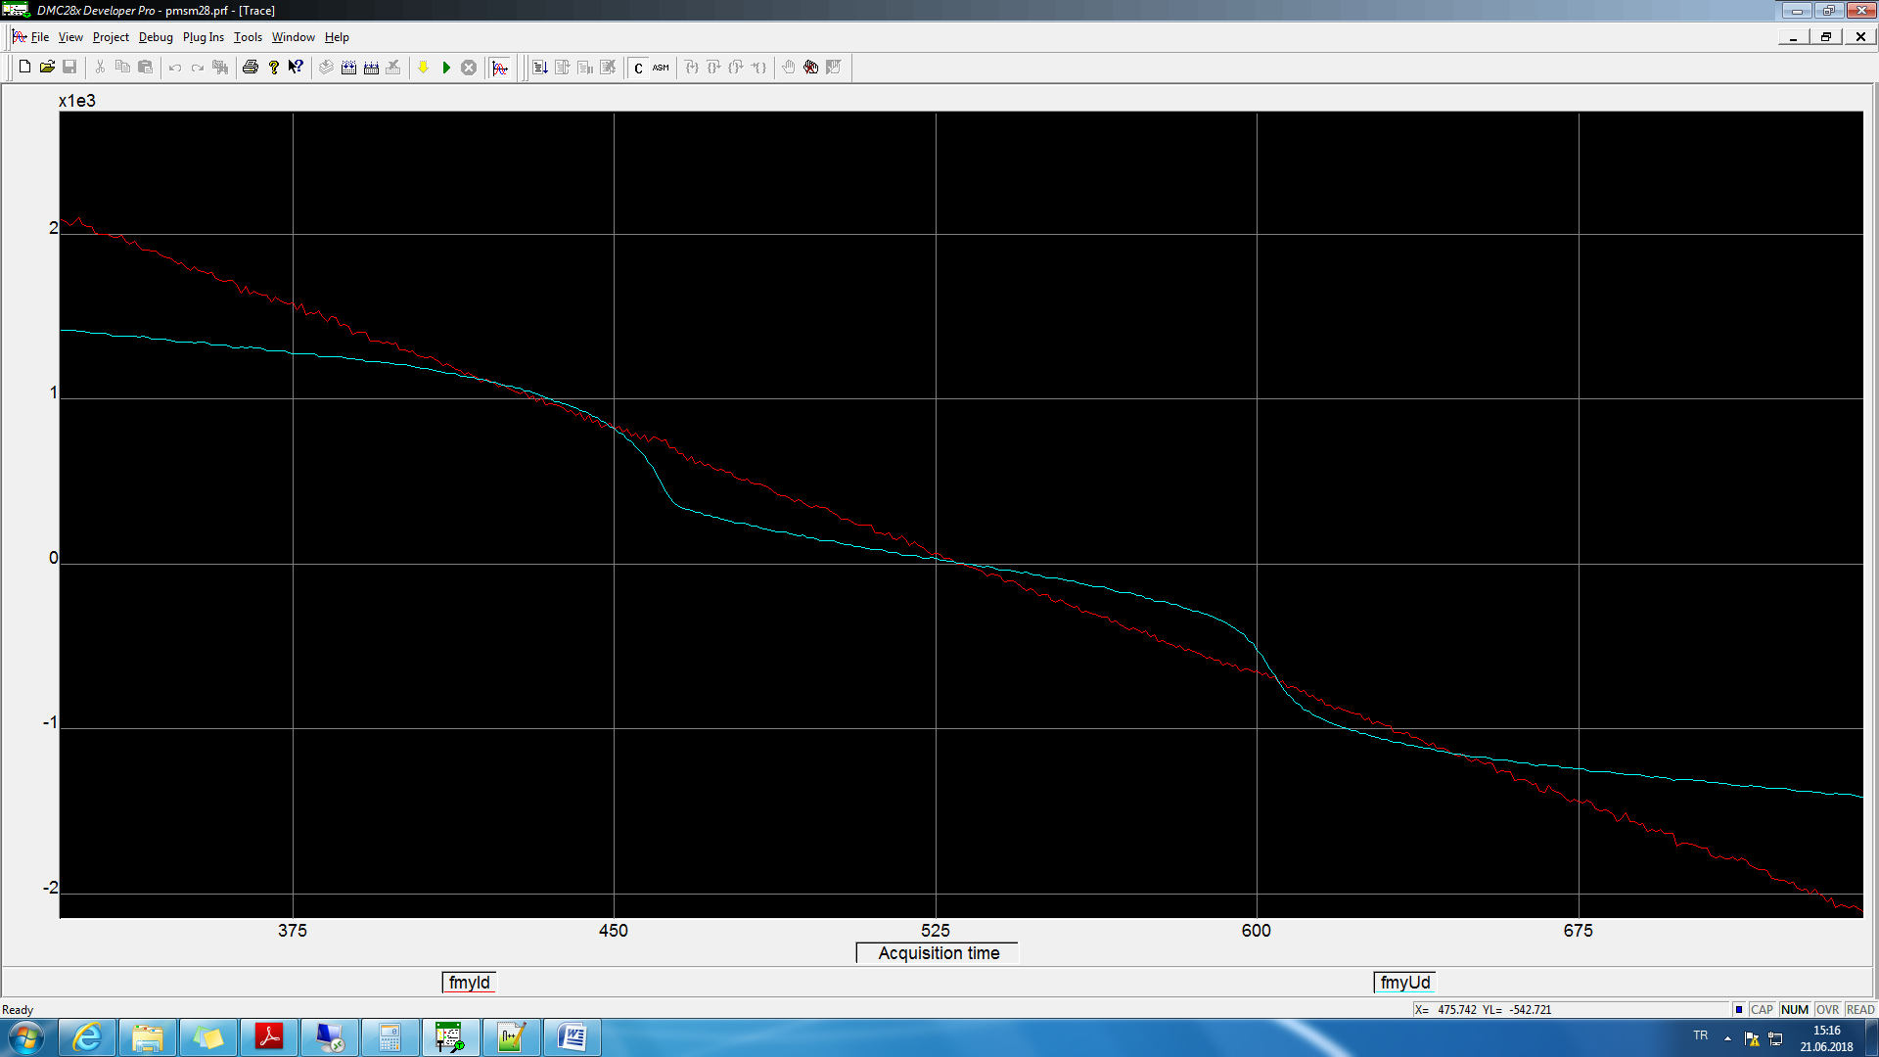

40kHz

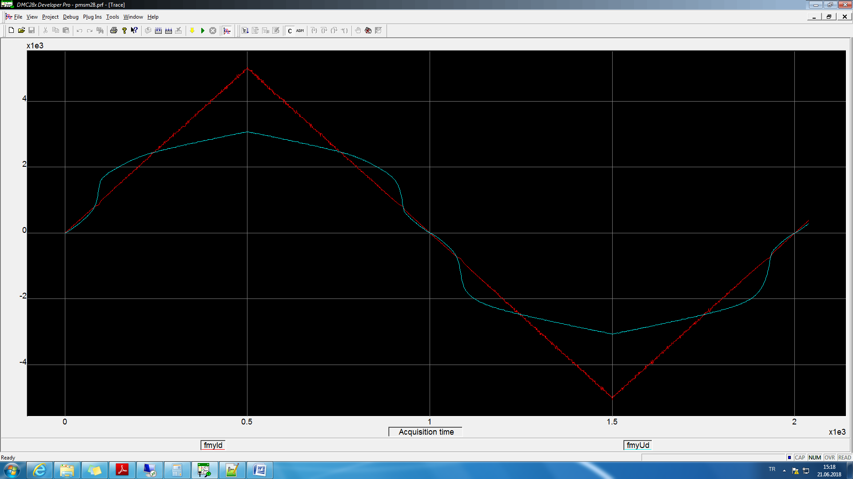

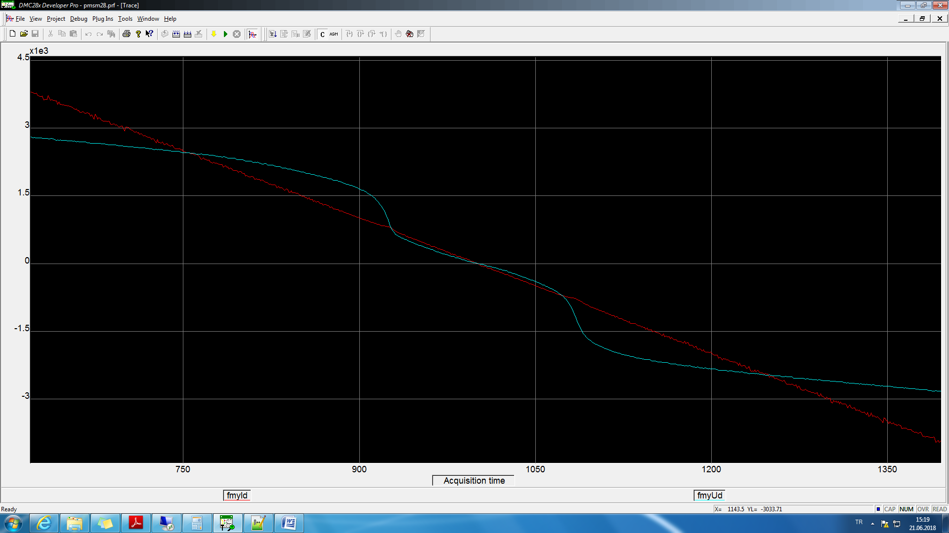

100kHz

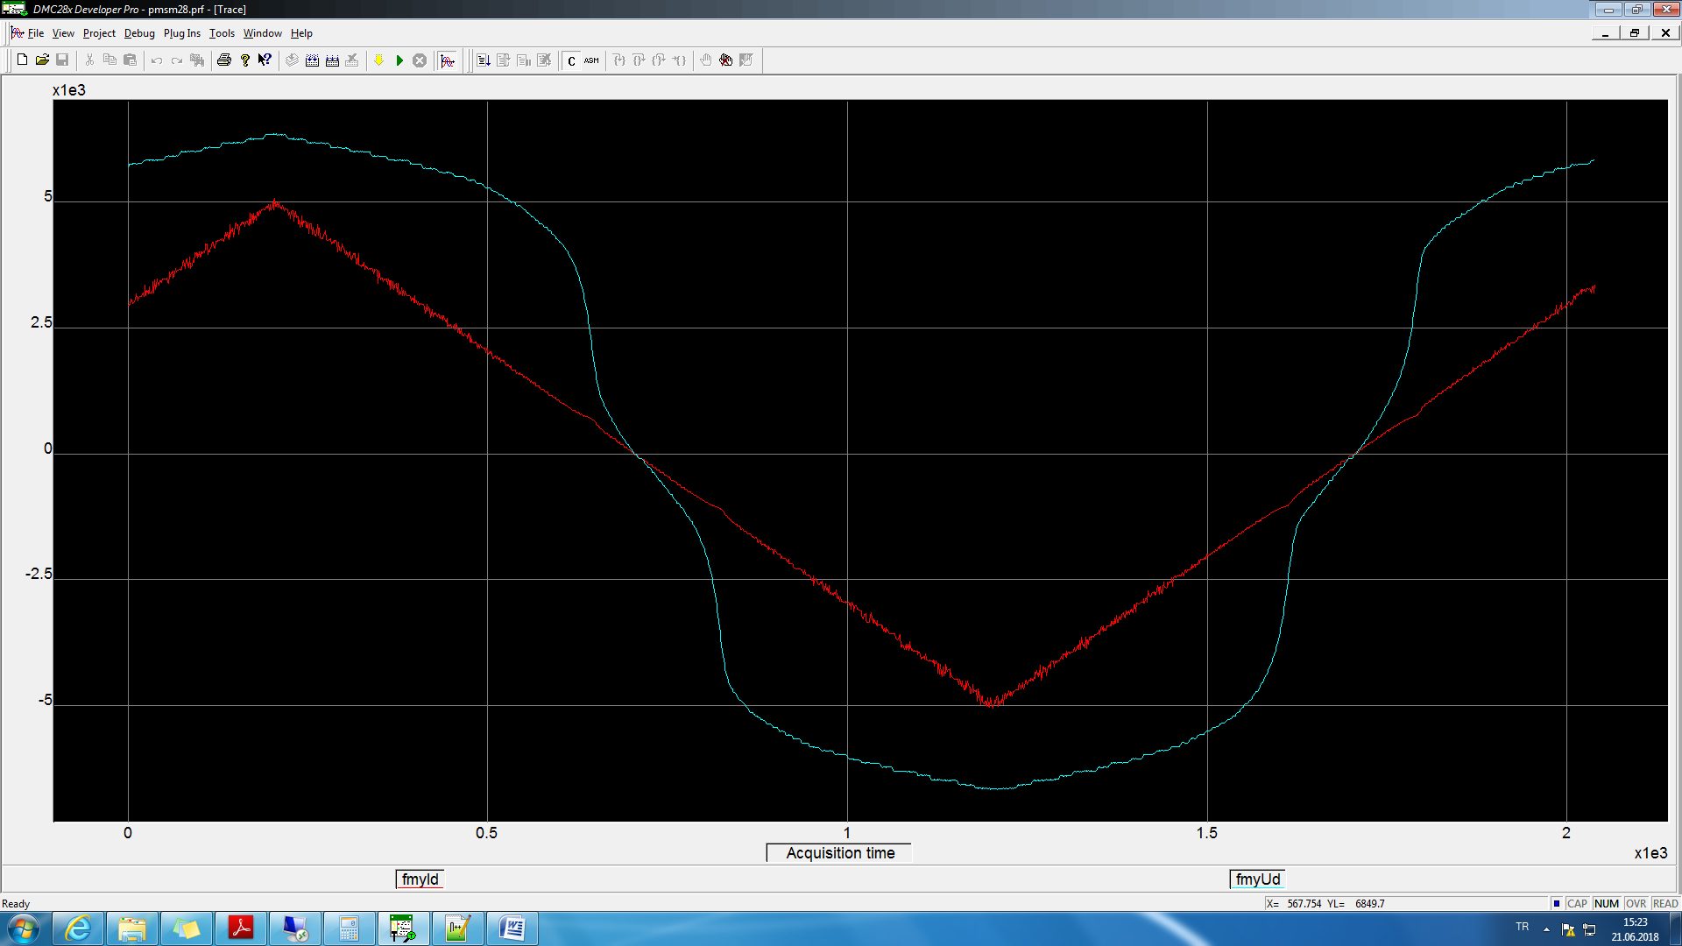

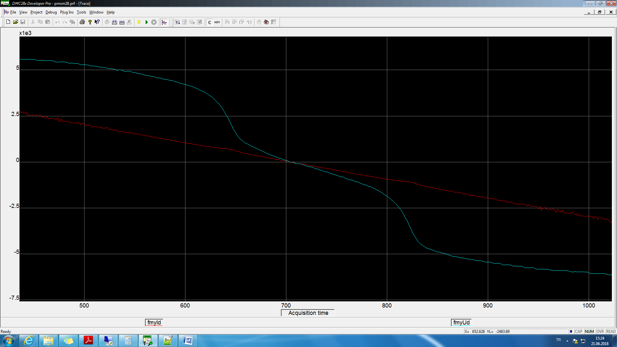

10kHz

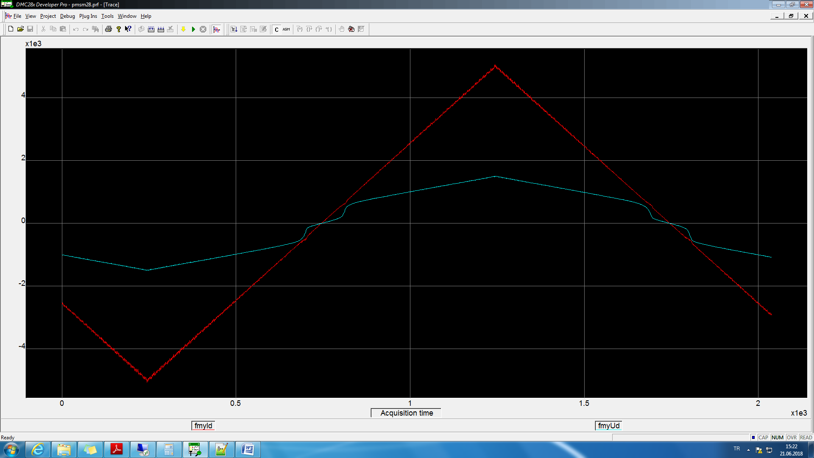

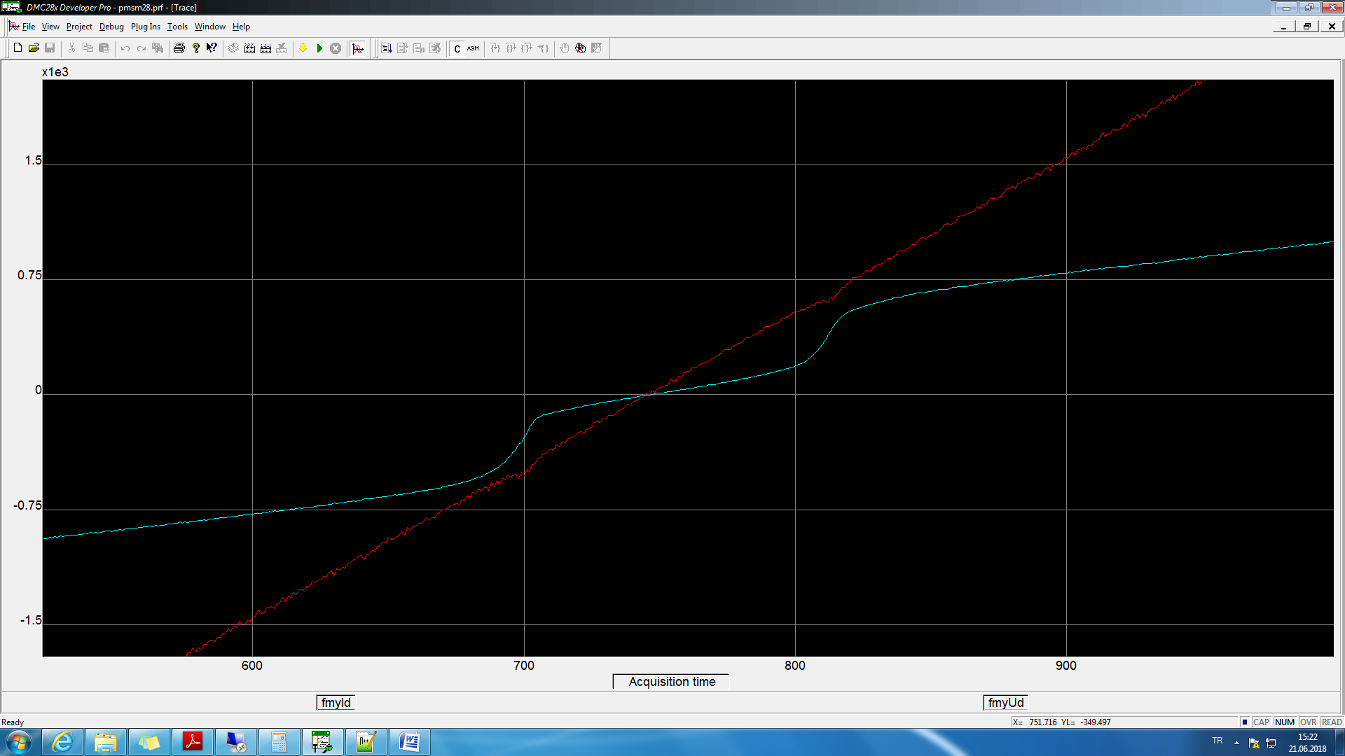

Step 100kHz

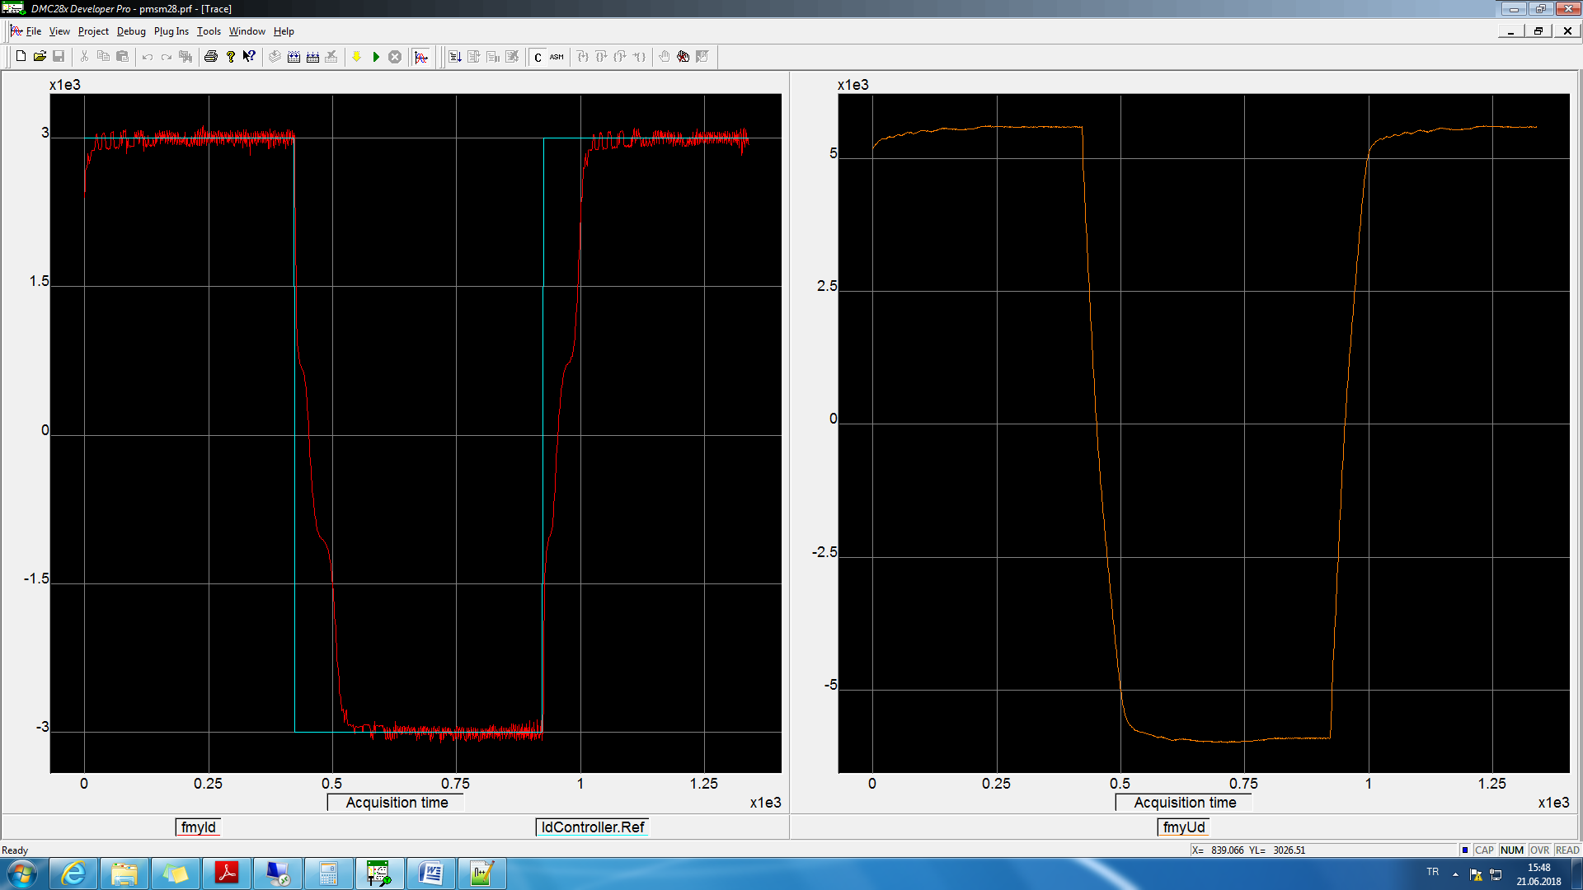

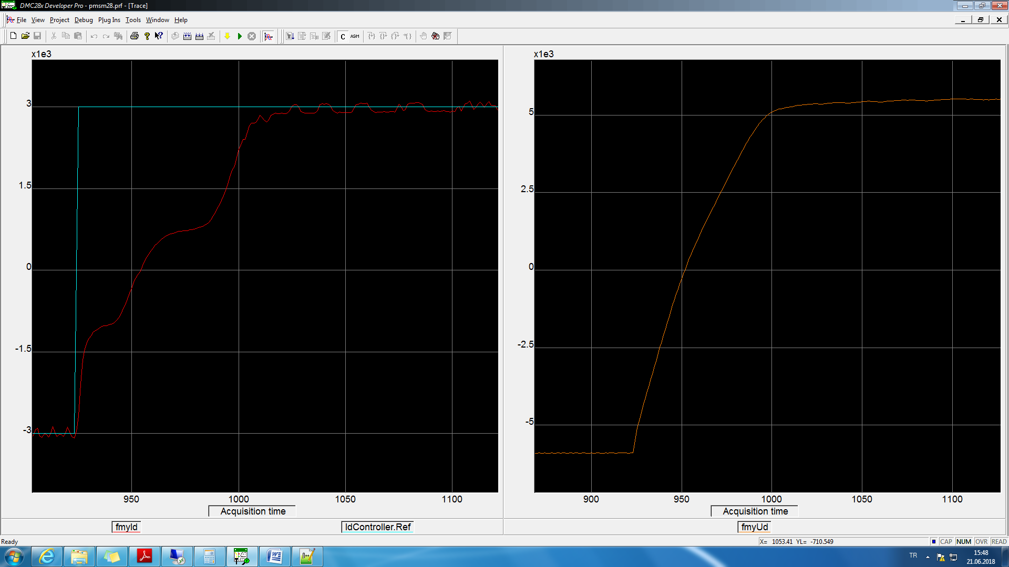

10kHz

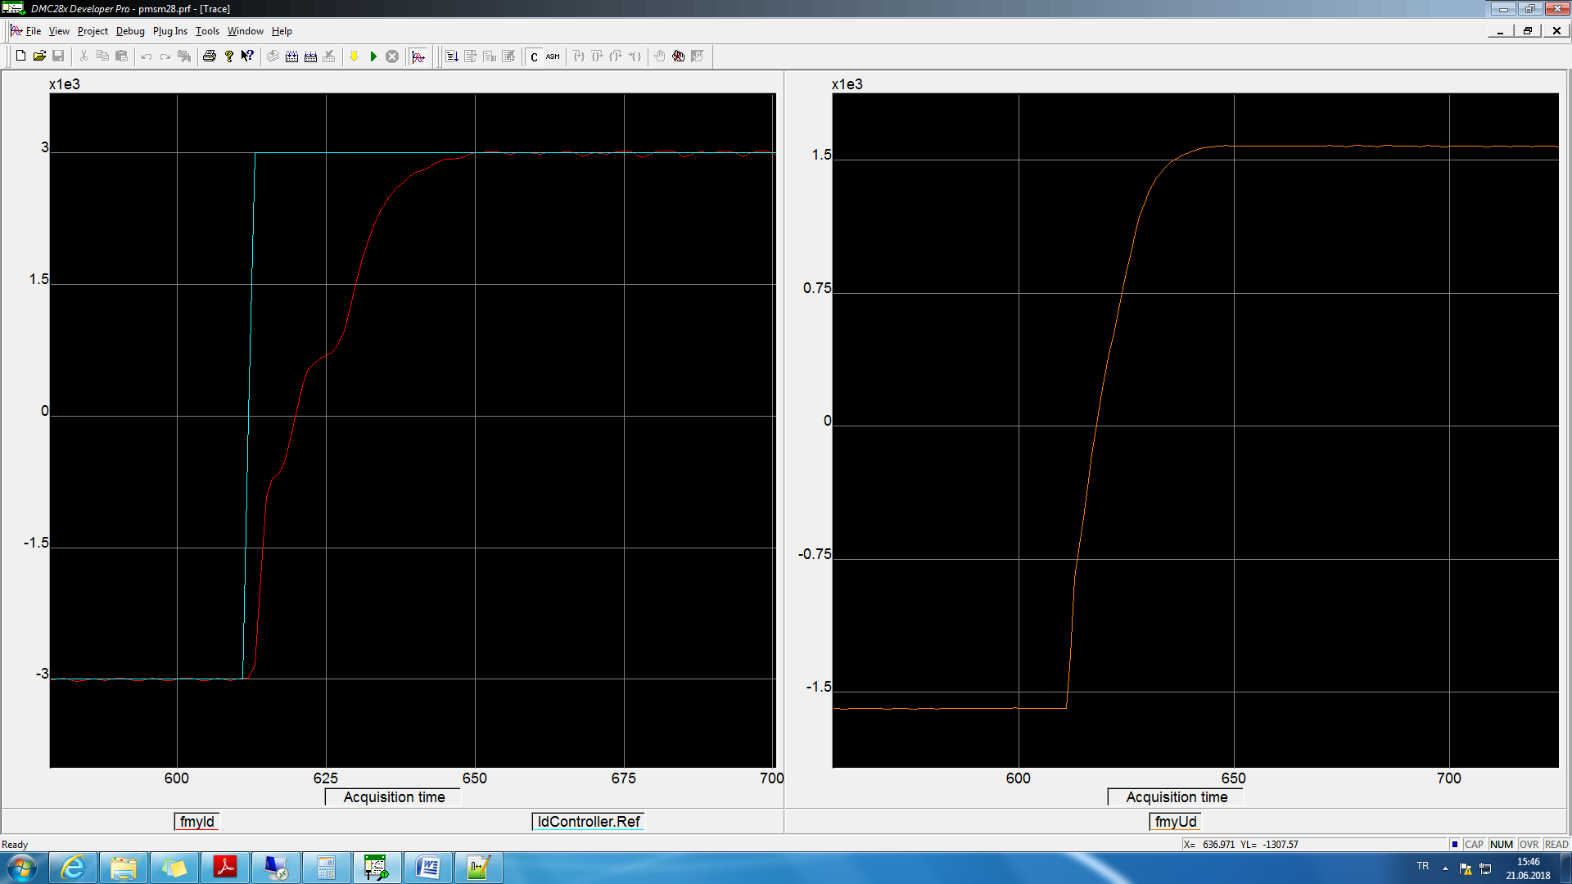

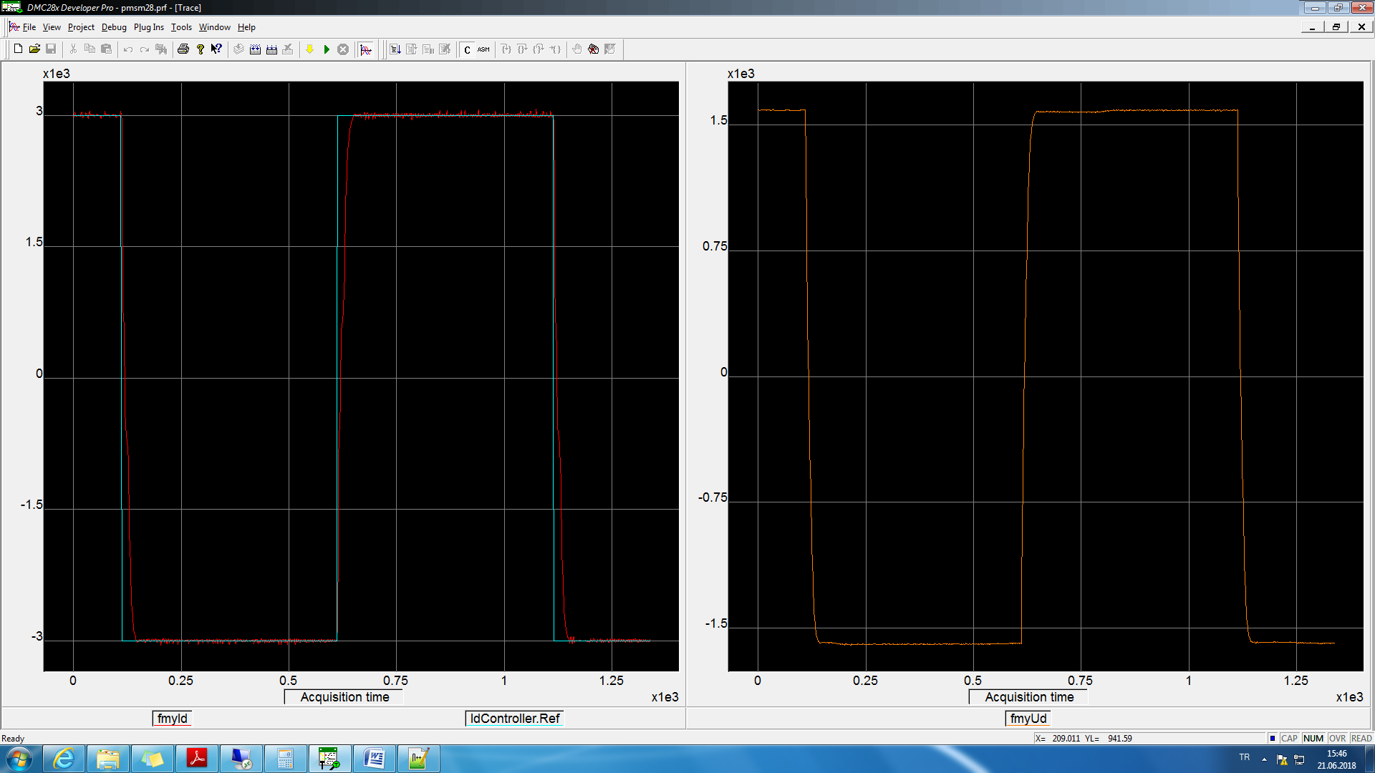

IdController.Ka = 0.2\*0.05;

100kHz

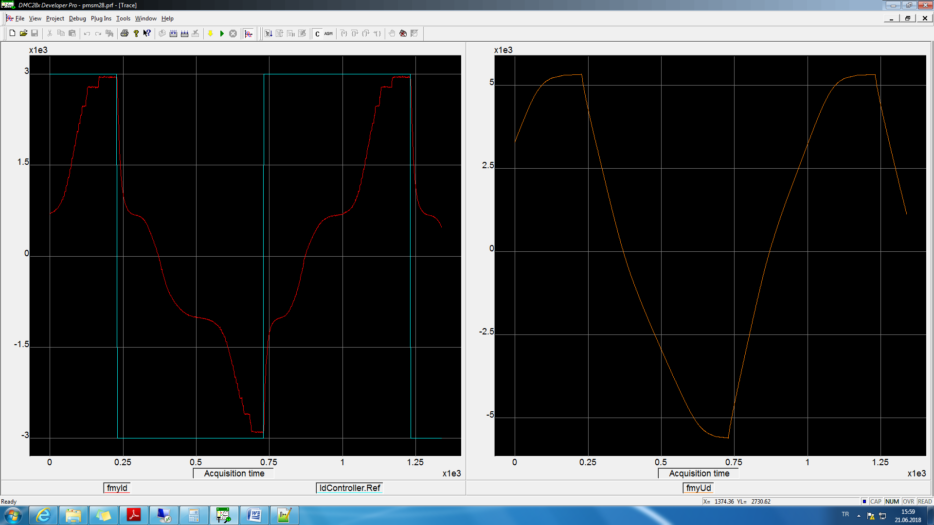

20kHz

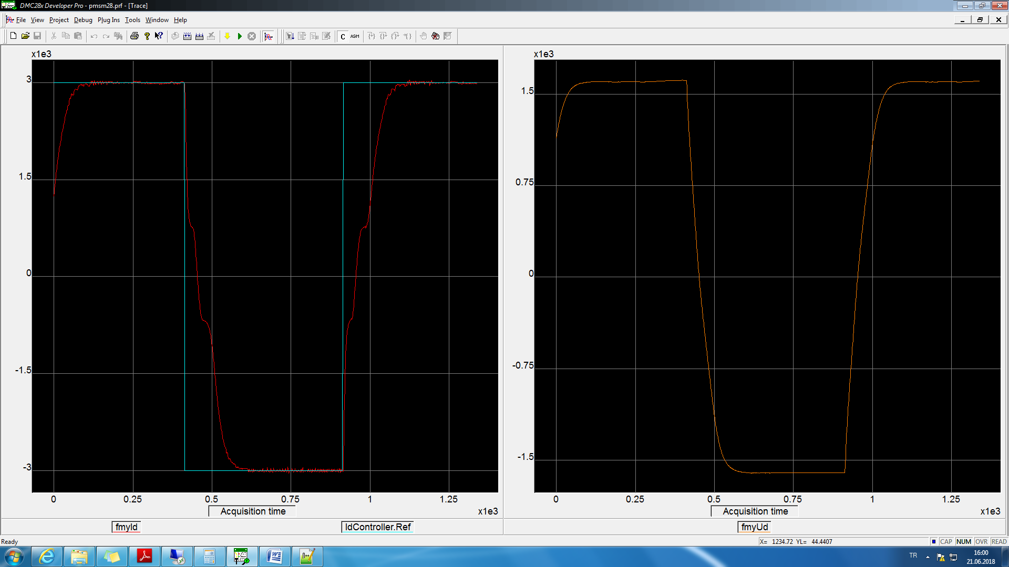

IdController.Ka = 5.0\*0.05;

20kHz

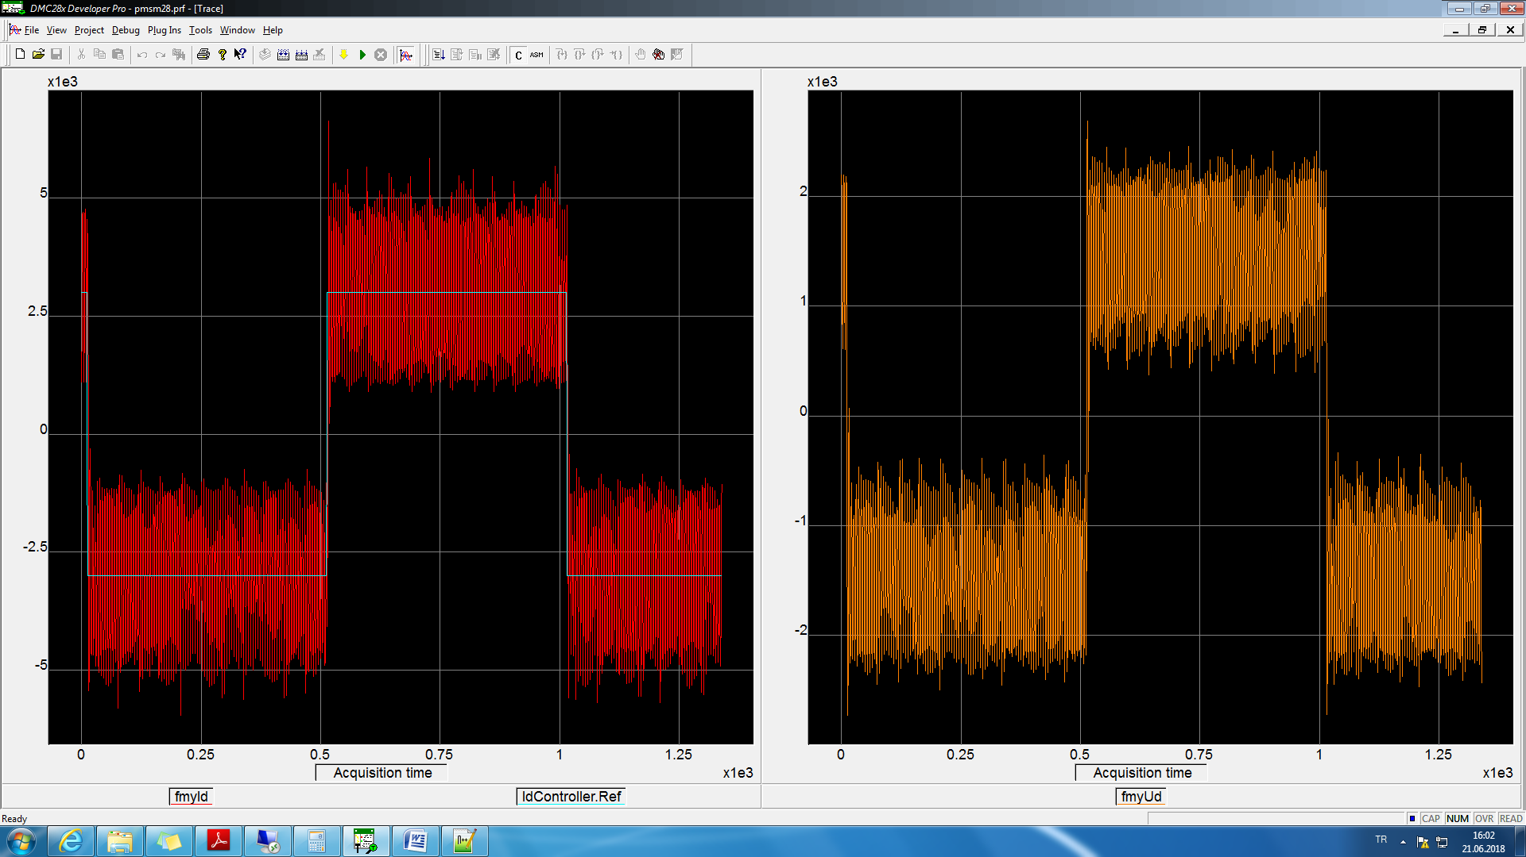

100kHz

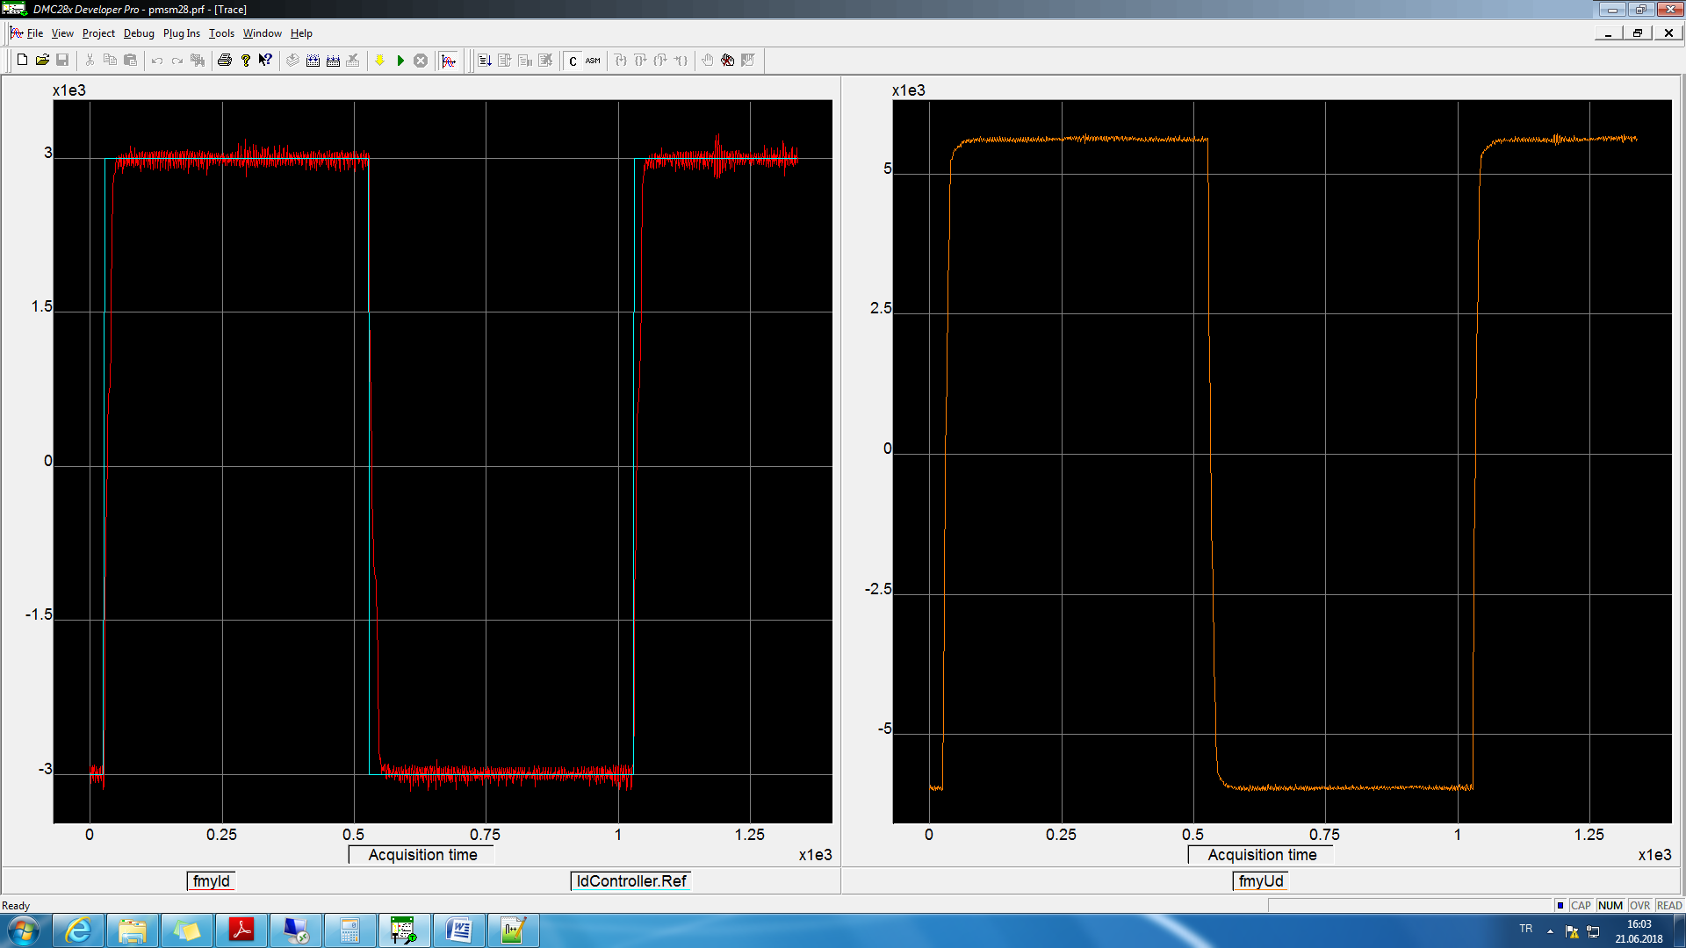

25.06.2018

20kHz

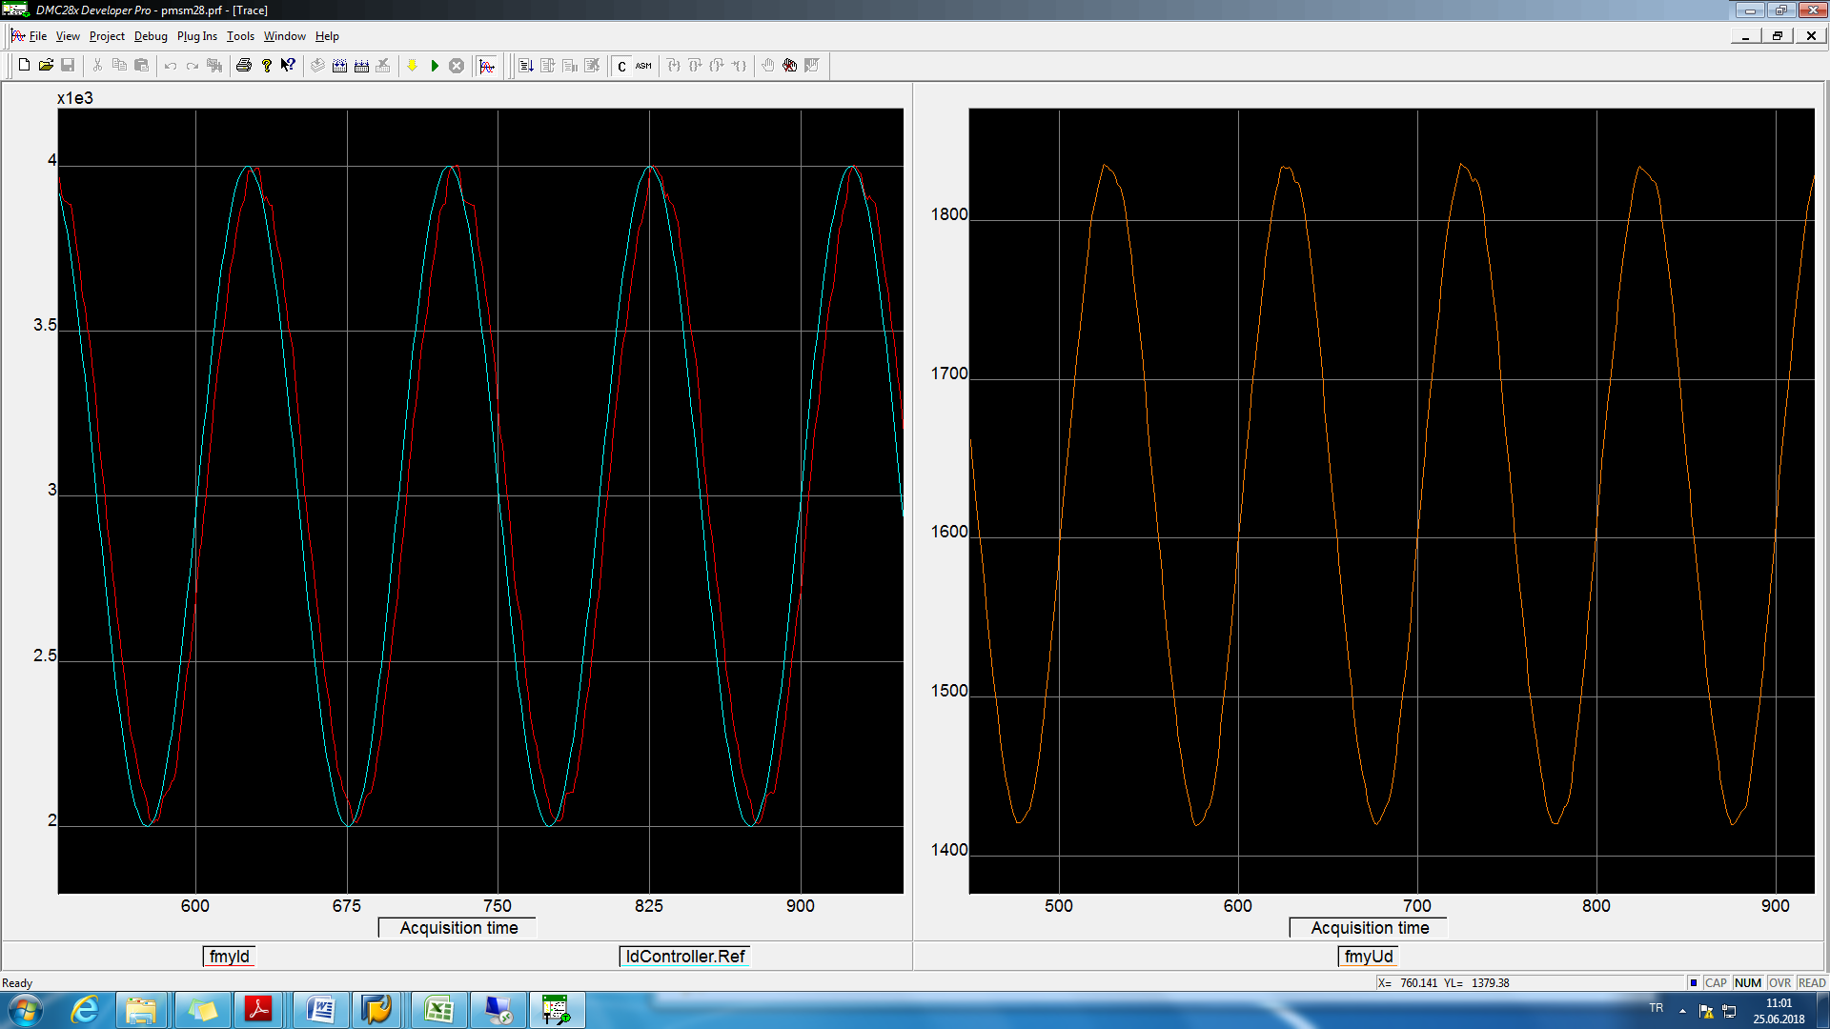

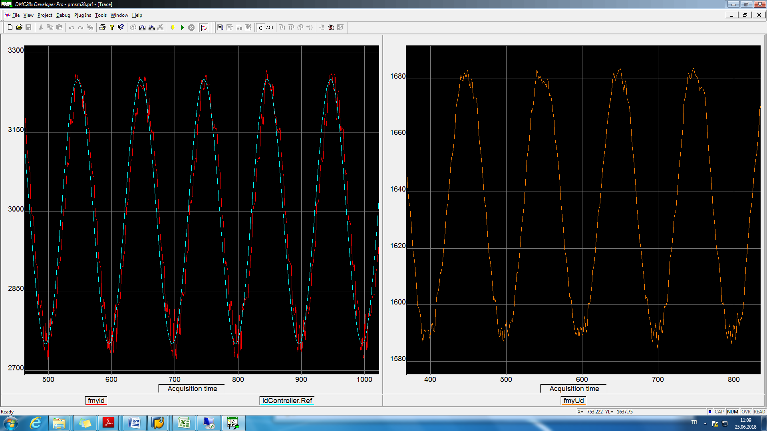

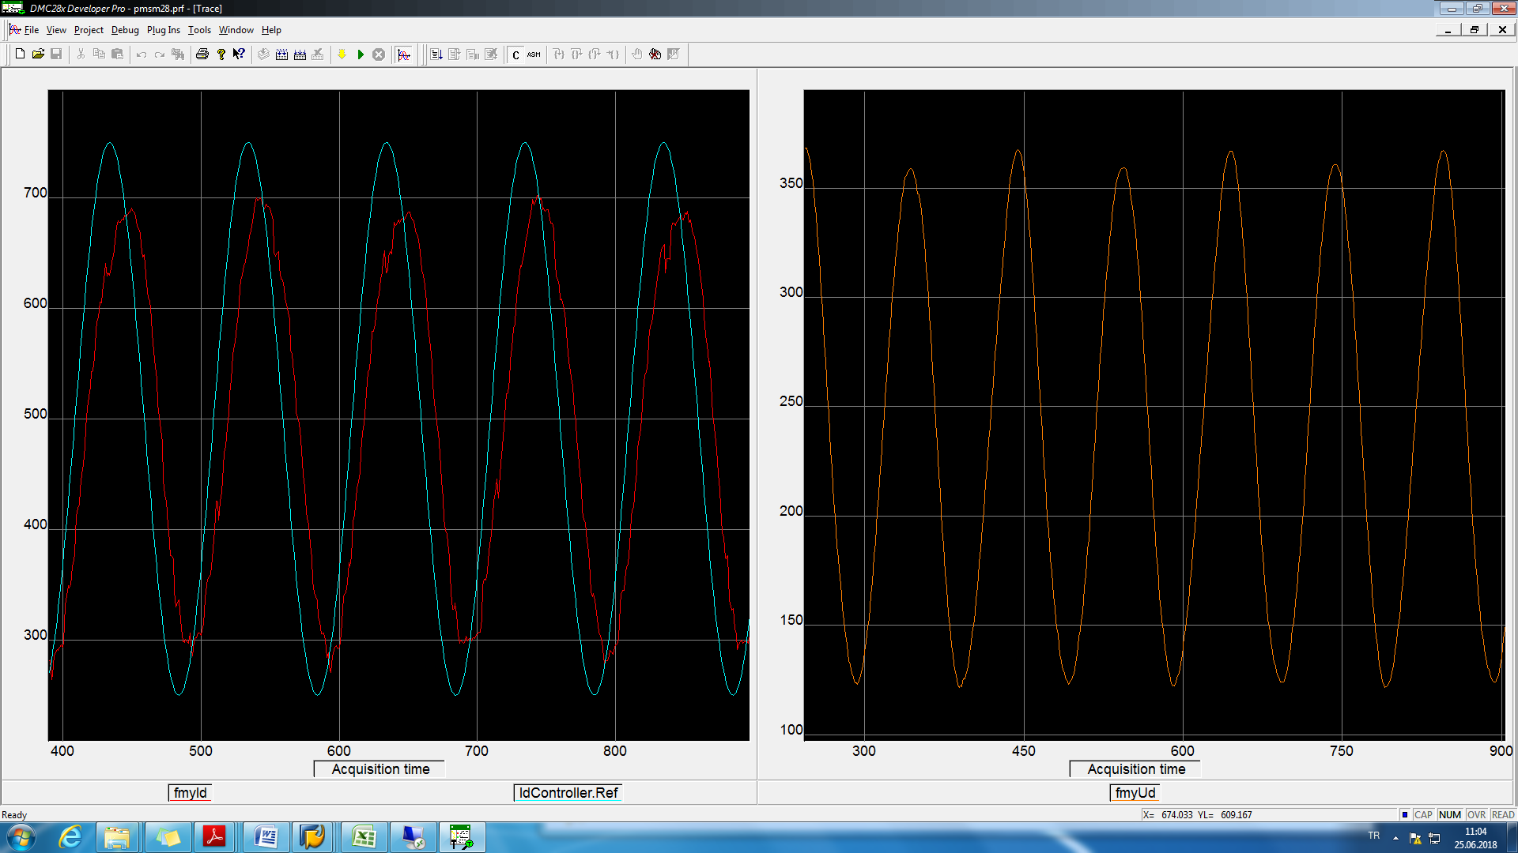

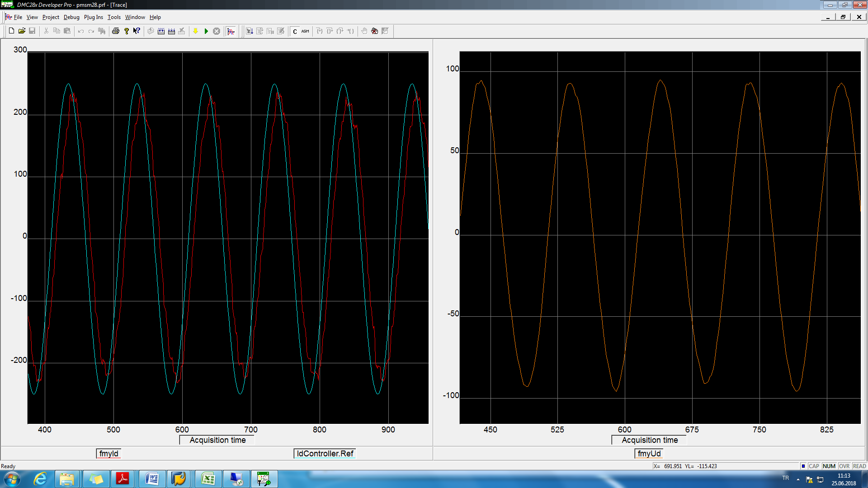

100kHz

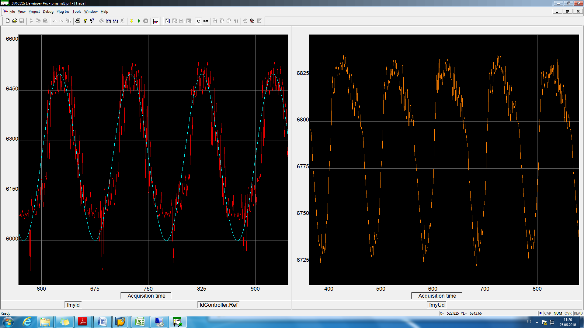

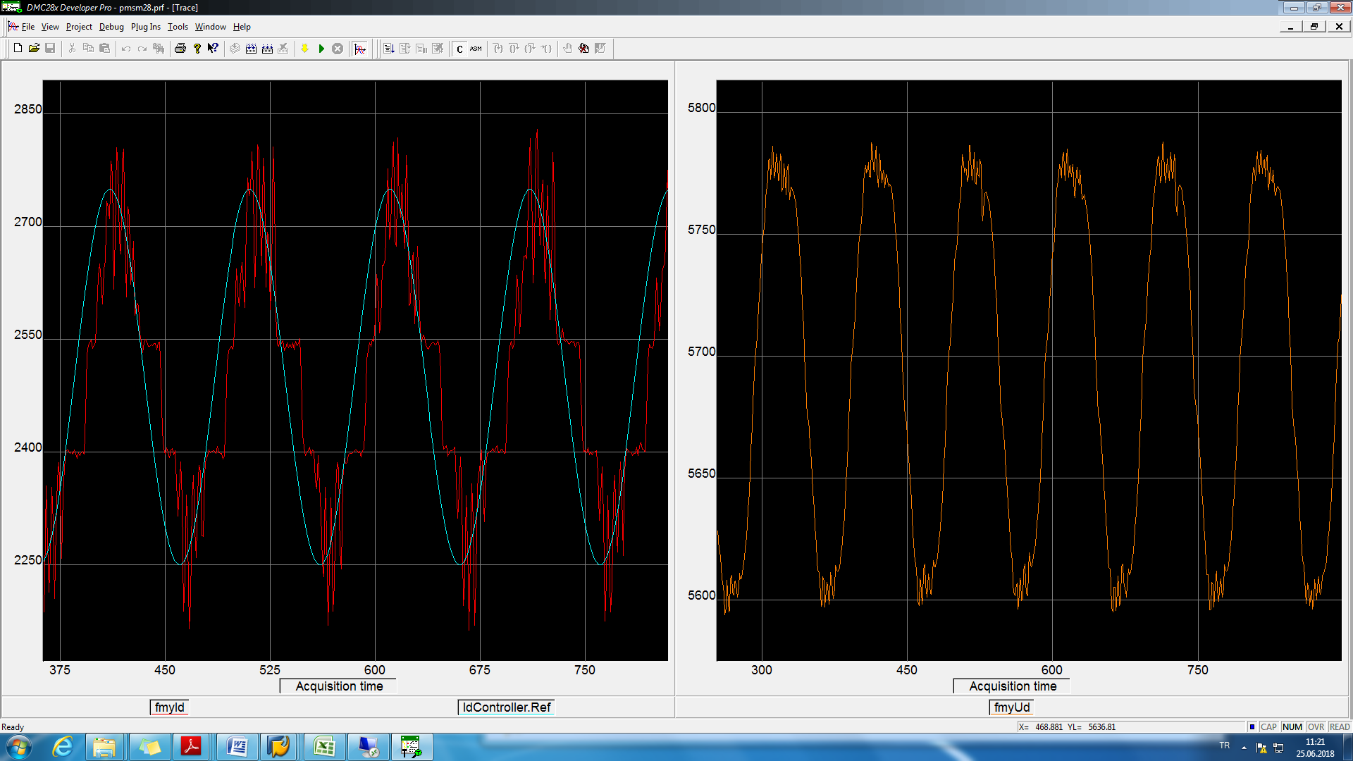

IdController.Ka = 0.2\*0.05

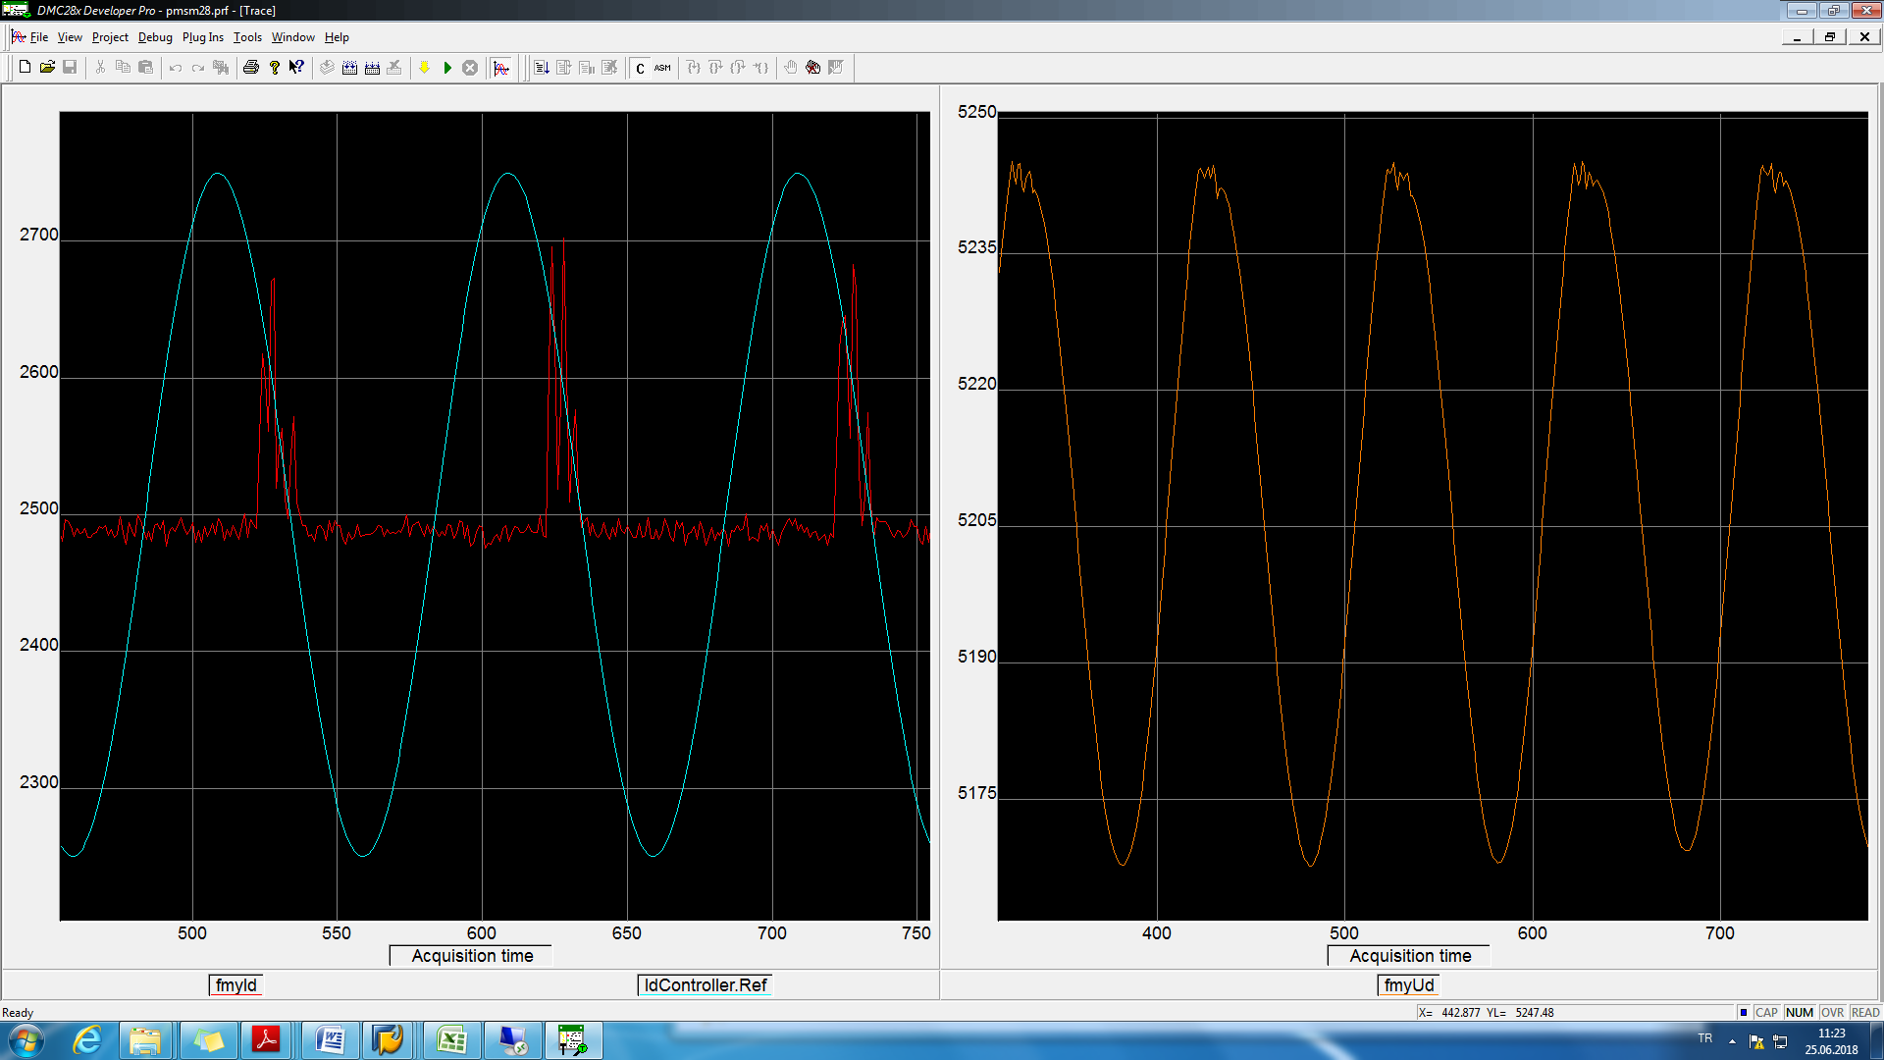

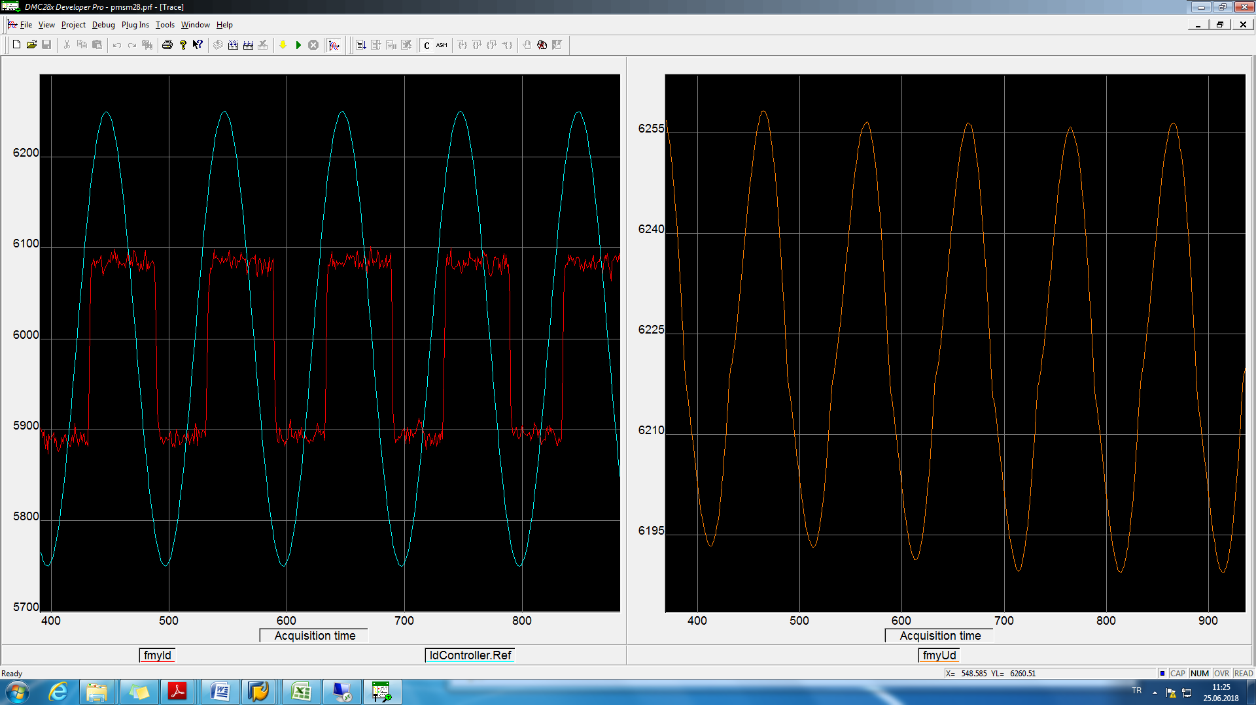

20kHzId&Vd graph





partI



Fitted curve coefficients

a^0..a^9

>>fittedCoeffs(1) = -2.3182; fittedCoeffs(2)=2.3159; fittedCoeffs(3) = 3.1649e-04; fittedCoeffs(4)= -4.7340e-06;

>>fittedCoeffs(5) = -6.1423e-10; fittedCoeffs(6) = 5.7700e-12; fittedCoeffs(7)=4.6816e-16; fittedCoeffs(8) = -3.0627e-18;

>>fittedCoeffs(9) = -1.3378e-22; fittedCoeffs(10) = 6.4007e-25;

partII



fittedCoeffs(1) = -4.7534e+03

fittedCoeffs(2) = 4.8038



fittedCoeffs(1) = -4.3928e+03

fittedCoeffs(2) = 4.6010

partIII



>>fittedCoeffs(1) = 4.5289e+03, >>fittedCoeffs(2) = 4.6803



>>fittedCoeffs(1) = 4.3690e+03

>>fittedCoeffs(2) = 4.5988



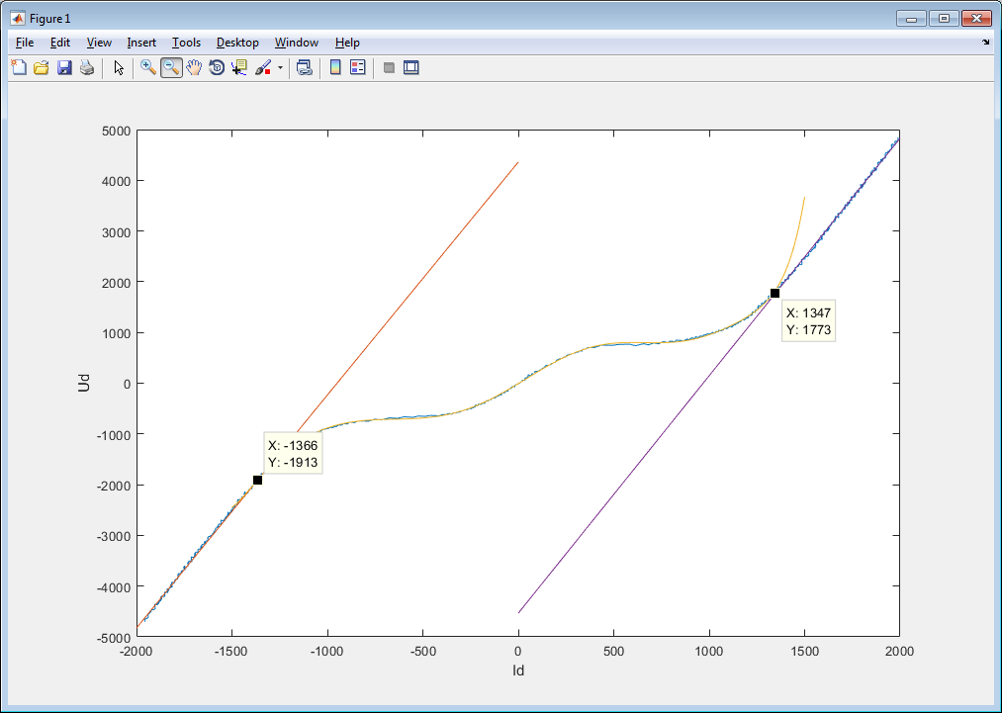

fittedcoe2.mat, fittedcoe3.mat, fittedcoe4.mat

26.06.2018

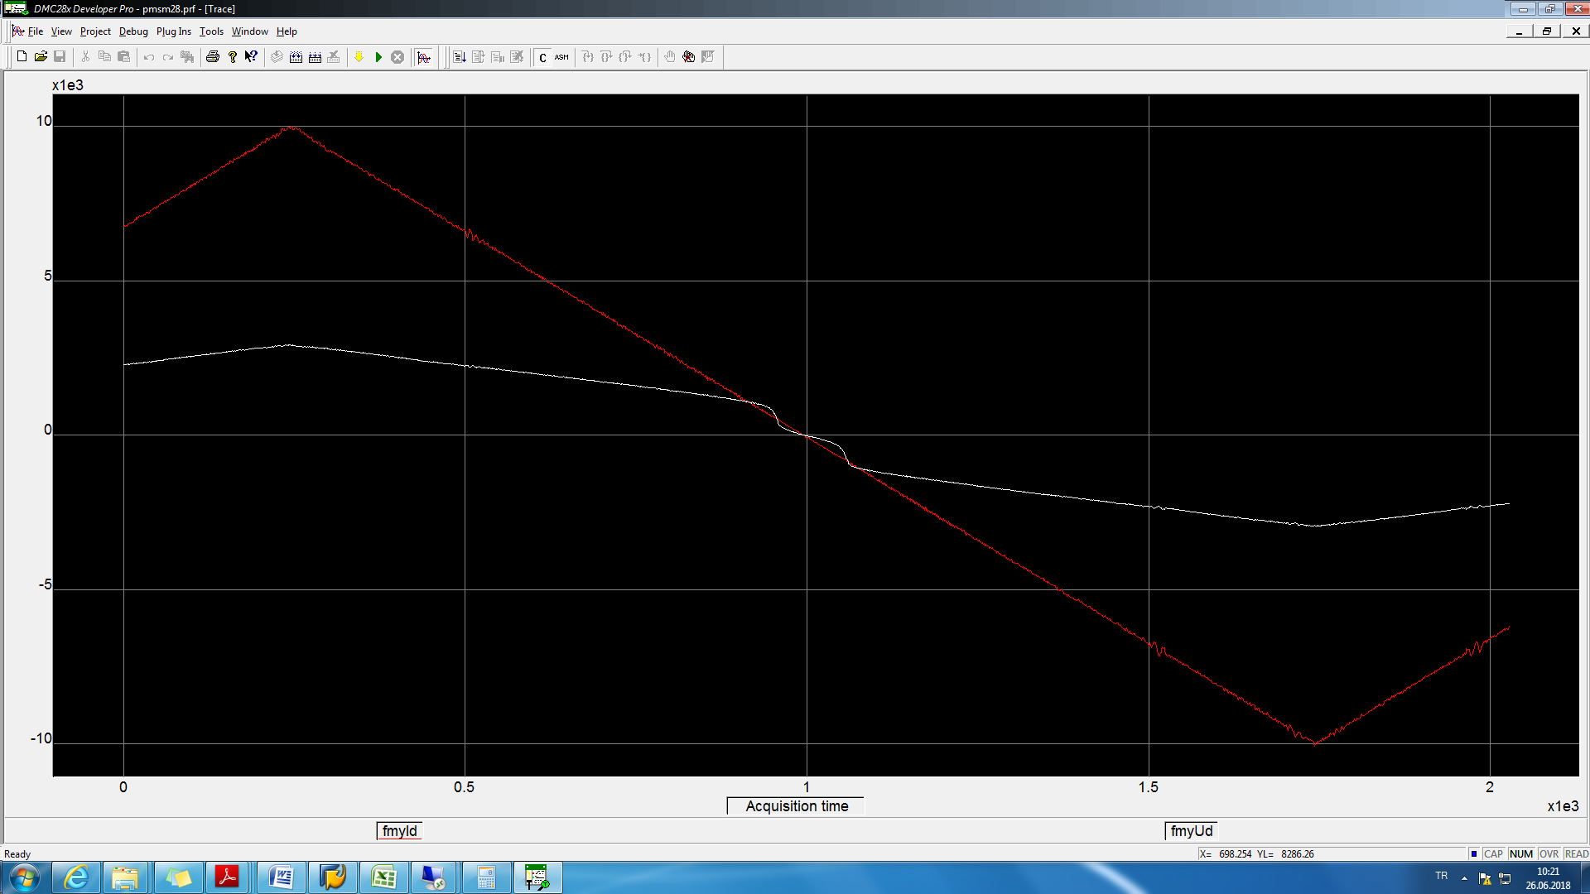

fittedcoe11.. fittedcoe18





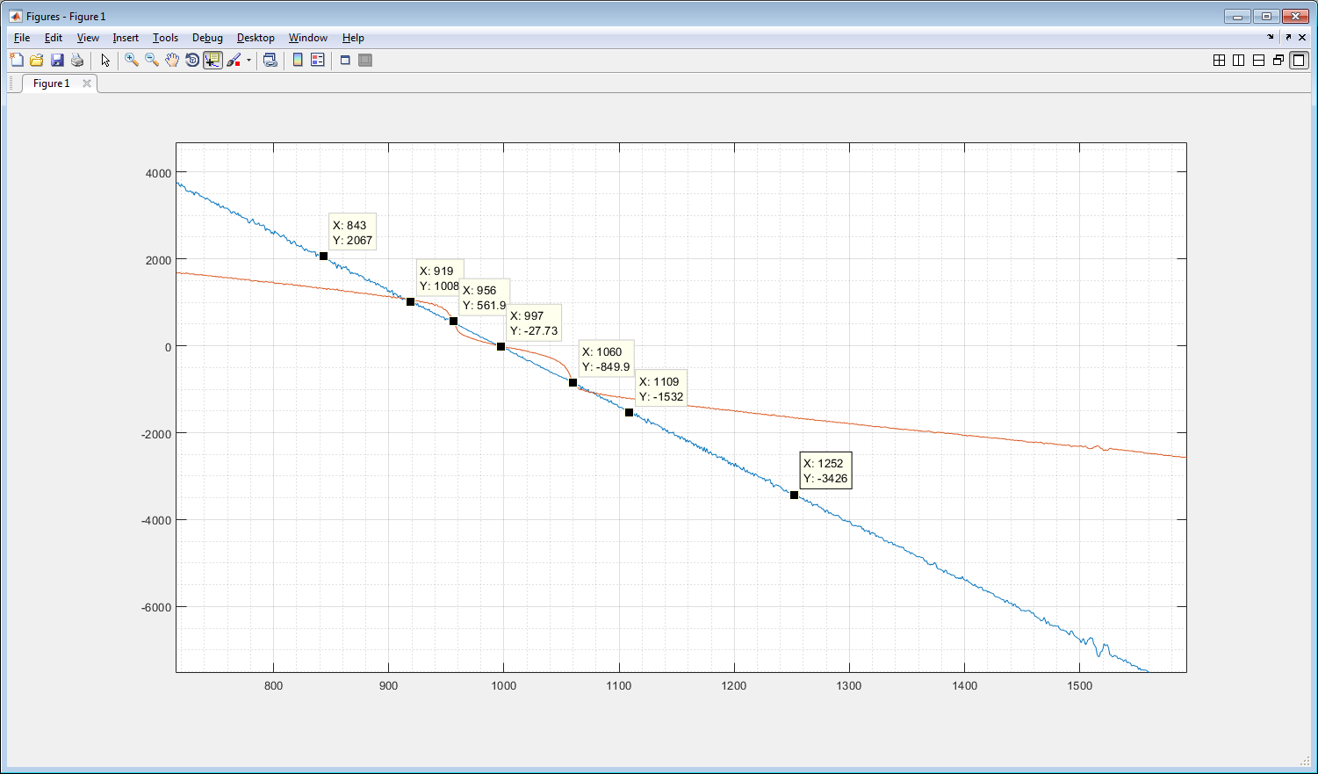

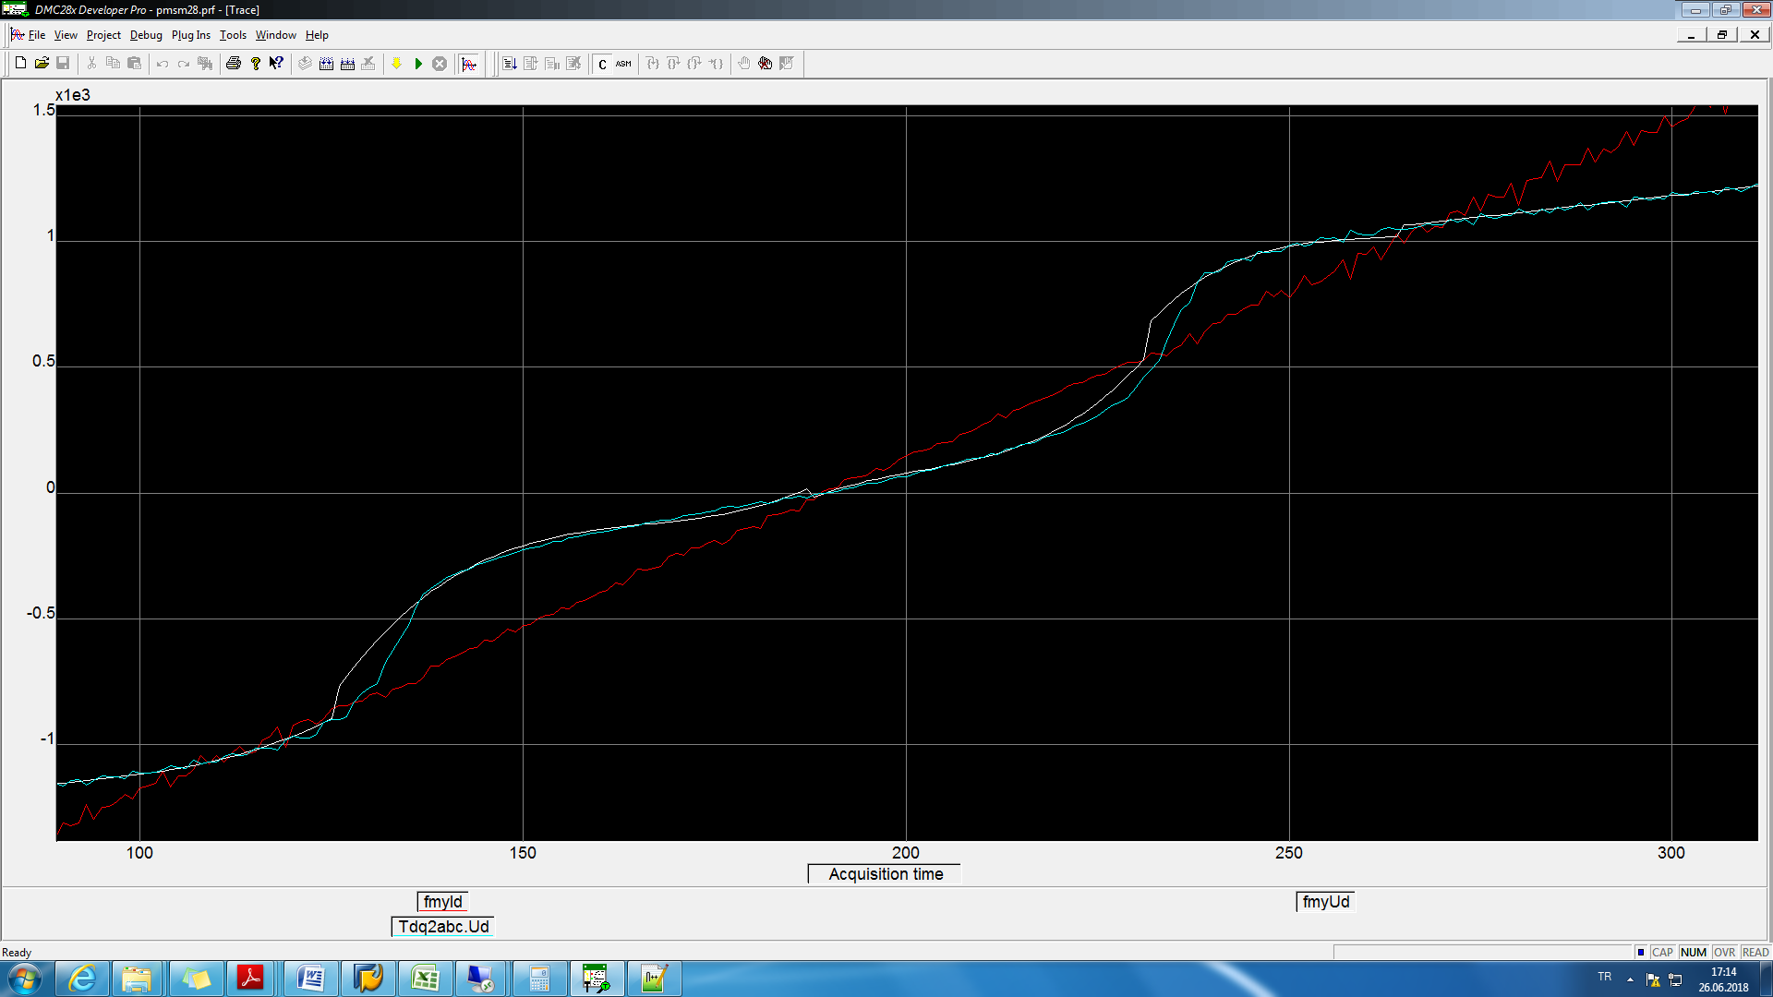

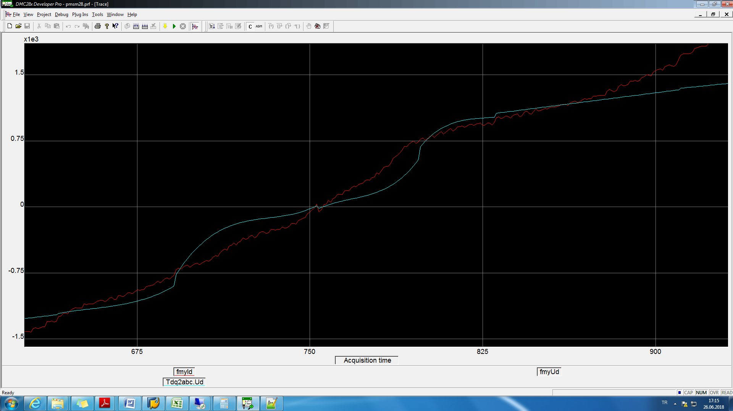

Üçkereölçümalındaveüstüsteaşağıdakigibiçizdirildi





Küsaratlarsonucuetkiliyoraşağıdagörüldüğügibi



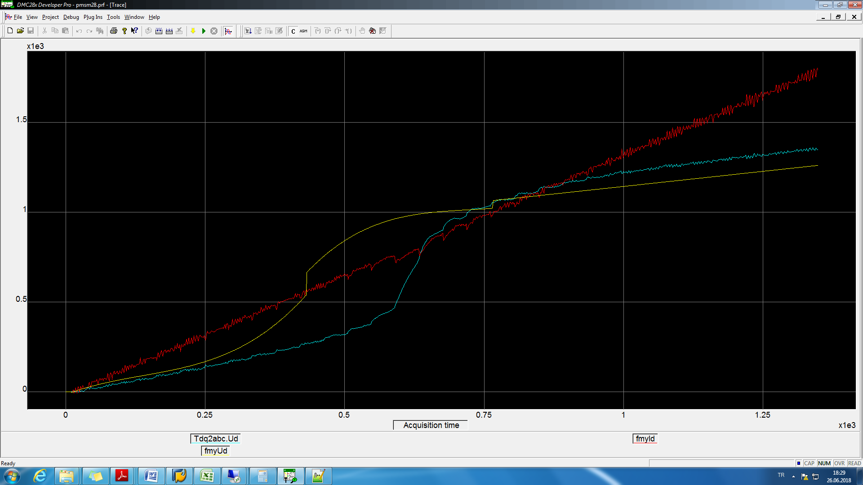



27.06.2018

Data ölçümü flash ileyapıldı



28.06.2018

Ölçüm3 e göre curve fit yapıldı

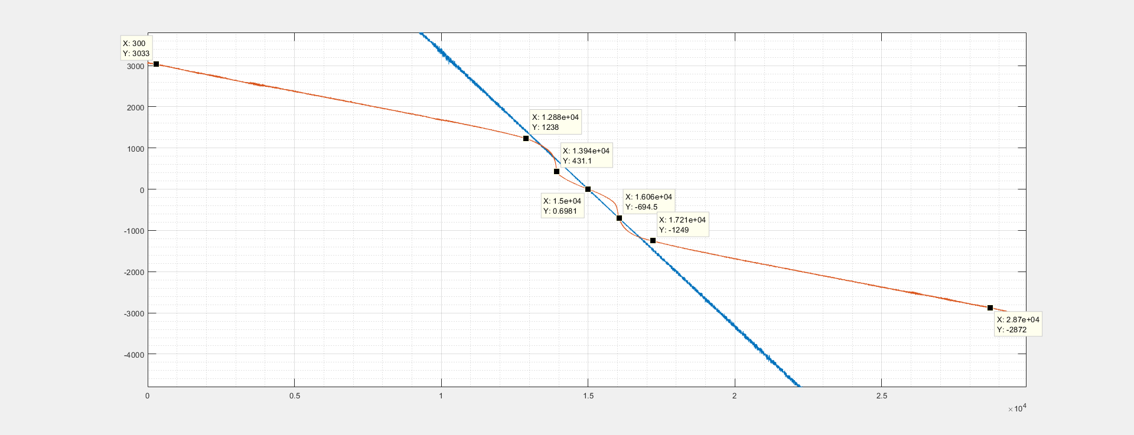

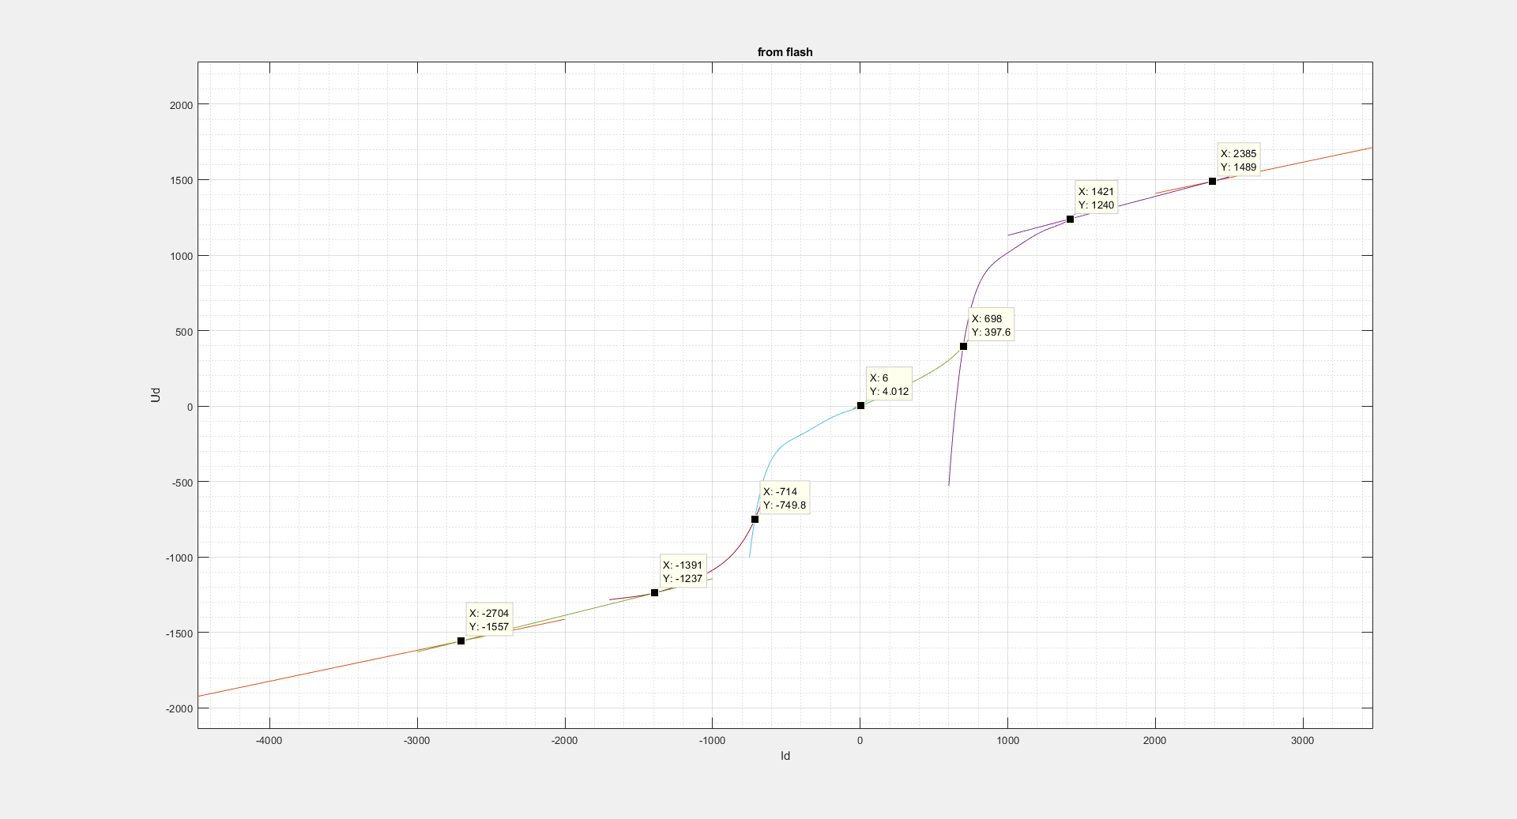

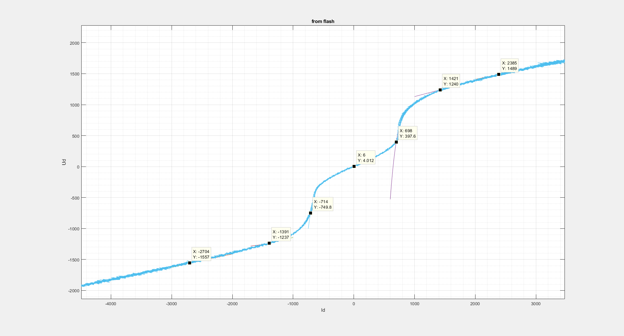

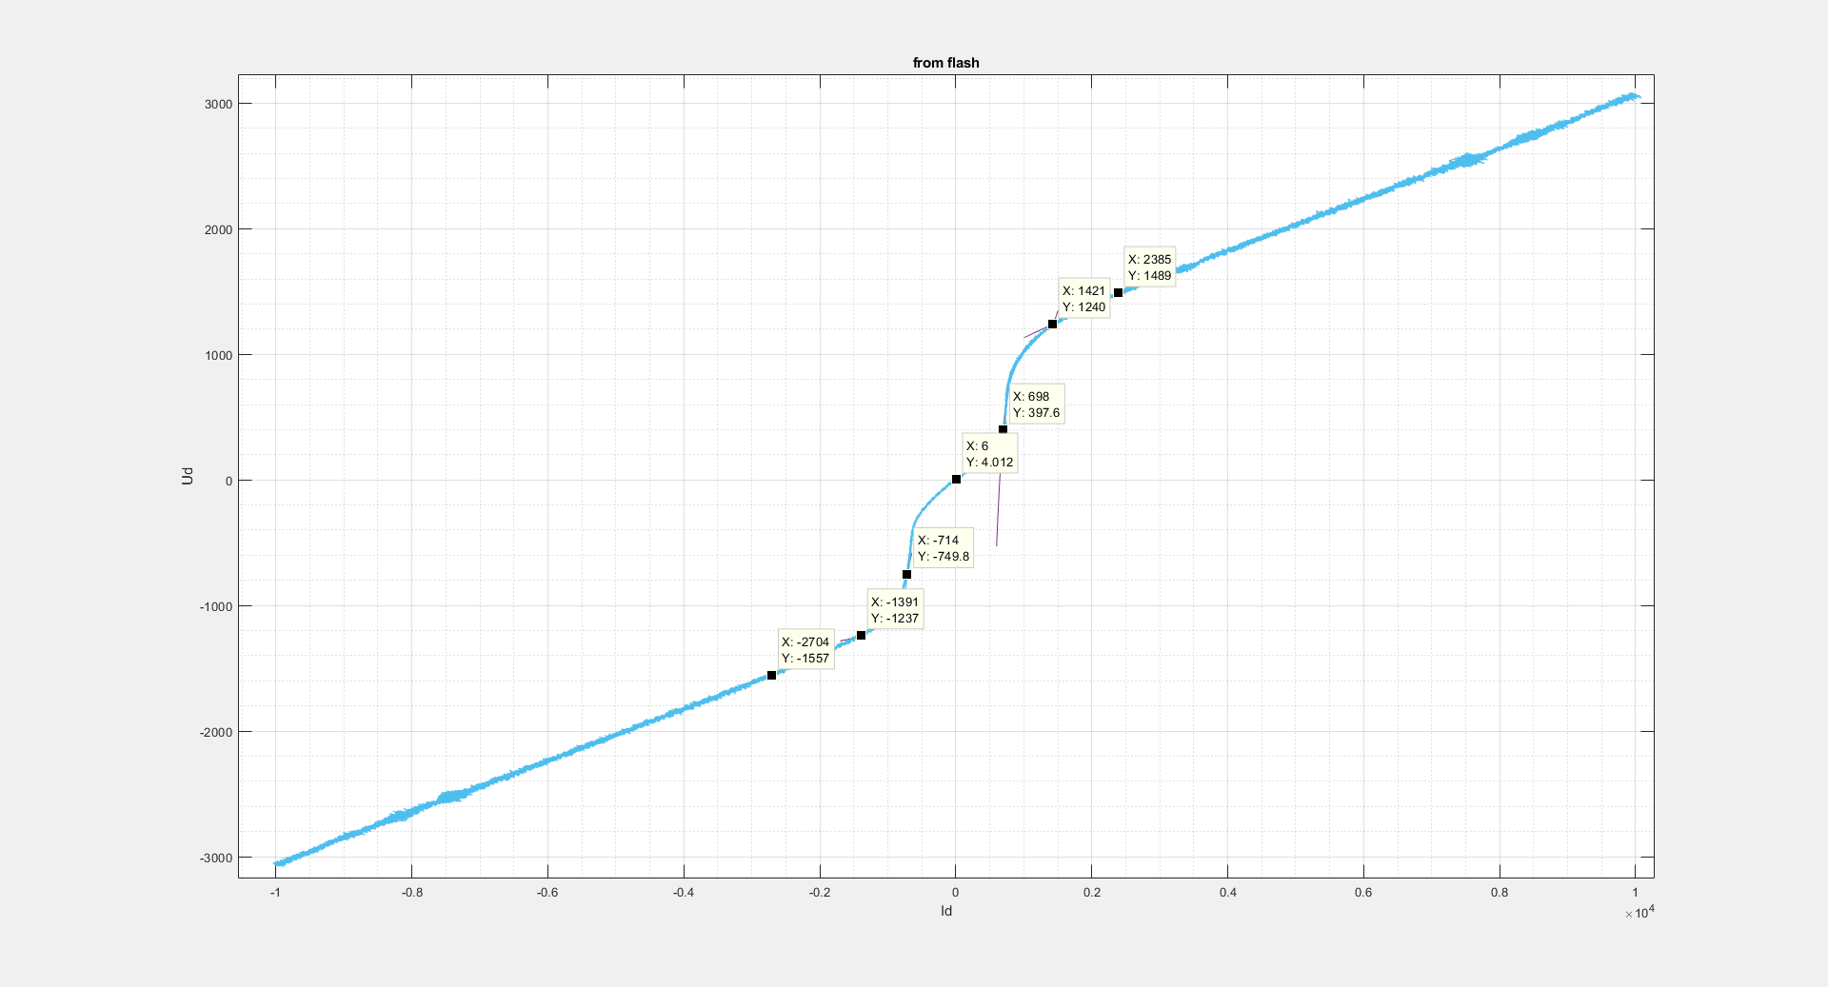

fittedCoeffs1.mat.. fittedCoeffs8.mat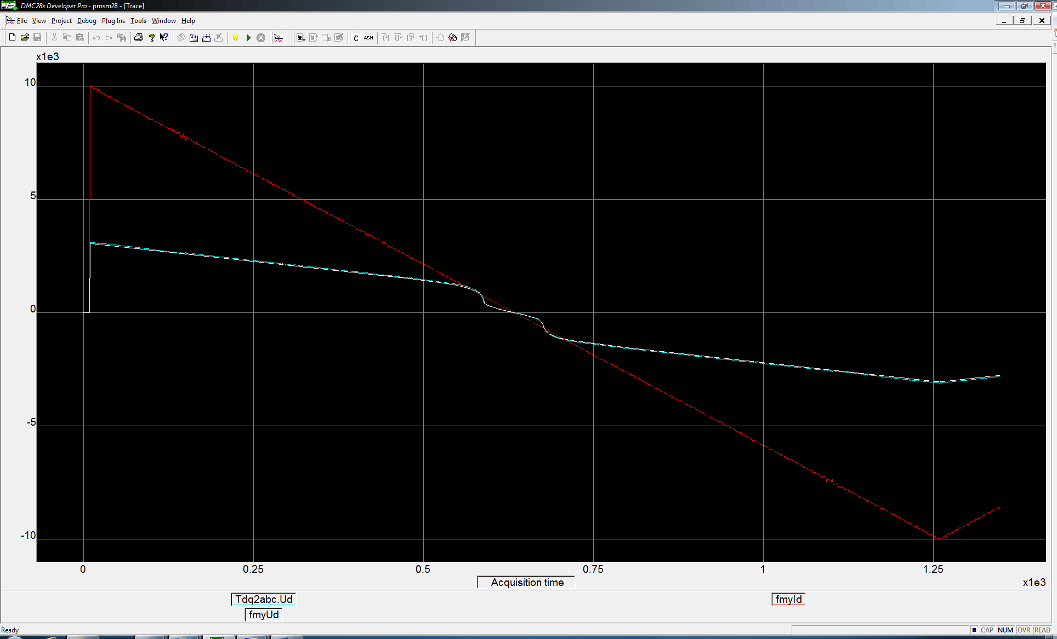

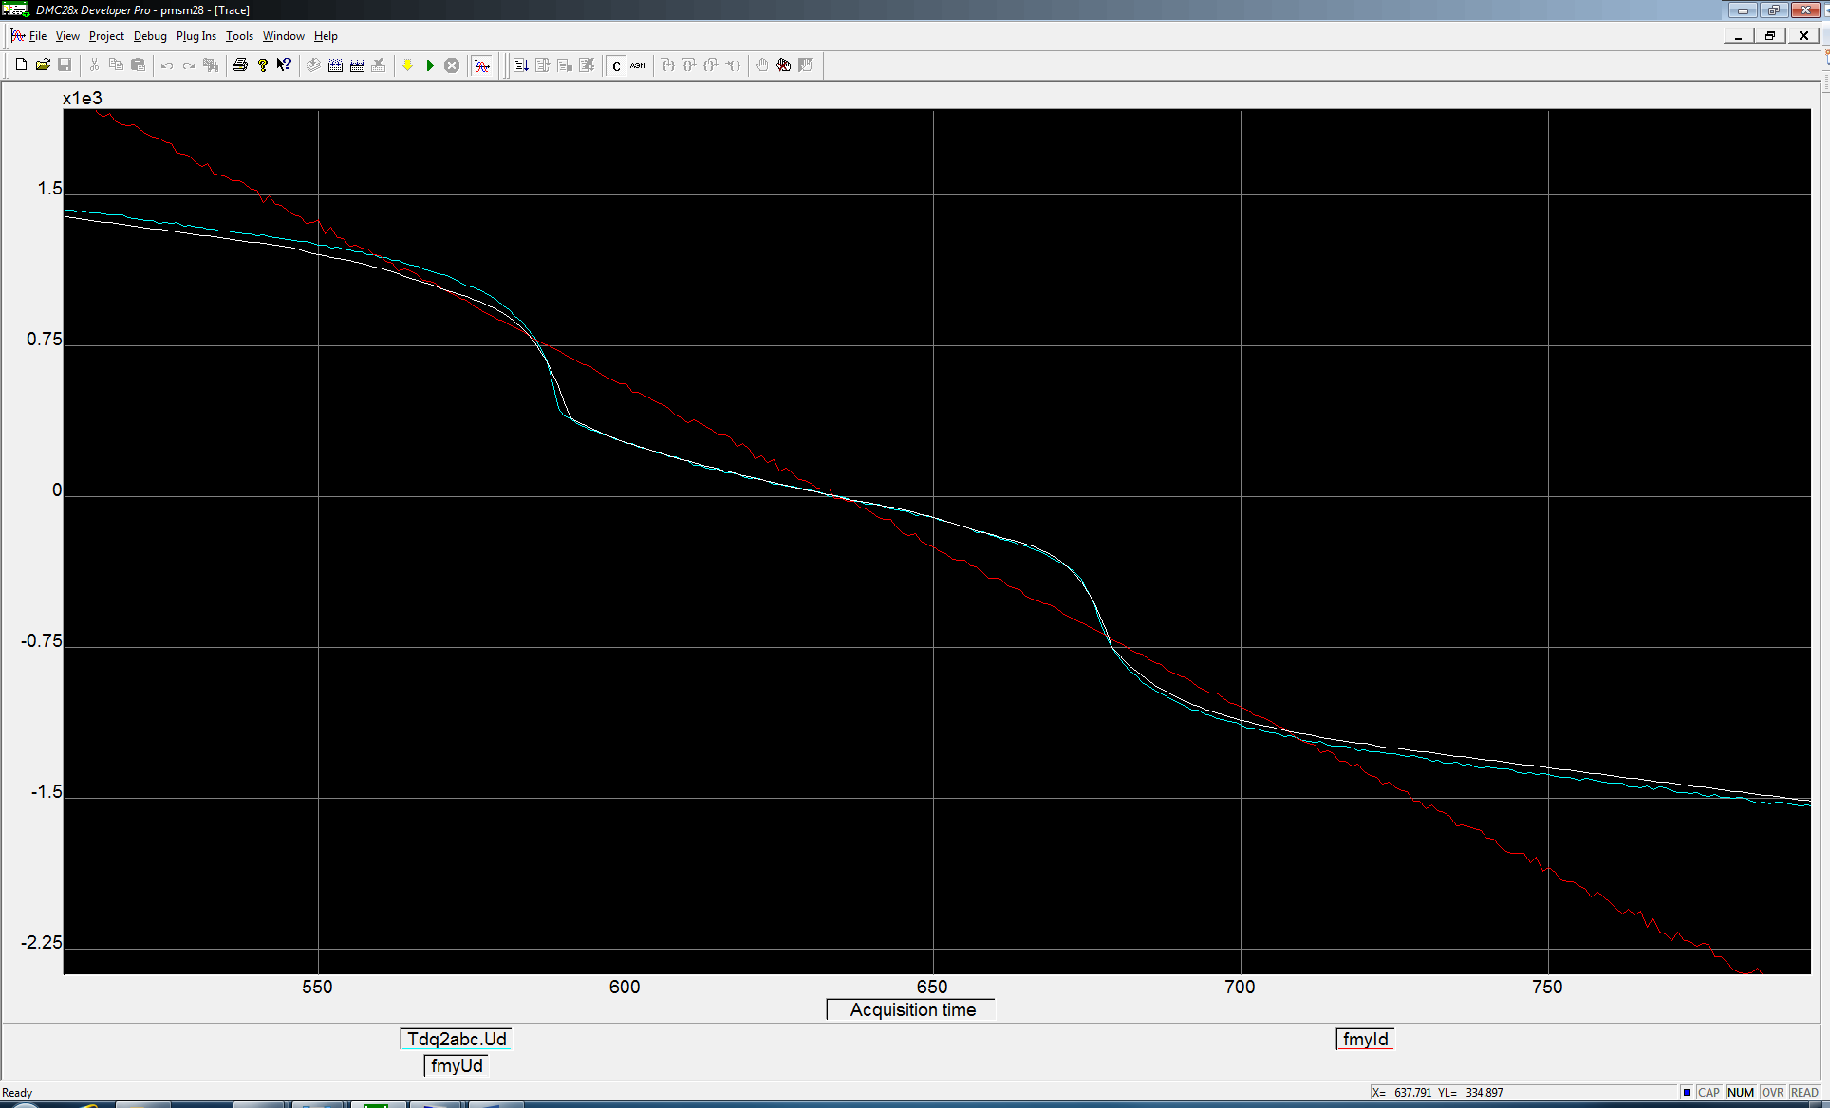

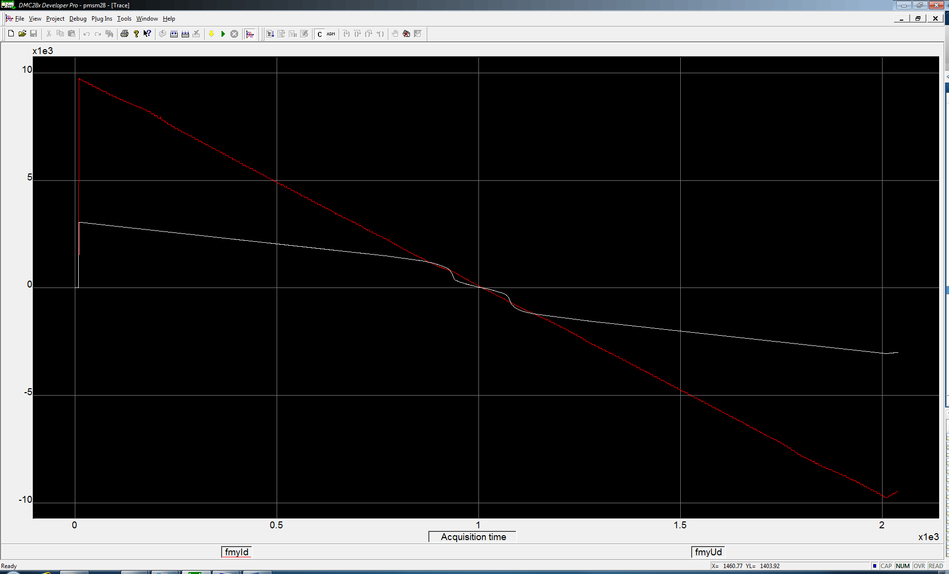

Compensated step

D:\hyuruk\deneme\ec4pole\speed_test_index\compansated_step2_Kp_onethird.wmf

Uncompensated step

D:\hyuruk\deneme\ec4pole\speed_test_index\notcompansated_step_Kp_onethird.wmf

Compensated 10Hz Idref

D:\hyuruk\deneme\ec4pole\speed_test_index\compansated_step2_Kp_onethird_10Hz.wmf

uncompensated 10Hz Idref

D:\hyuruk\deneme\ec4pole\speed_test_index\notcompansated_step_Kp_onethird_10Hz.wmf

Compensated 100Hz Idref

D:\hyuruk\deneme\ec4pole\speed_test_index\compansated_step_Kp_onethird_100Hz.wmf

uncompensated 100Hz Idref

D:\hyuruk\deneme\ec4pole\speed_test_index\notcompansated_step_Kp_onethird_100Hz.wmf

D:\hyuruk\deneme\ec4pole\speed_test_index\notcompansated_step_Kp_onethird_100Hz_2.wmf

Hızdöngüsü5hz ref. uncompensated

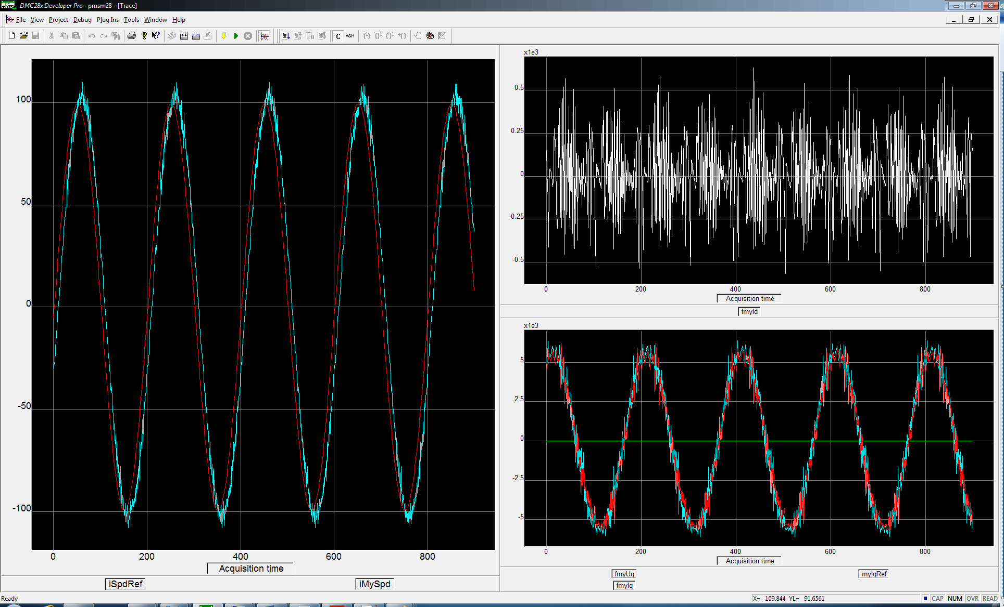

5hz sinus uncompensated + backemf FFW

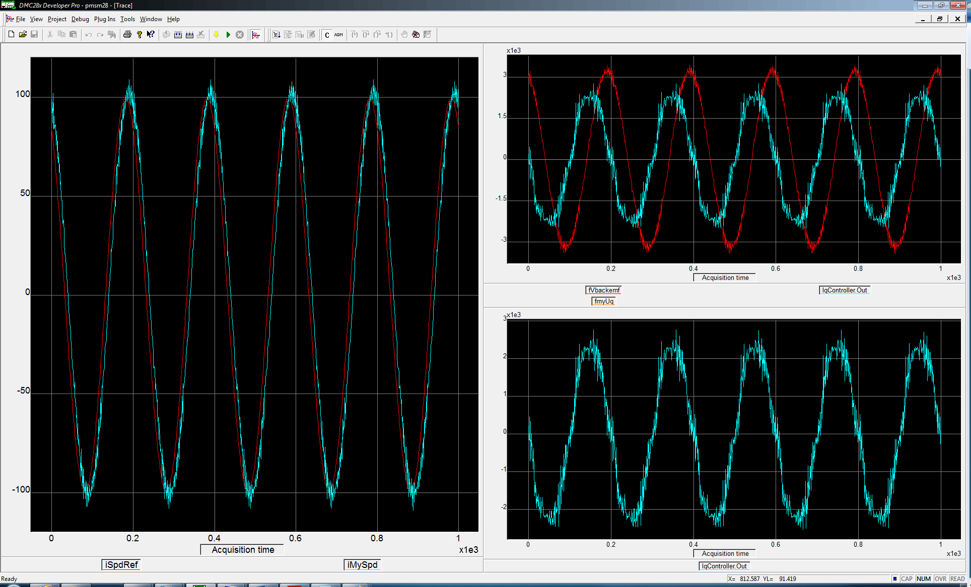

Hızdöngüsü5hz ref. compensated

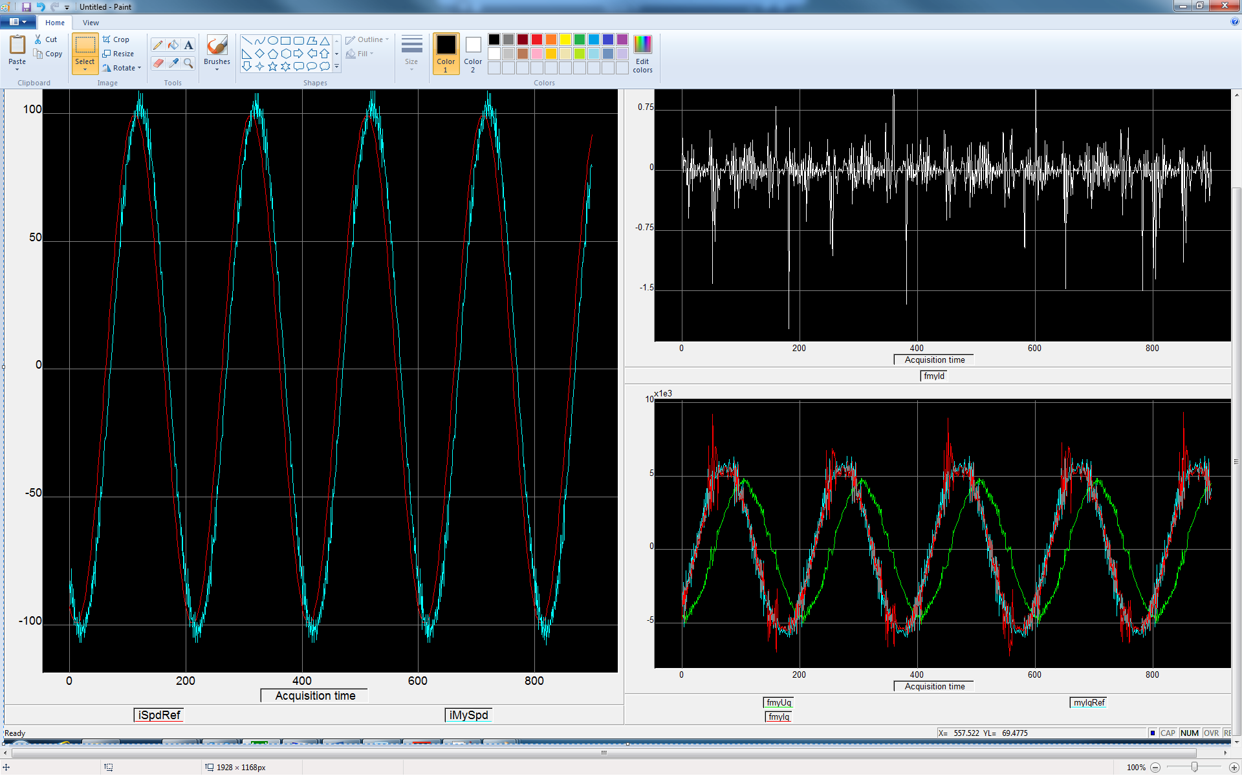

5hz sinus compensated + backemf FFW

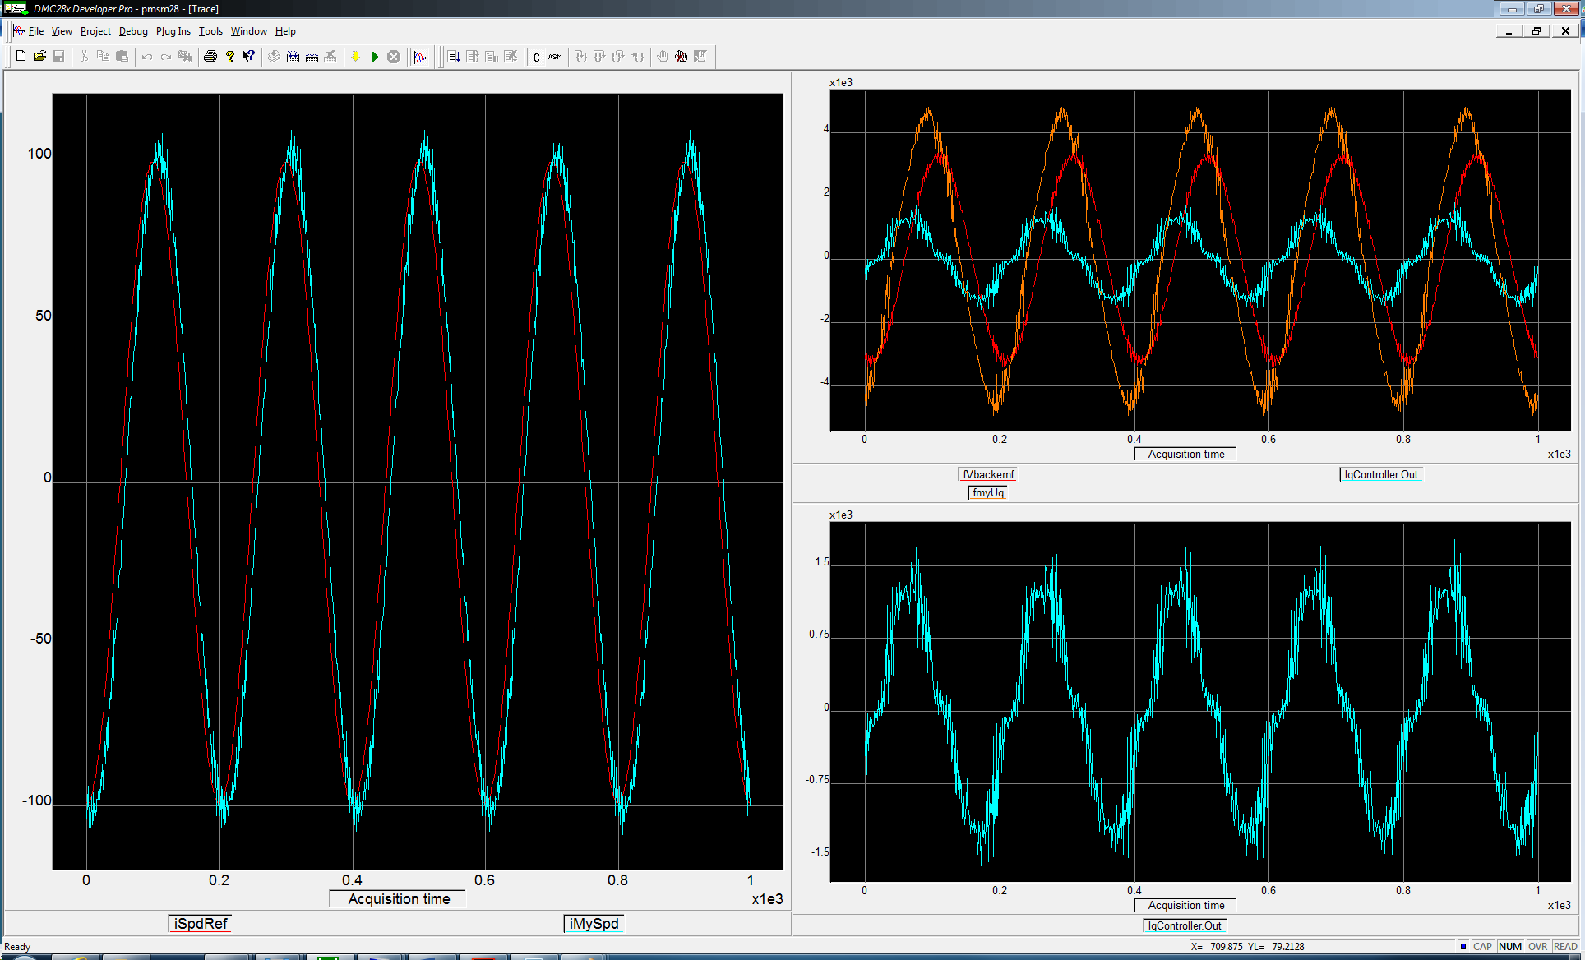

Hızdöngüsü1hz ref. compensated

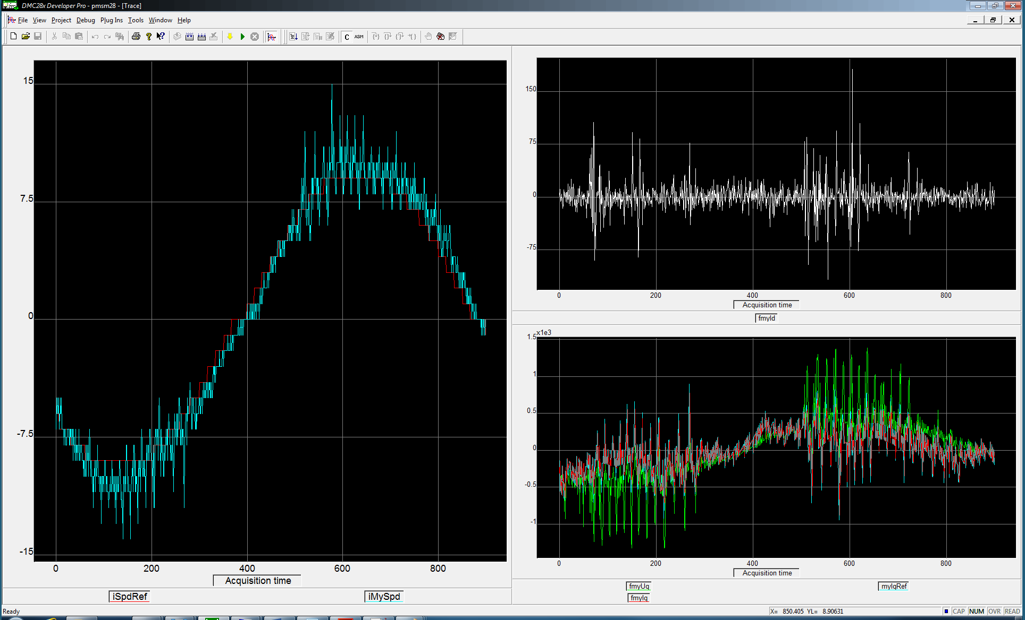

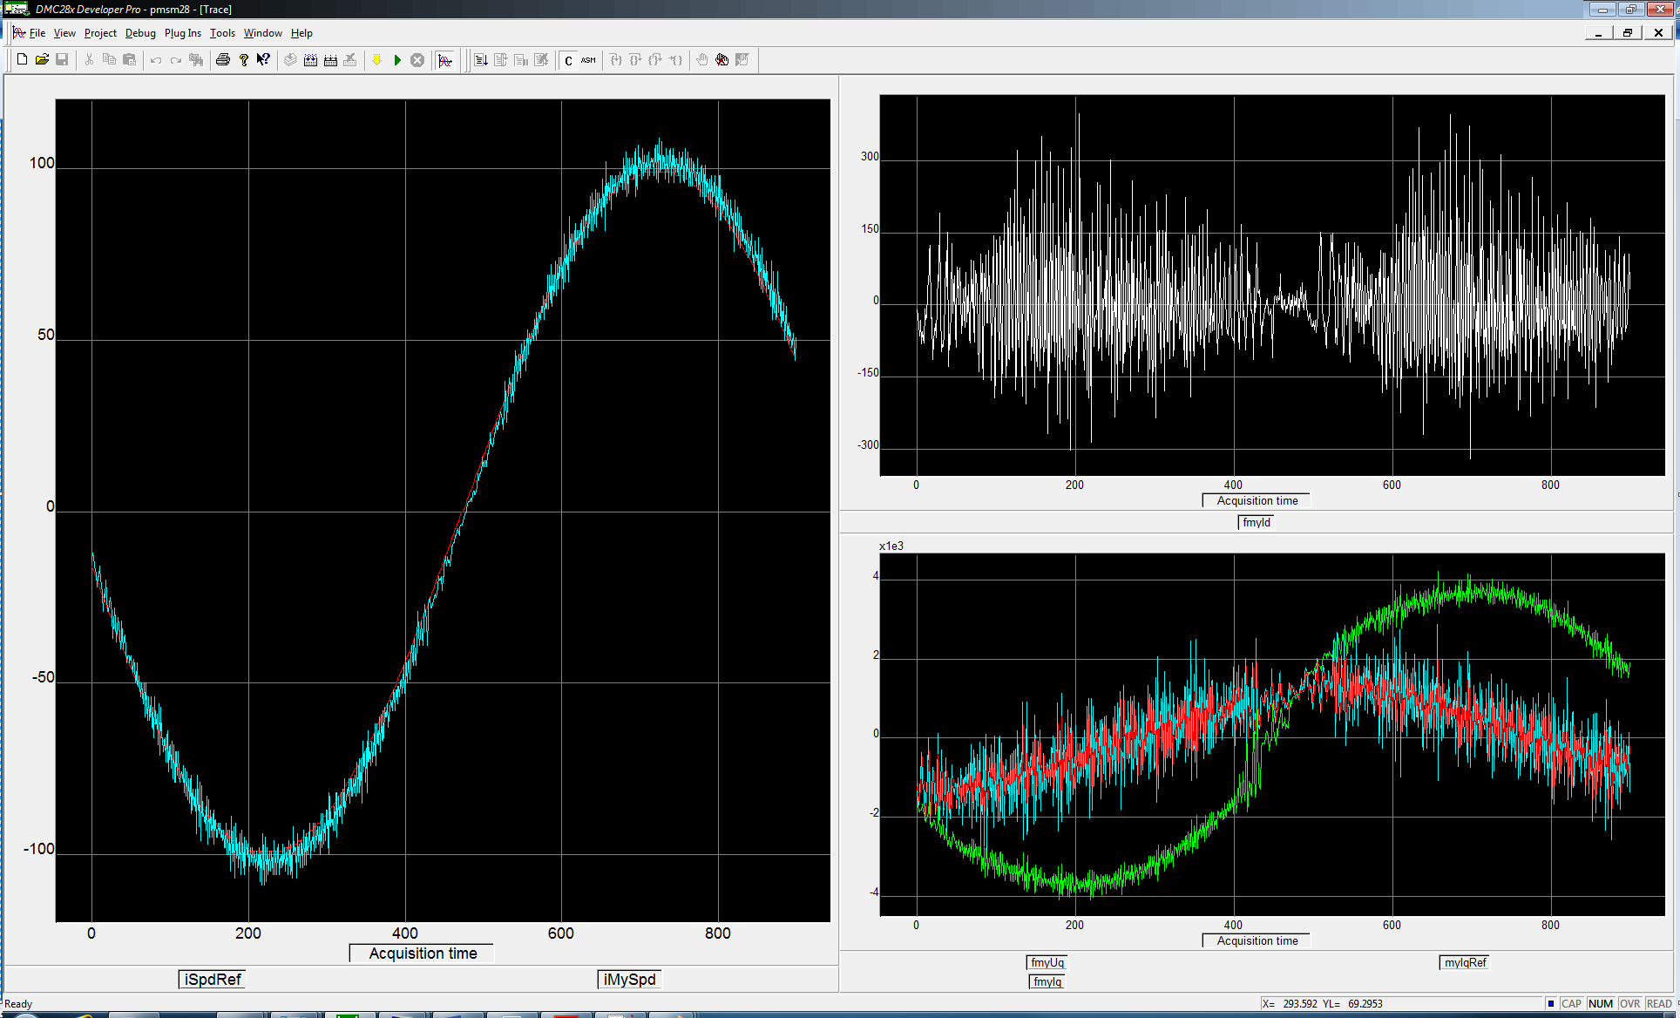

Hızdöngüsü1hz ref. uncompensated

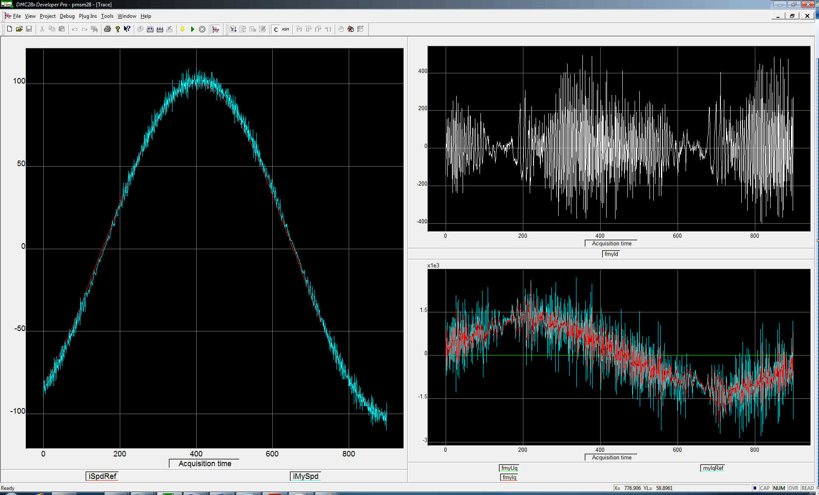

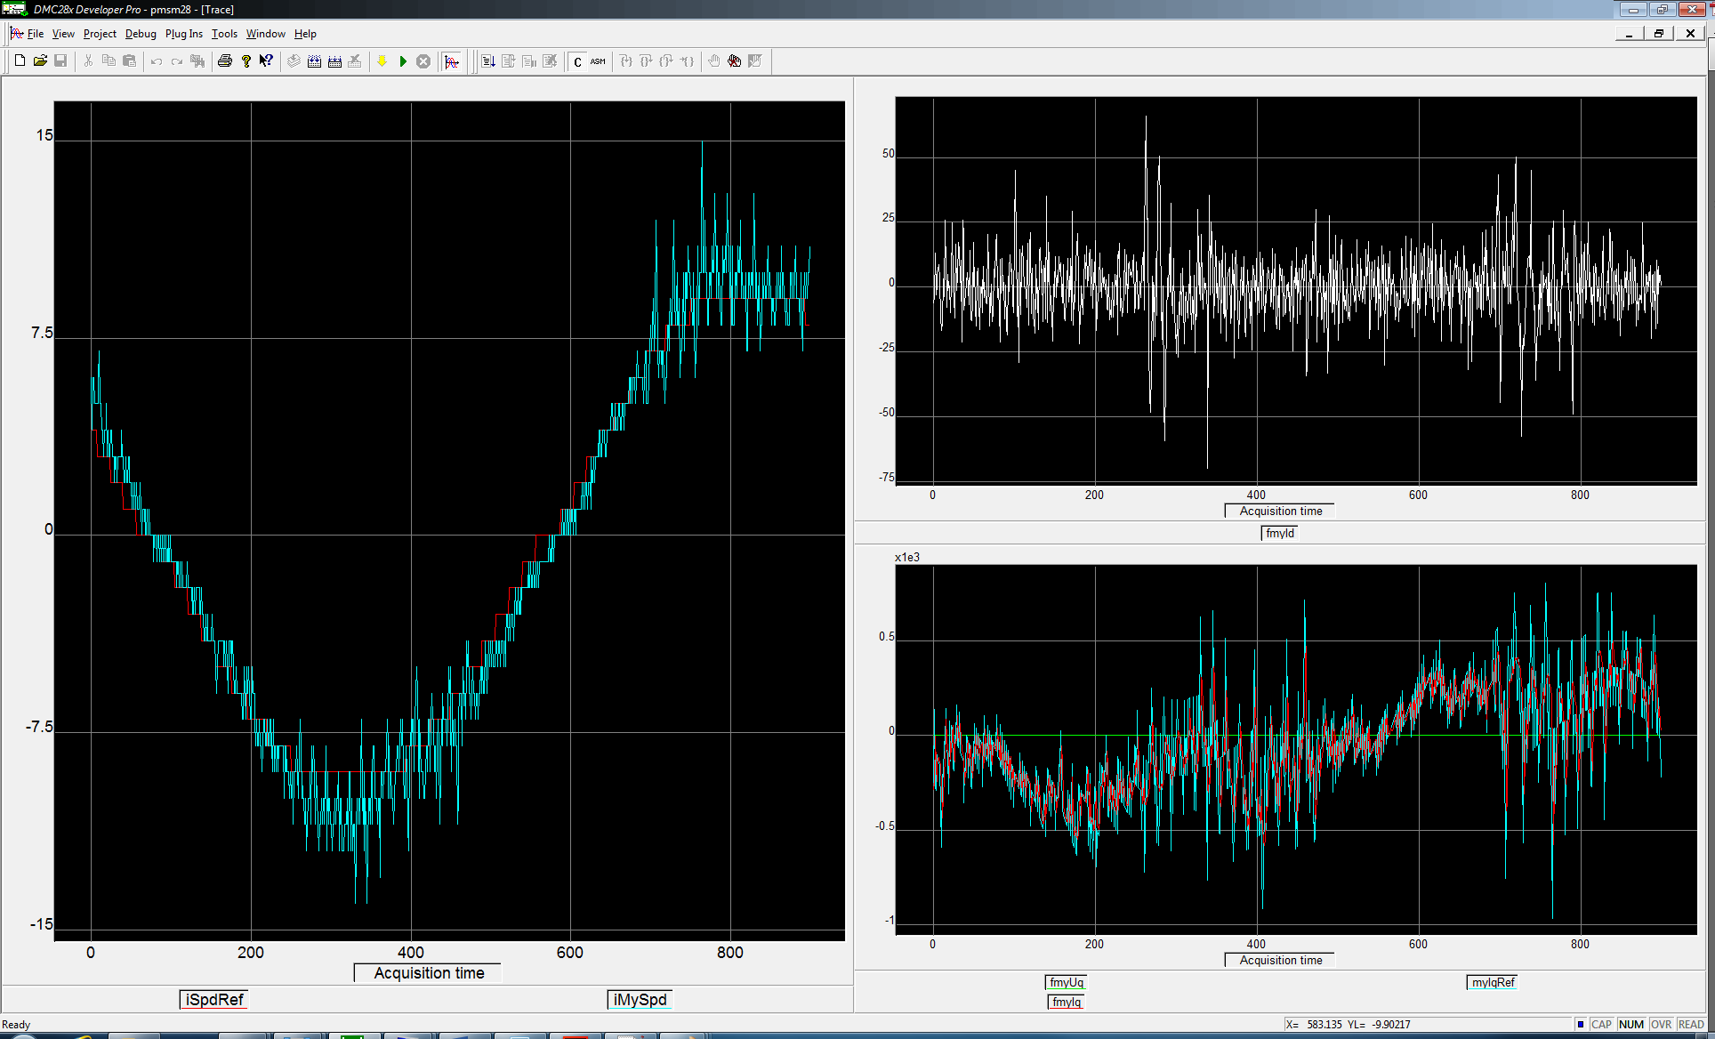

Hızdöngüsü compensated

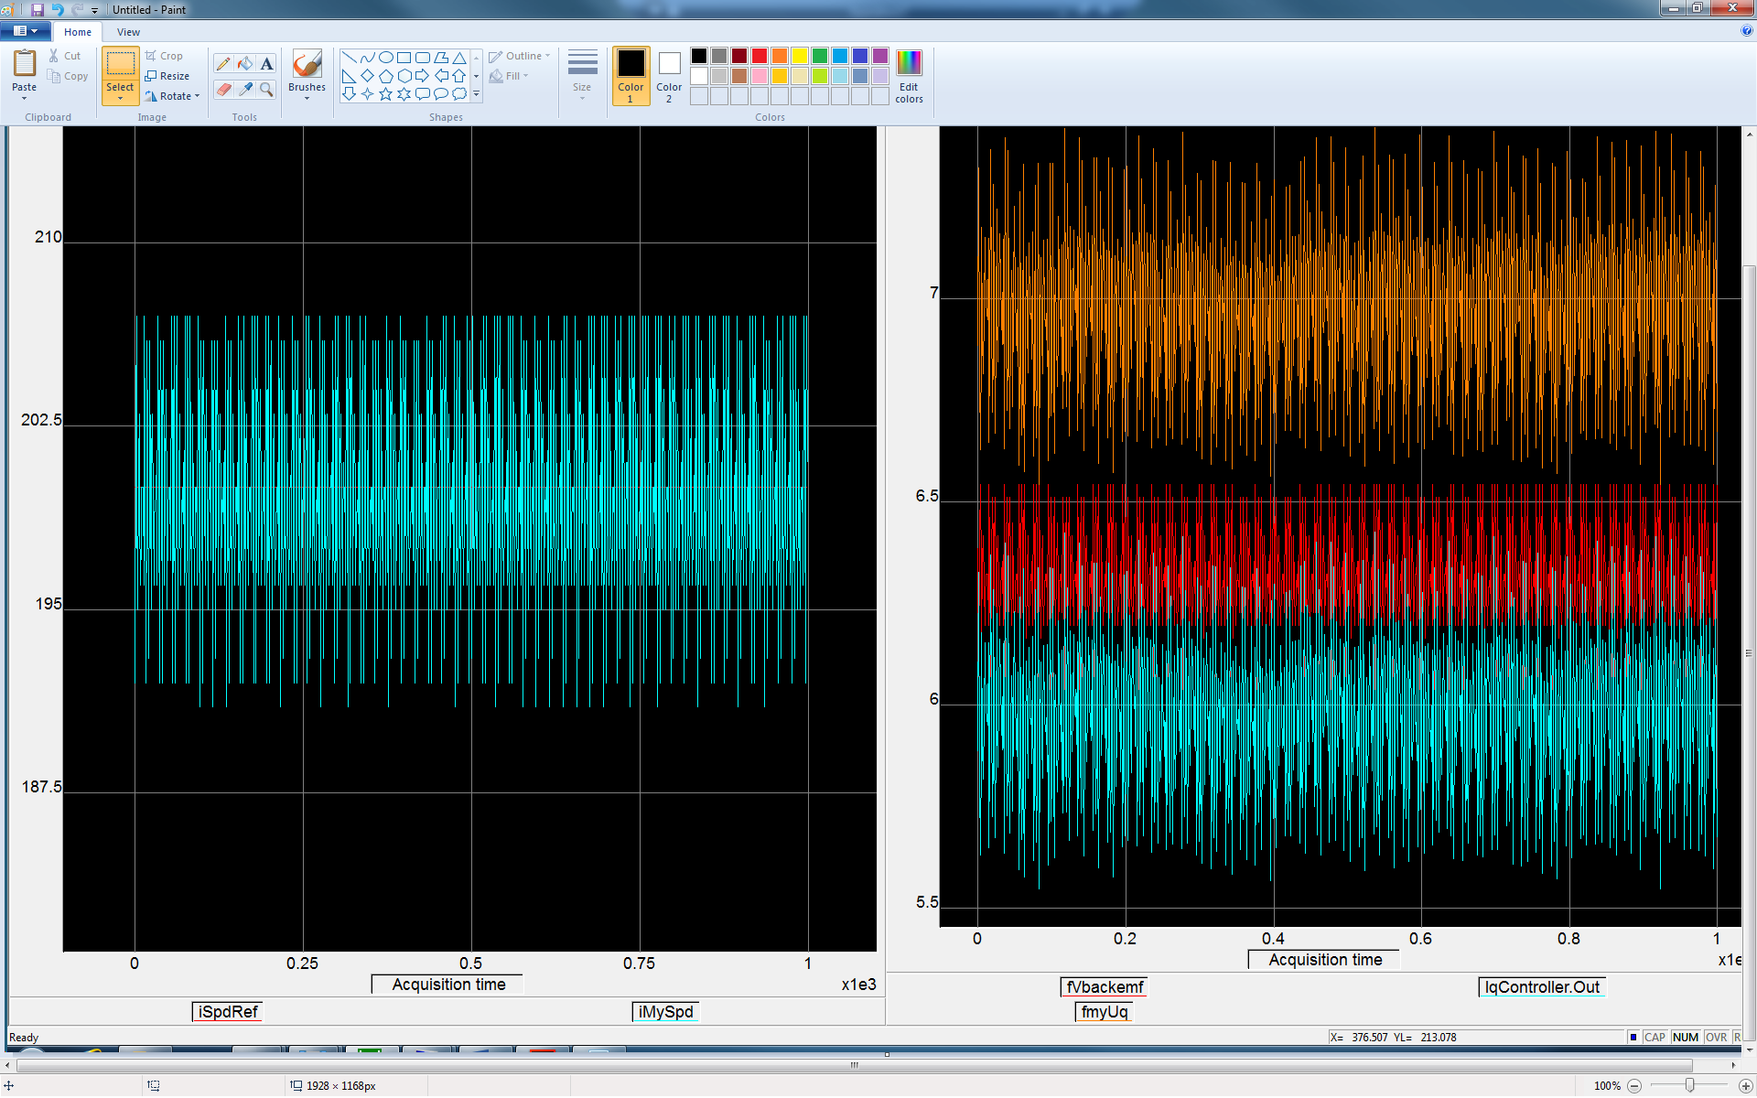

Hızdöngüsü compensated + back emf feedforward

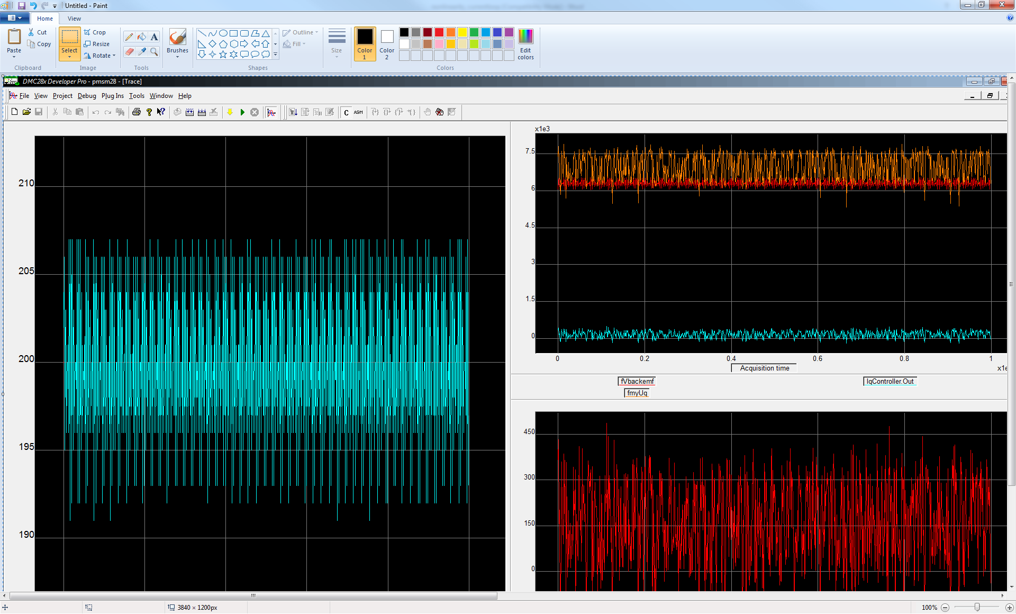

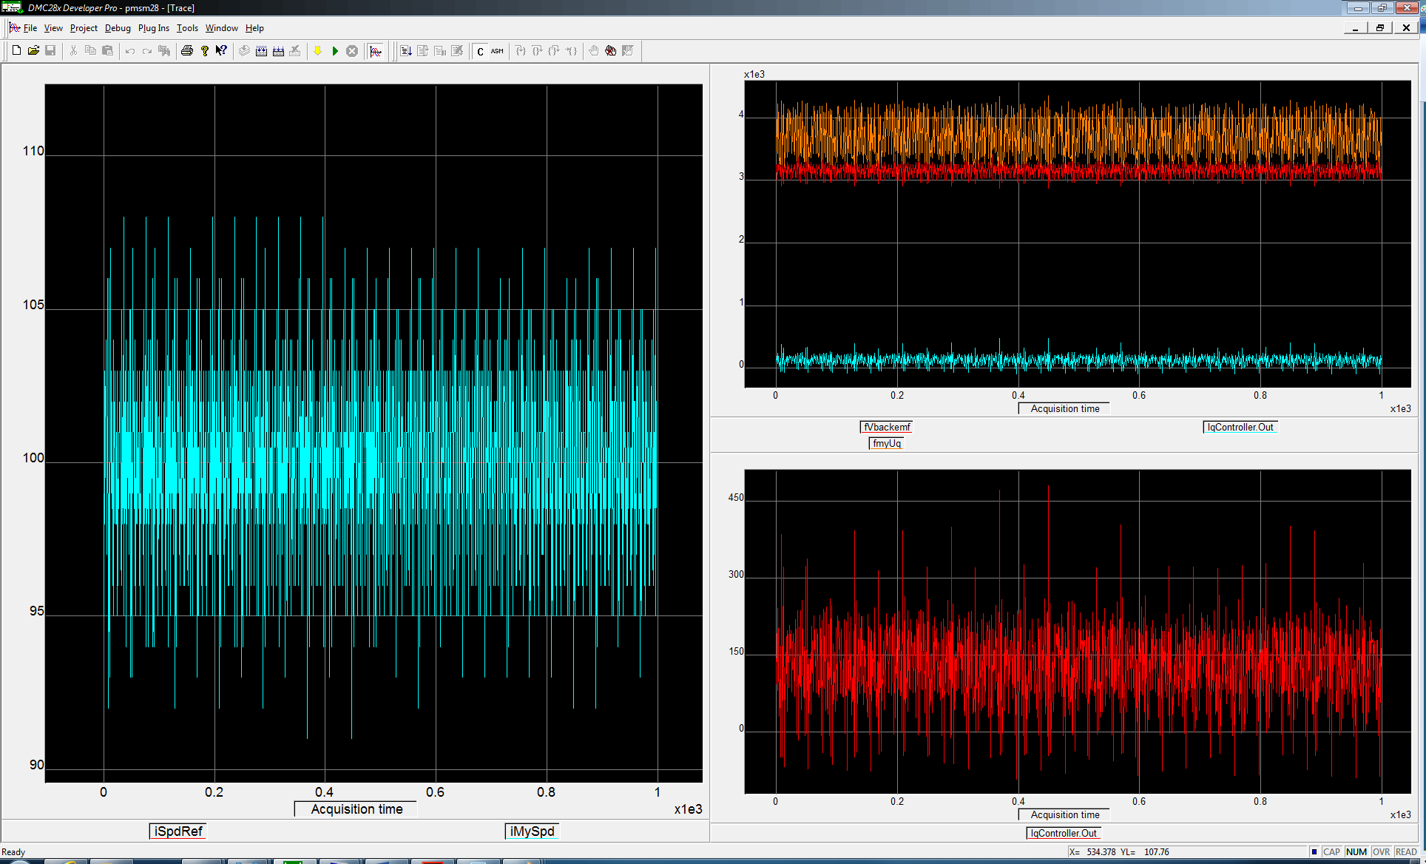

uncompensated + backemf FFW

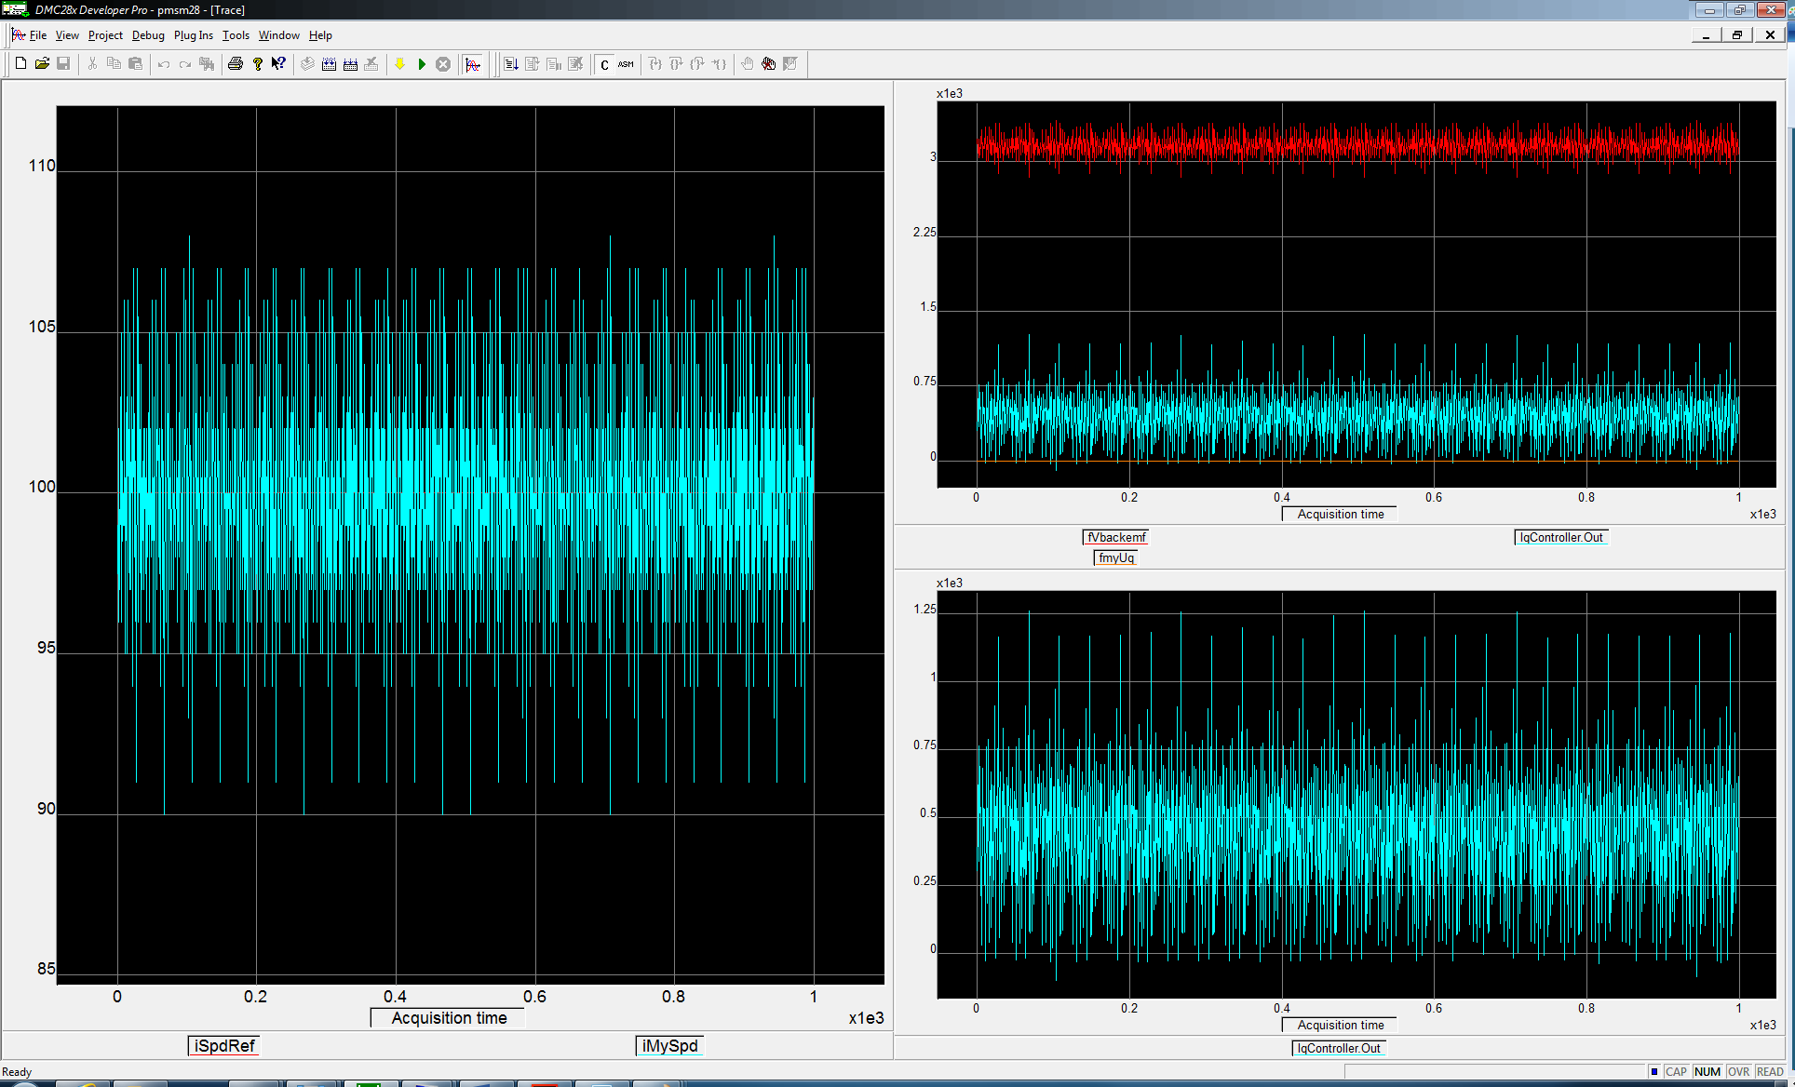

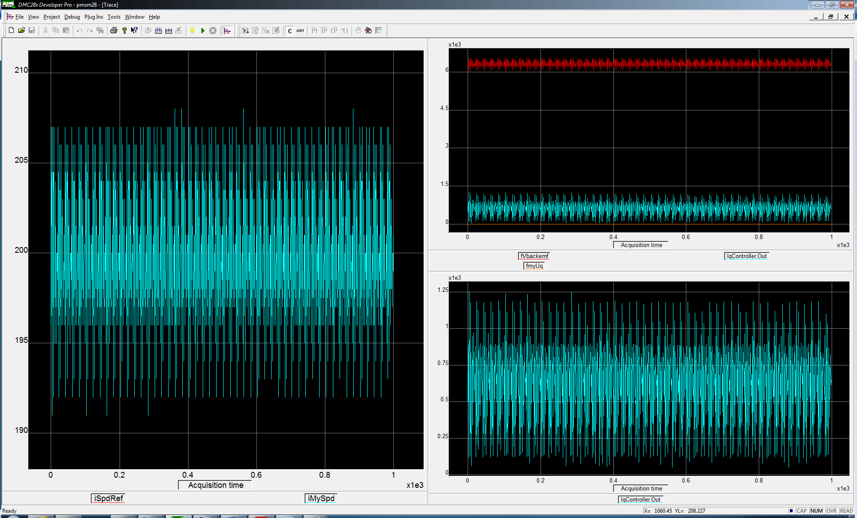

Step uncompensated

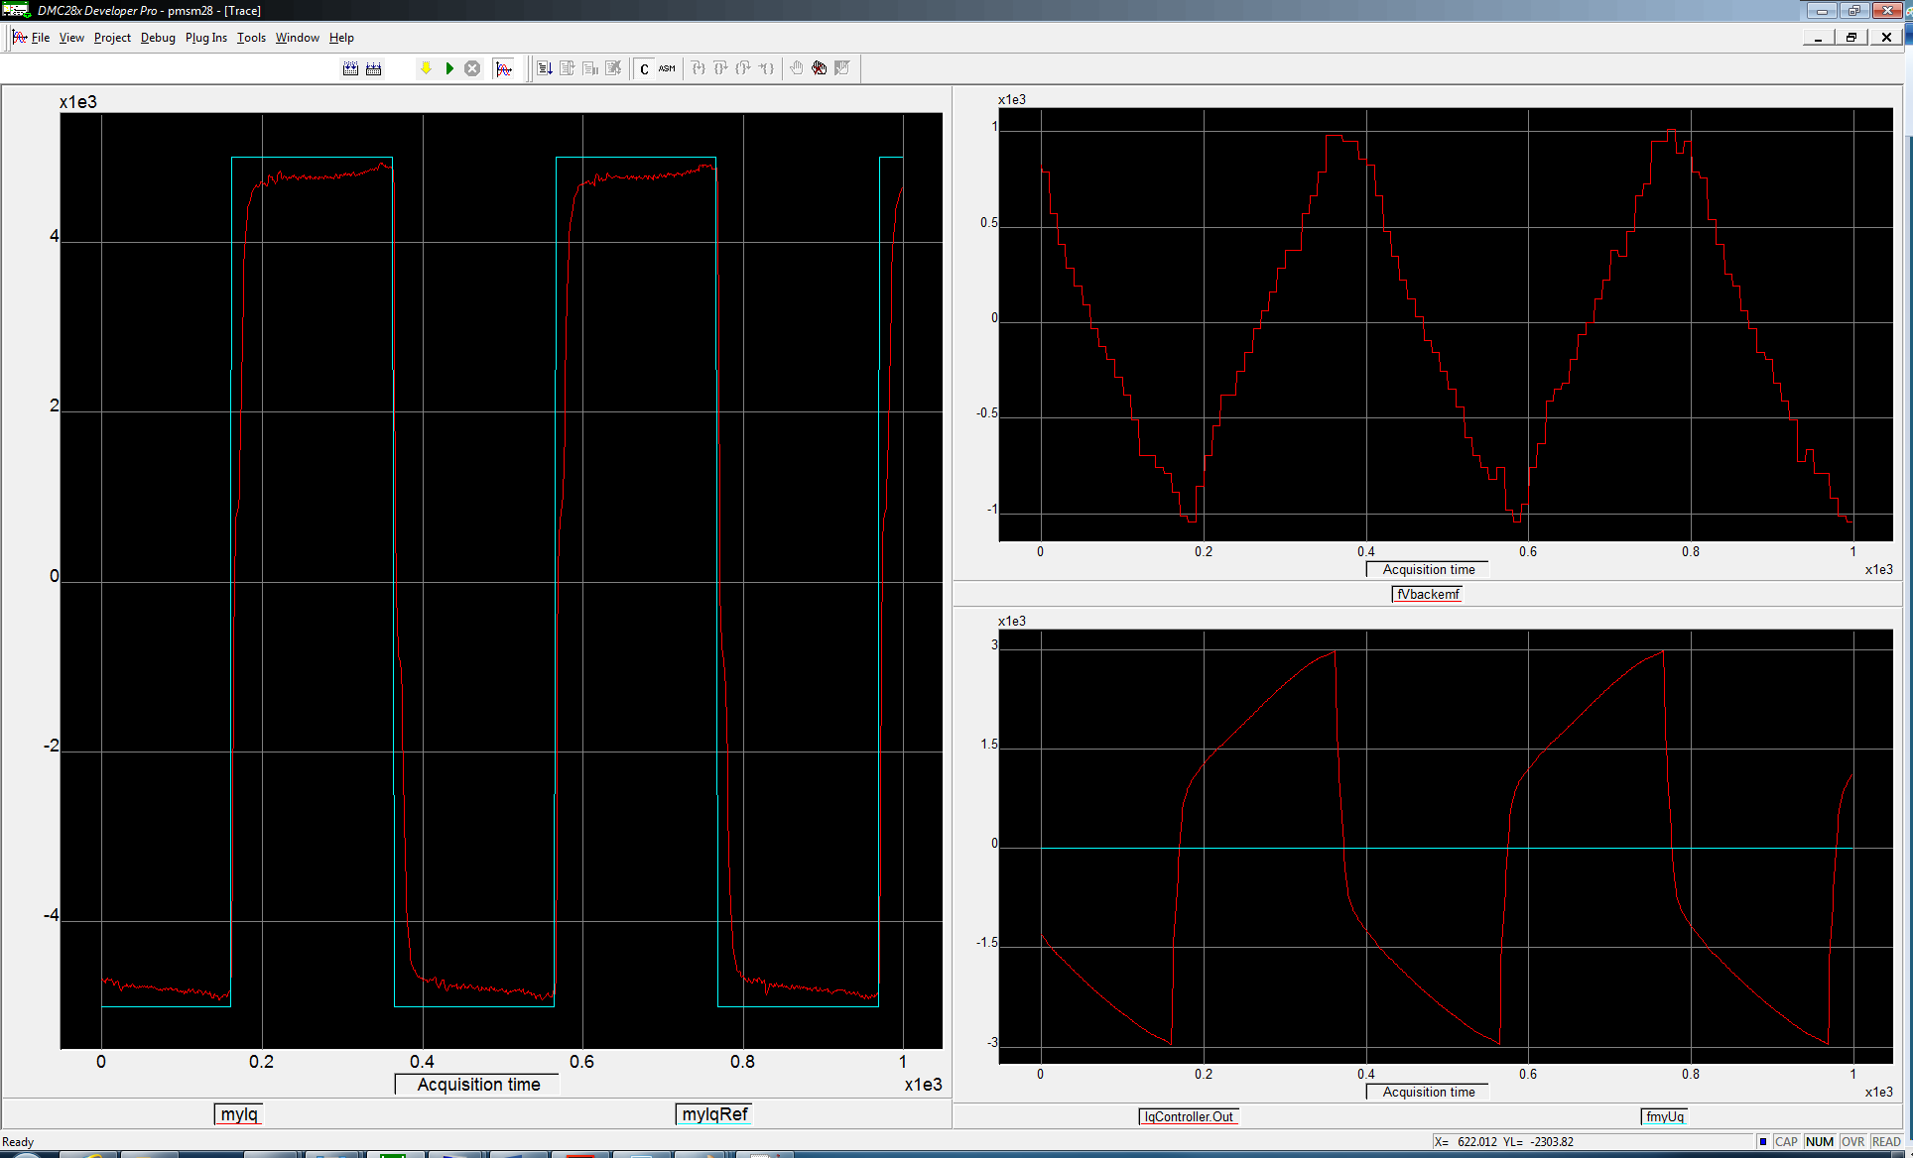

Step uncompensated + backEMF FFW

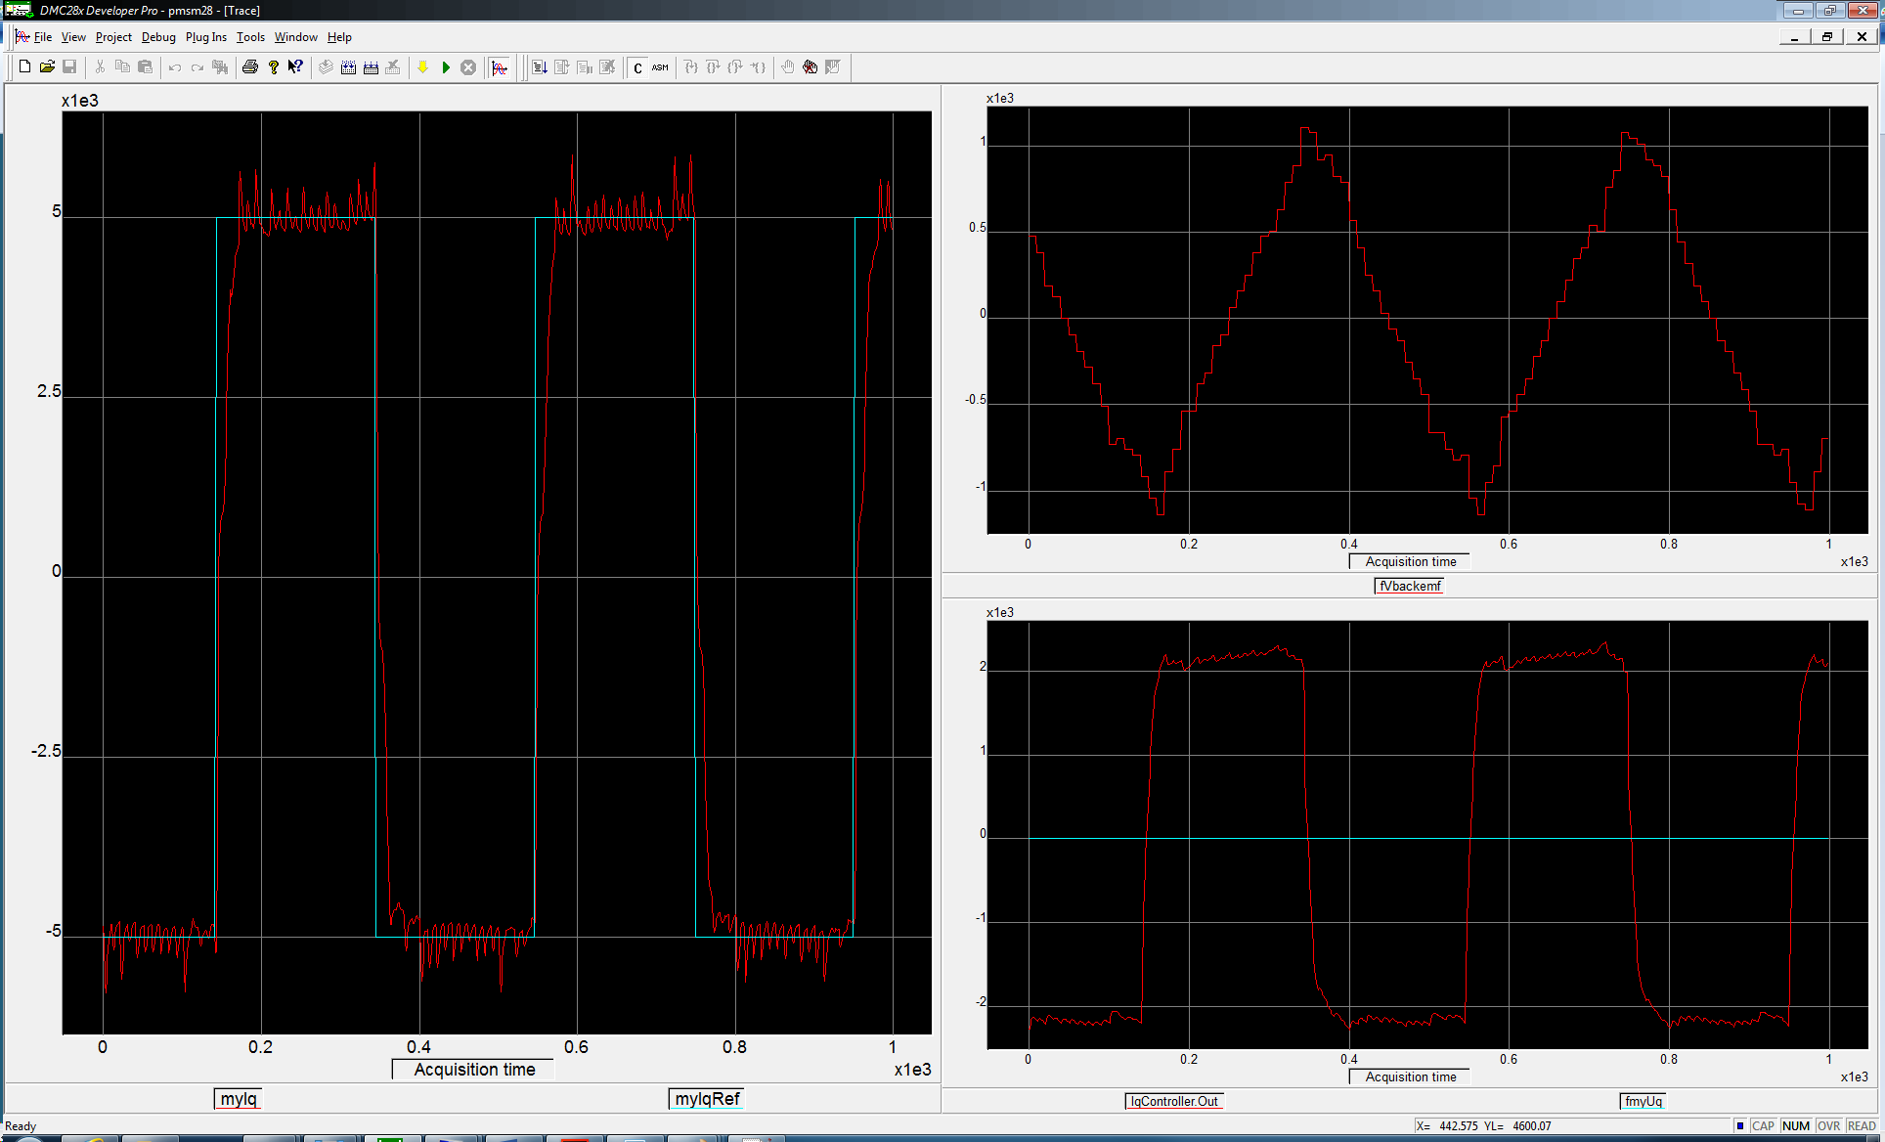

Step compensated

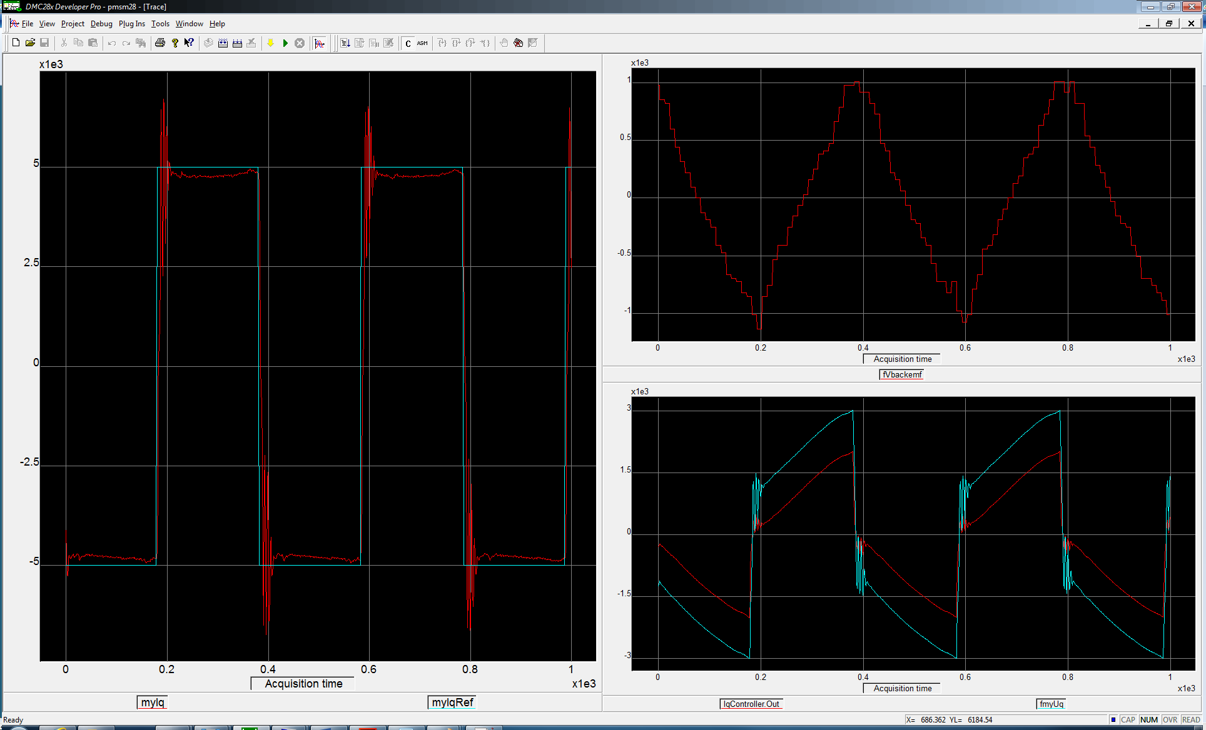

Step compensated + backEMF FFW

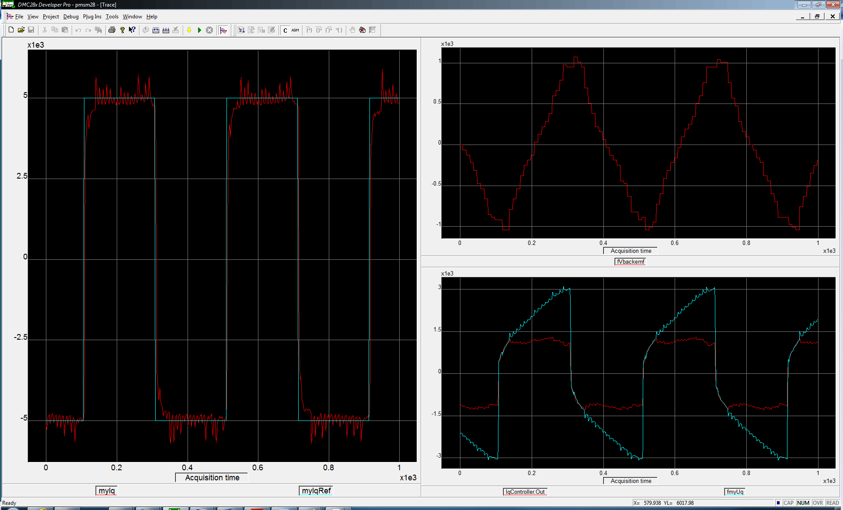

Sinus 10Hz compensated + backEMF FFW

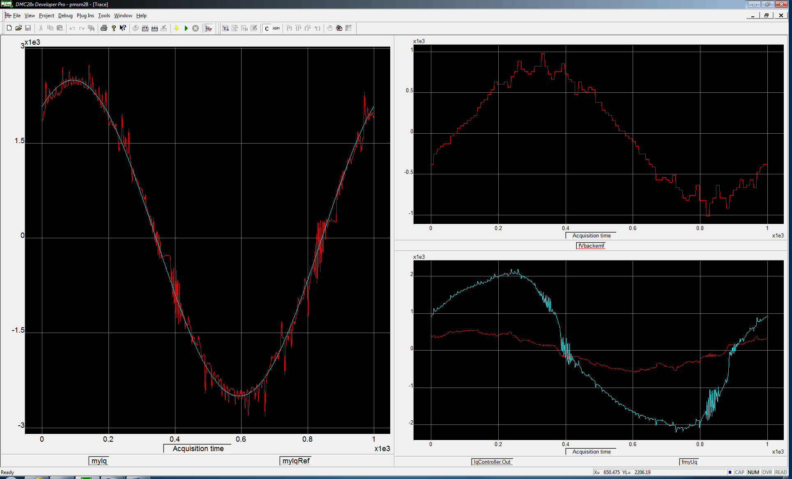

Sinus 100Hz compensated + backEMF FFW

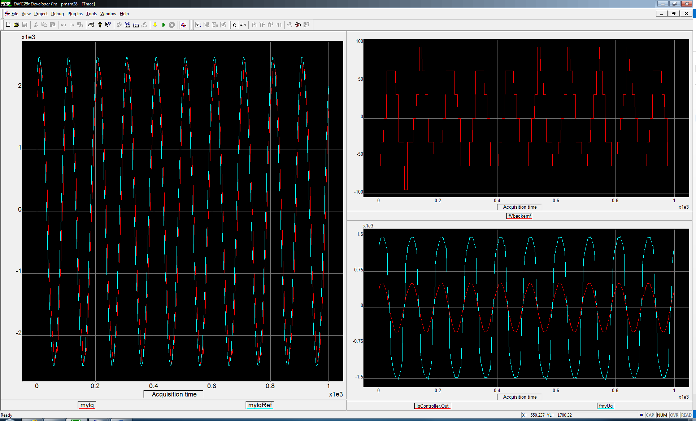

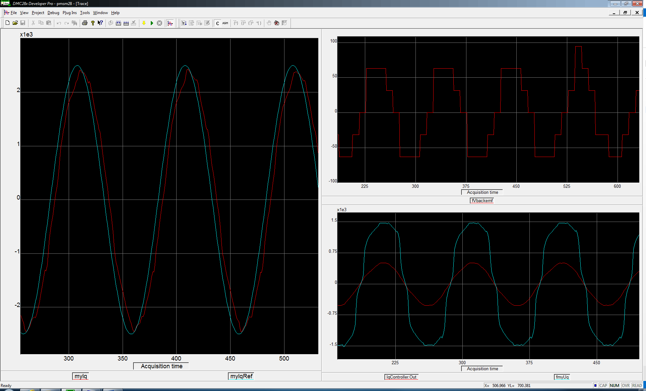

Sinus 10Hz compensated

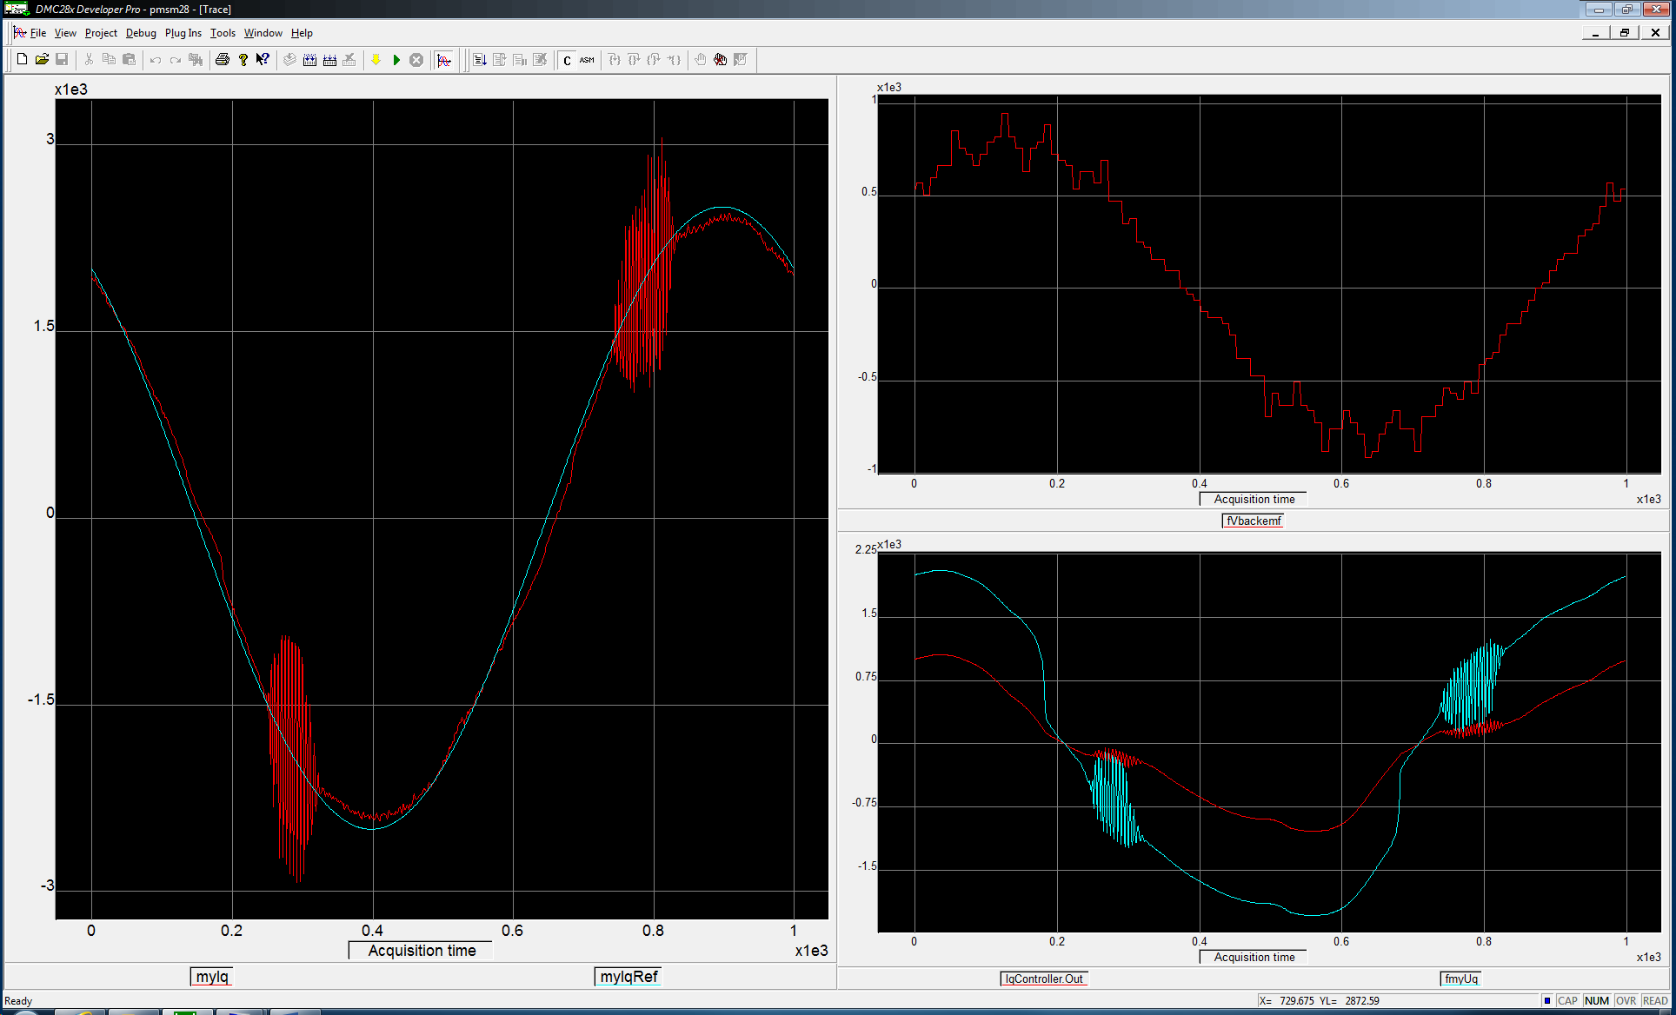

Sinus 100Hz compensated

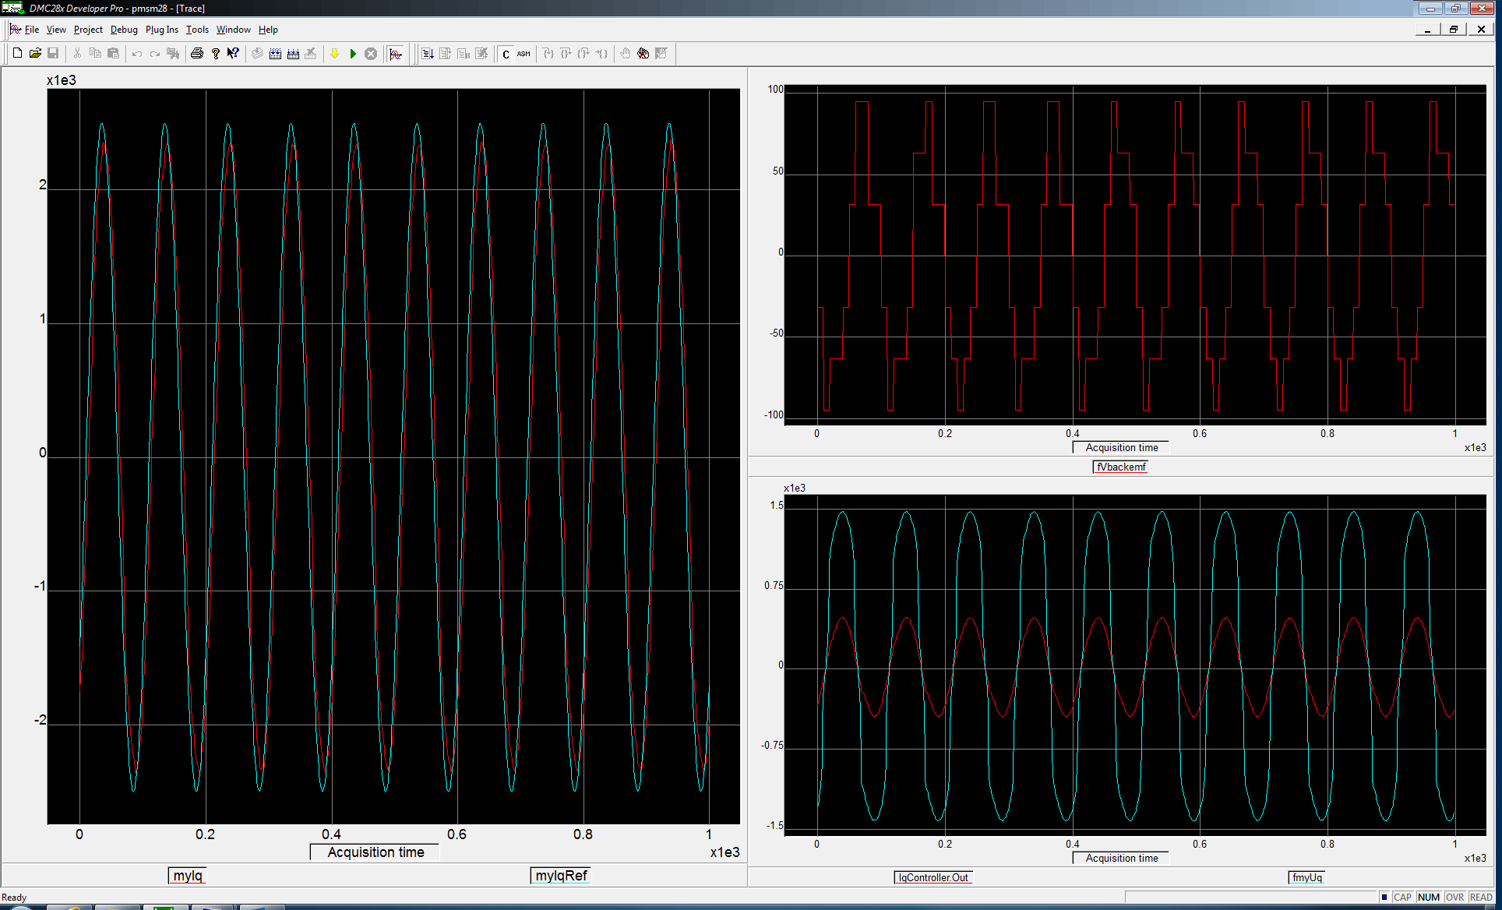

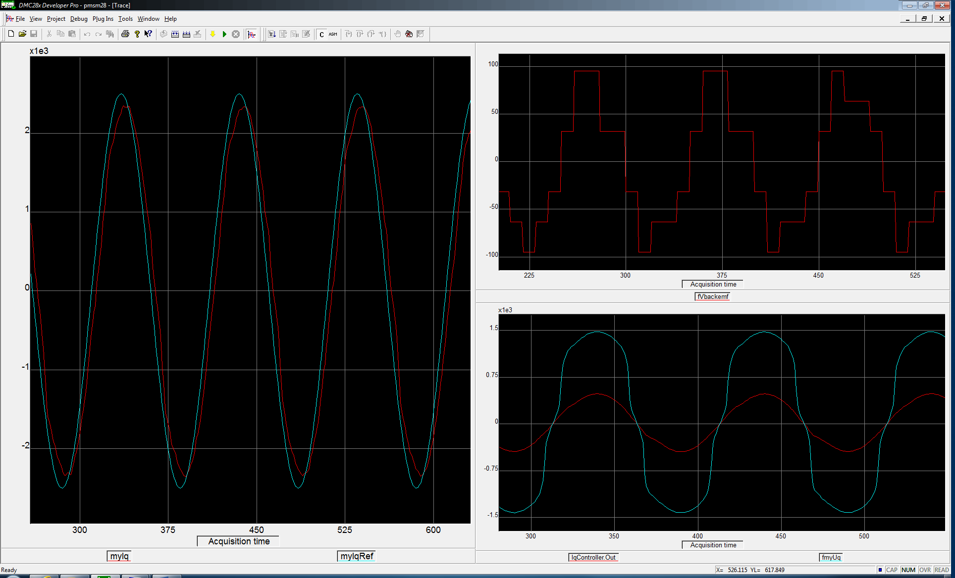

Sinus 100Hz uncompensated

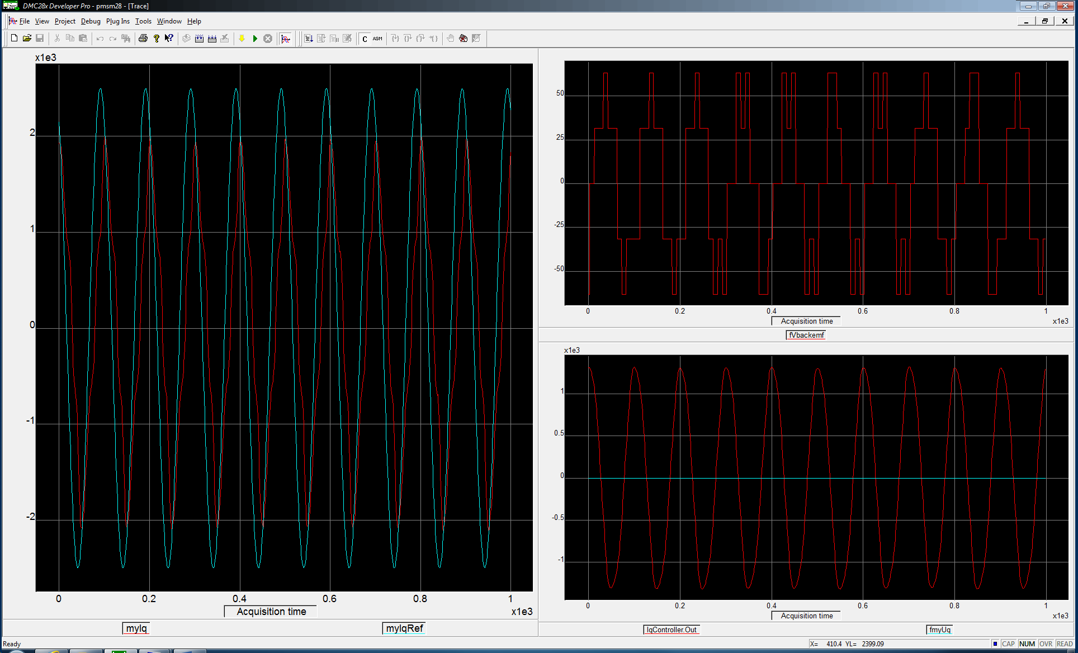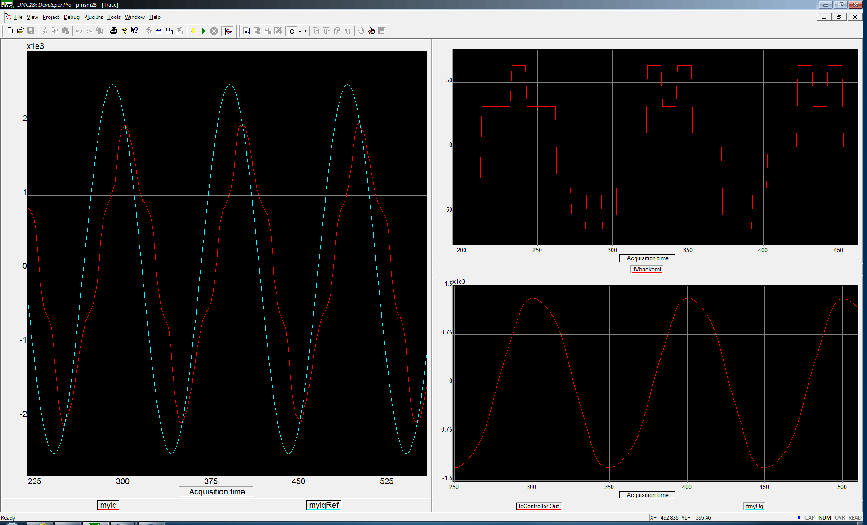

Sinus 100Hz uncompensated + backEMF FFW

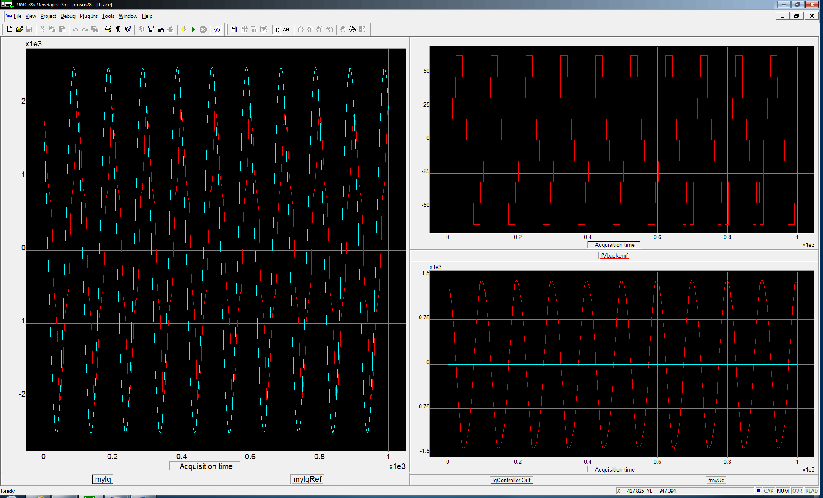

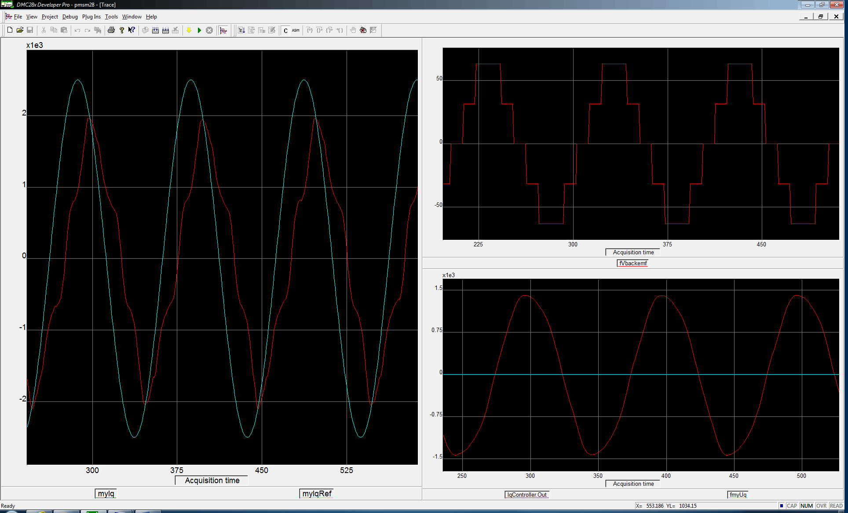

Sinus 10Hz uncompensated + backEMF FFW

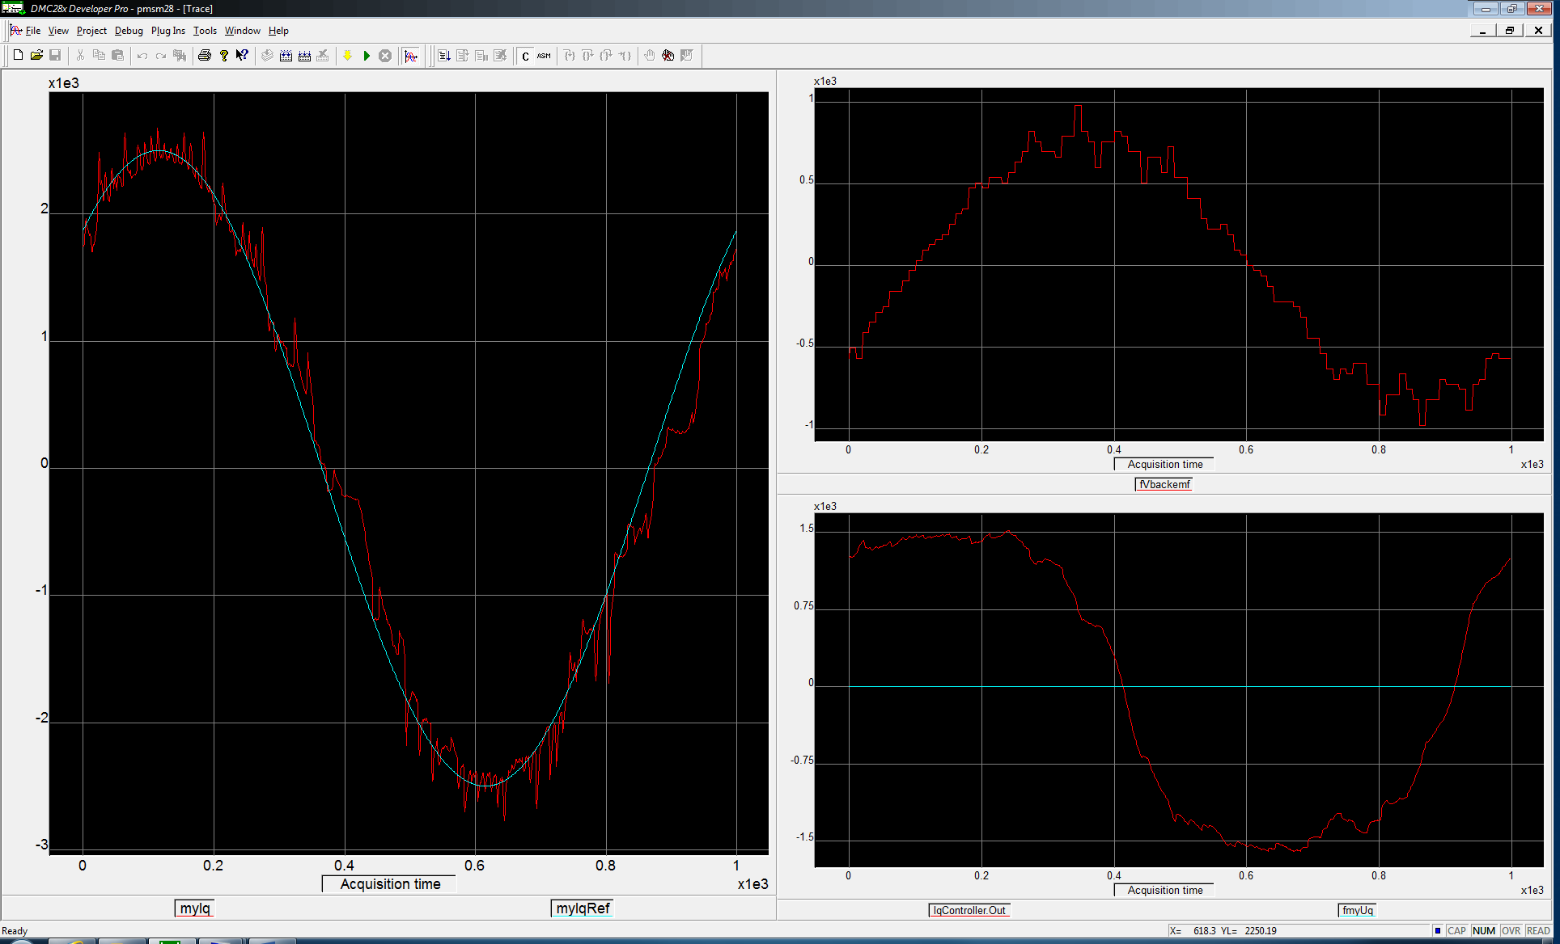

Sinus 10Hz uncompensated

